
GCSE Physical Education Paper 2 Section 6
Knowledge Organiser

R | I am not confident with this work  I am completely unsure what to do next  I have tried to find help independently using the text book and internet but still need help
A | I am almost confident with this work  I need to clarify exactly what to do next  I have tried seeking additional help, but would like further advice
G | I am confident with this work  I know what I need to do next  I have all the additional help I need

Ref: | Paper 2 Topics | Covered | R | A | G
P133 | Chapter 6: Health, Fitness and well being
P134-138 | Physical, emotional and social health and well-being, and fitness
P139-141 | The consequences of a sedentary lifestyle
P142-143 | Somatotypes
P144-145 | Energy use
P146-148 | A balanced diet
P149 | Maintaining water balance

Chapter 6 Health and Fitness
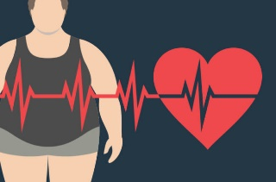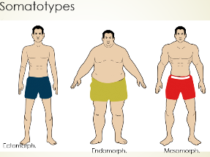
Ref no. | A01 Key Term | Definition
1.  2.  3.  4.  5.  6.  7.  8.  9.  10.  11.  12.  13.  14.  15.  16.  17.  18.  19.  20. | Health  Well-being  Fitness  Sedentary lifestyle  Obesity  Somatotype  Ectomorph  Endomorph  Mesomorph  Calorie  Balanced diet  Nutrition  Minerals  Vitamins  Carbohydrate  Fat  Protein  Hydration  Dehydration  Rehydration | A state of complete physical, mental and social well-being.  A mix of physical, social and mental factors that gives people a sense of being healthy and/or happy.  The ability to meet, or cope with, the demands of the environment.  A lifestyle with irregular or no physical activity.  A term used to describe people with a high fat content, caused by an imbalance in the number of calories consumed and the amount of energy expanded.  A method of classifying body types.  A somatotype characterized by being tall and thin, with narrow shoulders and narrow hips.  A somatotype characterized by a pear shaped body and a tendency towards fatness.  A somatotype characterized by a muscular appearance, wide shoulders and narrow hips.  A unit of measurement for heat or energy production in the body. Kcal  A diet that contains the right quantity of food and the right mix of different types of food.  The intake of food considered in the relation to the body’s dietary needs.  Inorganic substances that assist the body with many functions.  Organic substances that assist the body with many functions.  Food source that acts as the body’s preferred energy source.  Food source that provides energy at low intensities.  Food source which is predominantly for growth and repair of body tissues.  Having enough water in the body to enable it to function normally.  Excessive loss of water from the body, interrupting the normal functioning of the body.  Consuming water to restore hydration.
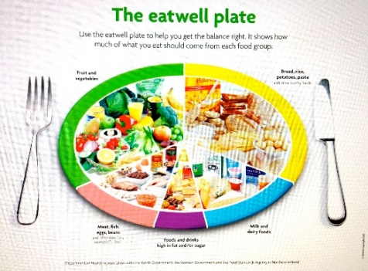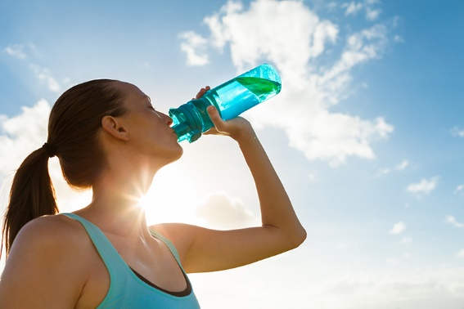

Ref no. | A02 / A03 Progress Check – Formative assessment | Marks
1.  2.  3.  4.  5.  6.  7.  8.  9.  10.  11.  12.  14.  15. | Name and explain two components of well-being.  Define Health and Fitness.  What do you understand by the term ‘sedentary lifestyle’?  Describe three possible negative effects of choosing a sedentary lifestyle.  Define obesity and explain one negative effect that it could have on mental health and well-being.  Explain one negative consequence that obesity can have on a person’s fitness.  With references to a sporting activity of your choice, explain why an ectomorph body type may be beneficial.  Sprinters often have wide muscular shoulders and a low fat content. State the somatotype that this describes.  With references to a sporting activity of your choice, explain why an endomorph body type may be beneficial.  What are the recommended percentages for carbohydrate, fat and protein within your diet?  What is the role of vitamins and minerals within the diet?  What do the terms hydration, dehydration and rehydration mean?  An adult man averages a daily intake of 3500 kcal per day. Is this too much or too little based on recommended guidelines? Justify your answer.  If an adult female is in training for an event, why might she eat and drink more calories than the recommended daily intake? | 4  2  1  3  2  1  3  1  3  3  2  3  2  2

Ref no. | A02 / A03 Progress Check – Summative assessment | Marks
1.  2.  3.. | A 6 and/or 9 marks question can be set by your subject teacher.  Zig Zag Topic Test  Exampro Sports Psychology Topic Test | 6 or 9  20

