Knowledge organiser for KS4 Biology Cells at Saint Ambrose College 2020+
What is covered in this unit?
Cell structure; eukaryotes and prokaryotes; magnitude calculations; animal and plant cells; cell specialisation; cell differentiation; microscopy, differences in magnification and resolution; culturing microorganisms; chromosome; mitosis and cell cycle; stem cells
Key vocabulary
Specialised Cells – cells that have adapted to perform a specific role/function
Resolution – The ability of a microscope to distinguish between two separate points
Cell membrane – Controls what enters and leaves the cell
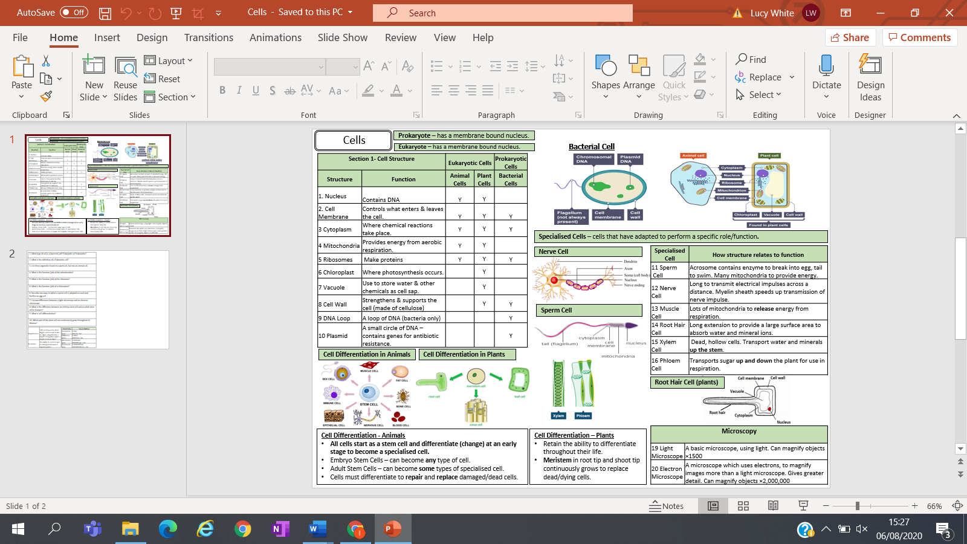
Key facts-

Possible homework tasks I Stretch & challenge (wider reading/independent work)
H/W: including project, Kerboodle, Kahoot, Exam Pro Stretch: modelling tasks, Biological Science Review research, Oxford Uni

