Knowledge organiser for KS4 Biology Transport in Cells at Saint Ambrose College 2020+
What is covered in this unit?
Diffusion; oxygen and carbon dioxide as gas exchange; urea as a waste product; different factors affect rate of diffusion; surface area to volume ratio; adaptations for exchanging materials; specialised organisms; osmosis; rate of water uptake; percentage gain and loss of mass of plant tissue; active transport; absorption of mineral ions; absorption sugar molecules; differences between three processes
Key vocabulary
Diffusion – The net movement of particles from an area of high concentration to an area of low concentration
Osmosis – The movement of water from a dilute solution to a concentrated solution through a partially permeable membrane
Active Transport – Movement of particles against the concentration gradient, requires energy
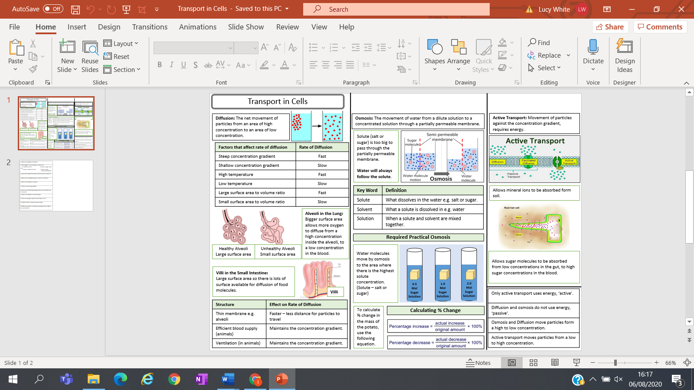
Key facts-

Possible homework tasks I Stretch & challenge (wider reading/independent work)
H/W: including project, Kerboodle, Kahoot, Exam Pro Stretch: modelling tasks, Biological Science Review research, Oxford Uni

