Knowledge organiser for KS4 Biology Mitosis and Stem Cells at Saint Ambrose College 2020+
What is covered in this unit?
Cell division; mitosis; stem cells; function of stem cells; cloning of stem cells; adult bone marrow; meristem tissue in plants; diabetes and paralysis; risks of stem cells
Key vocabulary
Stem Cell – A cell that can differentiate to become a different type of cell
Cell differentiation – When a stem cell changes to become a specialised cell e.g. red blood cell
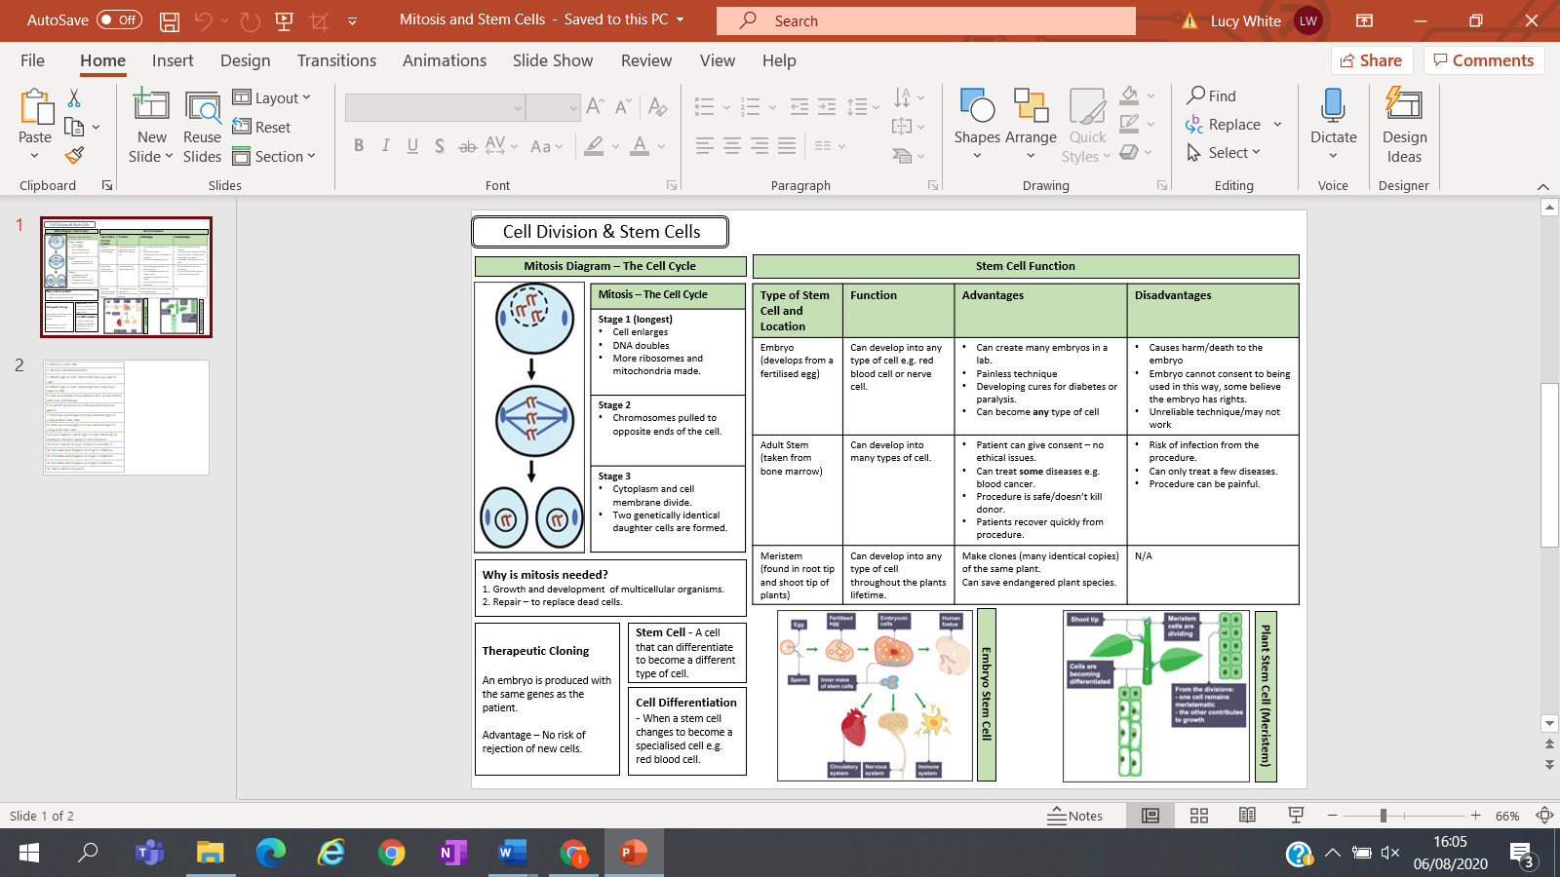
Key facts-
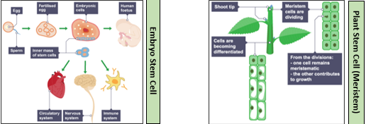

Possible homework tasks I Stretch & challenge (wider reading/independent work)
H/W: including project, Kerboodle, Kahoot, Exam Pro Stretch: modelling tasks, Biological Science Review research, Oxford Uni

