Knowledge organiser for KS3 Science Biology Detection- Forensic Science at Saint Ambrose College 2020+
What is covered in this unit?
Make and record observations and measurements using a range of methods starting with microscopy for different investigations and suggest possible improvements. Evaluate the impact of electron microscopy. Use appropriate techniques, apparatus, and materials during fieldwork and laboratory work, paying attention to health and safety. Explain that the genome interacts extensively with the environment to influence the development of the phenotype. Inheritance, chromosomes, DNA, and genes. Discuss the potential importance for medicine of our increasing understanding of the human genome. Interpret observations and data, including identifying patterns and using observations, measurements, and data to draw conclusions. Recognise the main components of the blood as red blood cells, white blood cells, platelets, and plasma and explain the functions of each. Predict the effect of factors such as temperature and water content on rate of decomposition.
Key vocabulary
DNA Fingerprinting – the analysis of DNA from body samples to identify individuals
Forensic science – the study of materials and situations that relate to a crime
Magnification – how many times bigger the image appears compared to the object
Blood analysis – used to help confirm the presence of a suspect at the scene of the crime
Pathologist – a doctor who specialises in understanding the nature and cause of death

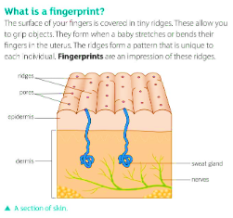
Key facts-
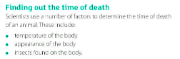

Possible homework tasks I Stretch & challenge (wider reading/independent work)
H/W:including Forensics project, Kerboodle, Kahoot. Stretch: Research of chosen crime, Biological Science Review research.

