Y9 LATIN
Big question: ‘Can I talk about holidays in Spanish?’ ‘Can I describe holidays in at least 3 different tenses?’
Module assessment level: ____________ Effort grade: ____________________
Target 1: _______________________________________________________________________________________________________
Target 2: ____________________________________________________________________________________________________
____________________________________________________________________________________________________________________
Success criteria
- Translation of perfect and imperfect tenses
- Fluent translation, eschewing glossaries
- Finding vocab. efficiently
- Completed trandslation and comprehension
- Extended writing in English on Source material

Key Skills and strategies
- Using vocab. knowledge
- De-construct sentence grammatically, using knowledge and understanding of case-endings
- Answering questions in English
- Make deductions from source evidence
- Argue a case for or against an interpretation of source material

Key details
Nature of assessment:
Comprehension, Translation, Response to Sources
Example question:
- Translate paragraph in ‘in arena’
- Answer qus. Onm text ‘venationes’
- How would a modern audience view gladiator contests differently from Romans?

Aims / Objectives
- Understand importance of gladiatorial contests in Roman like
- Translate texts with present and past events
- Understand importance of Bathing in Roman life

Assessment task to be completed by all Year 7 classes:
Completed? | Task | Assessment
 | Venationes | Teacher
 | Translation | Teacher/Peer
 | Vocab. tests | Peer
 | Source questio | Teacher

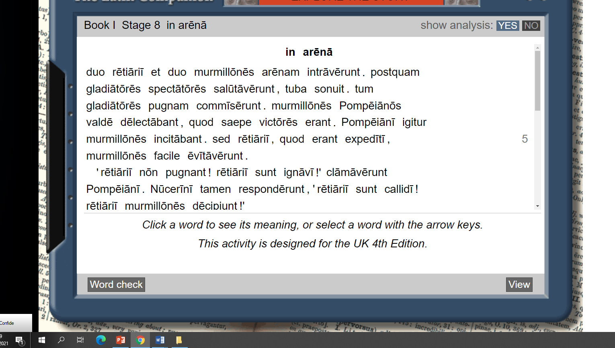

Vocabulary: Units 8 and 9 : Gladiatores et Balnea:


