GCSE – y10 Latin 21-22 Term 2a
Big question: ‘Can I talk about holidays in Spanish?’ ‘Can I describe holidays in at least 3 different tenses?’
Success criteria
- Translating more fluently
- Vocab. Test results
- Using source ref. systematically
- Knowing noun and adj. forms
- Explain differences between regular and irregular forms, and the terms of regular and irregular themselves

Assessment task to be completed by all Year 7 classes:
Completed? | Task | Assessment
 | Ch. 4 Comprehension | Teacher
 | Vocab. tests | Peer
 | Romanisation essay question | Teacher
 |  | Peer
 | End of unit assessment | Teacher

Key details
Nature of assessment:
Essay question on Roman Britain. Comprehension and translation from Seigel 3
Example question:
- How did the Romans ‘Romanise’ Britannia?
- Answer comprehension qus. On text from Greek myth
- Translate sections of text on Greek myth

Key Skills and strategies
- Making links between Noun and Adj
- Parsing a sentence
- Translating in detail
- Using evidence and forming arguments
- Learning vocab. in systematic way

Aims / Objectives
- Roman Britain- Sources: to understand the importance of site of BATH and religion
- To understand and recognise two main forms of adjectives and how endings link to noun endings
- To recognise and translate comparative and superlative forms of adverbs and adjectives.
- To know and recognise, and translate forms of irregular verbs ‘esse’ and ‘ire’

- Adverb endings – 2-1-2 and 3

Module assessment level: ____________ Effort grade: ____________________
Target 1: _______________________________________________________________________________________________________
Target 2: ____________________________________________________________________________________________________
____________________________________________________________________________________________________________________

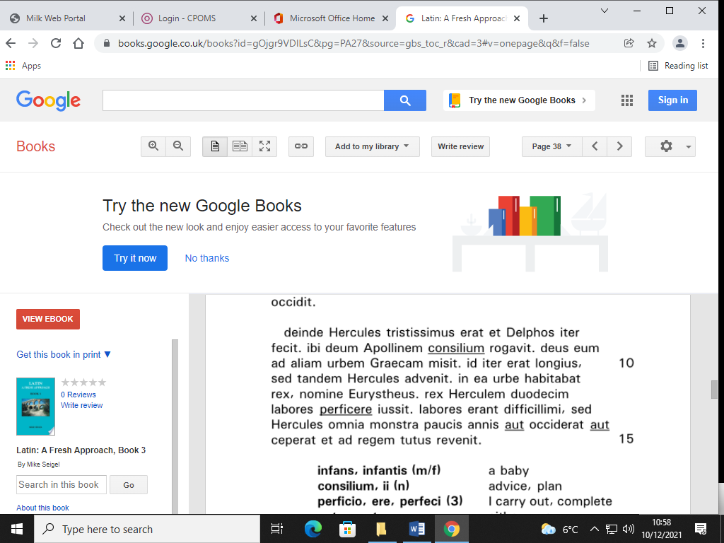
Then Hercules was VERY sad. There… HE asked. That journey was LONGER. The King ordered Hercules…

Vocabulary:
Attached separately

