Y8 LATIN –
Big question: Can you identify subject and object nouns in both singular and plural?
Module assessment level: ____________ Effort grade: ____________________
Target 1: _______________________________________________________________________________________________________
Target 2: ____________________________________________________________________________________________________
____________________________________________________________________________________________________________________
Success criteria
- Completion of exercises
- Oral and written translation work
- Vocab. Test scores
- Extended writing on Slavery
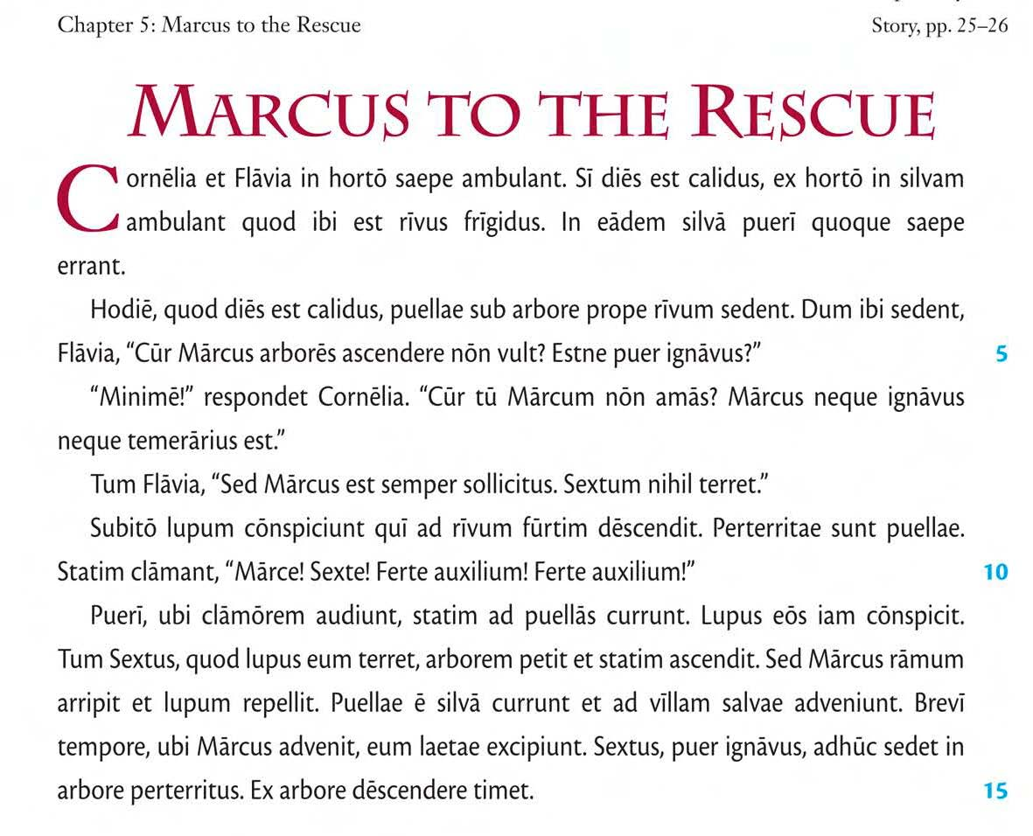
Key Skills and strategies
- Recognise agreements
- Search vocab.)
- Memorise vocab.
- Re-using language
- Use sources to draw conclusions ( about Slavery)

Key details
Nature of assessment:
Comprehension
Example question:
- Answer qus in English on ‘Marcus Comes to Rescue’.
- Translate a section accurately
- Translate sentences from English into Latin
- Respond to literary sources in English

Aims / Objectives
- Recognise accusative case endings
- Recognise verb-groups and person-endings
- Draw simple conclusions from Source material on Slavery
- Translate, and show comprehension of, longer Latin texts.
- Revise vocabulary.

Assessment task to be completed by all Year 8 classes:
Completed? | Task | Assessment
 | Ex. 7c | Peer/ Teacher
 | Source work on Slavery | Teacher
 | End of unit assessment – Unit 6 | Teacher
 |  | T

