GCSE – y10 Latin 21-22 Term 3b
Big question: ‘Why was public entertainment so important to Romans?’
Assessment task to be completed by all Year10 classes:
Completed? | Task | Assessment
 | Test on senences | Teacher
 | Vocab. tests | Peer
 | Short essay ( Sources) | Teacher
 | Exercises in class/ hw. -comp. and translation | Peer
 |  | Teacher

Key details
Nature of assessment:
Responding to sources. Short essay
Example question:
- Translate participles in sentences
- Answer comprehension qus. on stories
- What does Colosseum’s design and size tell us about the importance of the Shows?

Key Skills and strategies
- Irregular / regular stem - understanding
- Making links between verbs
- Translating in detail
- Reading for gist/detail
- Learning vocab. in systematic way
- Understand value of evidence of Public Entertainment in Rome

Success criteria
- Translating more fluently
- Vocab. Test results
- Knowing noun and adj. forms
- Explain differences between regular and irregular forms, and the terms of regular and irregular themselves
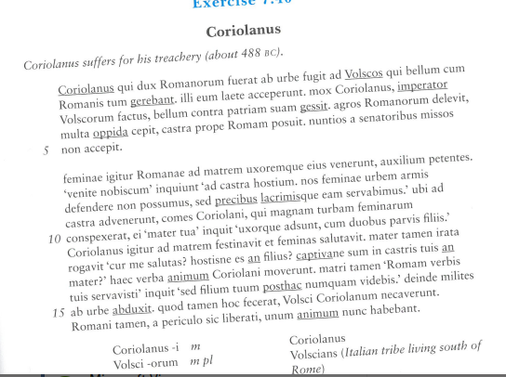

Aims / Objectives
- To understand and recognise Subjunctive Mood in ut clauses
- To understand Deponent verbs have an active meaning- continued
- Understand what a participle is and does in Latin- continued
- To practise parsing sentences for case, number, gender, and verb-noun agreements
- Expand and improve knowledge of GCSE vocab.
- Know facts about stadia, gladiators, chariot-racing. Appreciate its importance to Roman state.

- Adverb endings – 2-1-2 and 3

Module assessment level: ____________ Effort grade: ____________________
Target 1: _______________________________________________________________________________________________________
Target 2: ____________________________________________________________________________________________________
____________________________________________________________________________________________________________________

