Year 9 LATIN 22-23 – Term 1b
Big question: ‘Can read stories about past events?’
Module assessment level: ____________ Effort grade: ____________________
Target 1: _______________________________________________________________________________________________________
Target 2: ____________________________________________________________________________________________________
____________________________________________________________________________________________________________________
Key Skills and strategies
- Read for gist
- Read for detail
- Apply pattern
- Learn tables/ endings
- Learn/ note vocabulary
- Look up vocabulary quickly
- Construct an interpretation based on historical evidence

Key details
Nature of assessment:
Comprehension of longer texts; evaluating sources
Example question:
- How can we tell that Gladiatorial Games were very important to the Romans?

Aims / Objectives
- Know how slaves could be become freedmen and become successful as citizens.
- Know the types of gladiators.
- Know how Games fit into the Roman state
- Recognise perfect tense stems and person-endings
- Translate parts of text
- Extract meanings from a text

Assessment task to be completed by all Year 7 classes:
Completed? | Task | Assessment
 | Vocab tests – | Teacher
 | Comprehension | Peer/ Teacher
 | Essay ( Sources) | Teacher
 | Photocard | Peer
 | End of unit assessment | Teacher

Success criteria
- 60% + on Sources essay
- 40%, 60%, 80% success in Comprehension/Translation depending on initial levels in Language ( Dev, Sec, Ex)

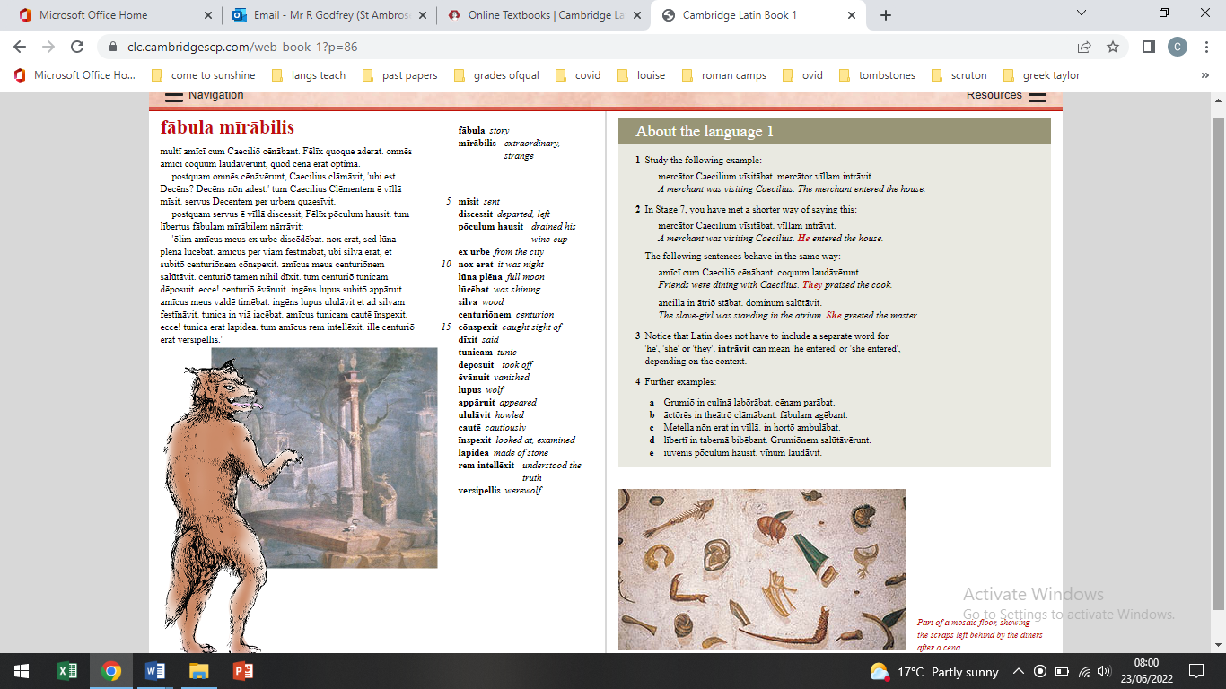

Vocabulario

FOUNDATION

Spanish | English
(no) fumador | (non) smoking
a mano derecha  /izquierda | on the right/  left-hand side
a pie | on foot, walking
aeropuerto, el | airport
agencia (de viajes), la | travel agent’s
aire acondicionado, el | air-conditioning
albergue juvenil, el | youth hostel
alemán | German
Alemania | Germany
alojamiento, el | accommodation
alojarse | to lodge, to stay
ambiente, el | atmosphere
andén, el | platform
aparcar | to park
asiento, el | seat
autocar, el | coach
autopista, la | motorway
avión, el | airplane, plane
bañarse | to bathe, to swim
barco, el | boat
billete (de ida/de ida y vuelta), el | (single/  return) ticket
británico | British
buscar | to look for
cama de matrimonio, la | double bed
cambiar | to change
caminar | to walk
camino, el | path, route
camping, el | camp site; camping
Canarias, las Islas | Canary Islands
carnet de conducir, el | driving licence
carnet de identidad, el | identity card
carnet, el | pass; card
carretera, la | highway
coche, el | car
coger | to take, to catch
conducir | to drive, to lead
conductor, el | driver
consigna, la | left luggage office
crema solar, la | suncream
crucero, el | cruise
cruzar | to cross
cheque (de viaje), el | travellers’ cheque
deportes acuáticos, los | water sports
descansar | to rest
descanso, el | rest, pause
dirección, la | management
disponible | available
doblar | to turn
equipaje, el | luggage
escocés | Scot, Scottish
Escocia | Scotland
España | Spain
español | Spanish
esperar | to wait
esquí, el | skiing
esquiar | to ski
estación (de autobuses/trenes), la | (bus/coach/train)  station
estación de servicio, la | service station
Estados Unidos, los | United States
estar de vacaciones | to be on holiday
Europa | Europe
europeo | European
excursión, la | trip, excursion
extranjero (en el _, al _) | abroad
ferrocarril, el | railways
ficha, la | registration form
folleto, el | leaflet, pamphlet
francés | French
Francia | France
Gales | Wales
galés | Welsh
gasolina (sin plomo), la | (unleaded) petrol
Gran Bretaña | Great Britain
Grecia | Greece
griego | Greek
guía, el | guide
guía, la | guidebook
habitación (doble/individual), la | (single/double) room
informar(se) | to find out
Inglaterra | England
inglés | English
instalaciones, las | facilities
Irlanda | Ireland
irlandés | Irish
isla, la | island
latinoamericano | Latin-American
libre | available
Londres | London
llegada, la | arrival
llegar | to arrive
llevar | to take
maleta, la | suitcase
máquina (de fotos), la | camera
mar, el | sea
media pensión | half board
Mediterráneo, el | Mediterranean Sea
metro, el | underground
montaña, la | mountain
norteamericano | North American
país, el | country
papel higiénico, el | toilet paper
parada, la | stop
parador, el | state owned hotel (in Spain)
parar | to stop
parque de atracciones, el | fairground, funfair
parque temático, el | theme park
pasajero, el | passenger
pasar | to spend time;  to go through; to pass
paso subterráneo, el | underpass, subway
pensión completa | full board
pensión, la | boarding house
perder | to lose; to miss
perderse | to get lost
permiso de conducir, el | driving licence
playa, la | beach
postal, la | postcard
quedarse | to stay
recepción, la | reception
recordar | to remember
recuerdo, el | souvenir
regresar | to go back
regreso, el | return
relajarse | to relax
reserva, la | reservation
reservar | to book, to reserve
retraso, el | delay
sacar (fotos) | to take photos
saco de dormir, el | sleeping bag
sala de espera, la | waiting room
salida, la | exit
señal, la | sign, signal
sitio, el | space, room
sitio, el | place, site
sudamericano | South American
taquilla, la | ticket office
tardar | to take time
tarjeta, la | card, postcard
tienda, la | tent
tomar el sol | to sunbathe
torcer | to turn
tranvía, el | tram
vacaciones, las | holidays
venir | to come
ver | to see
vía, la | track, lane
viajar | to travel
viaje, el | trip, journey
viajero, el | traveller
vista, la | view
volver | to return
vuelo, el | flight

HIGHER
HIGHERSpanish | English
abanico, el | fan
aduana, la | customs
avería, la | breakdown, fault
averiado | broken down
bonobús, el | bus pass
broncearse | to get a tan
camión, el | lorry
casco, el | helmet
castellano | Castillian,
cinturón de seguridad, el | seat belt
cruce, el | crossroads
decepcionar | to disappoint
detener(se) | to stop
DNI | ID card
hacer transbordo | to change, to transfer
insolación, la | sunstroke
motor, el | engine
queja, la | complaint
quejarse | to complain
rueda, la | wheel
sombrilla, la | sunshade, parasol

