Maths Skills for A Level Chemistry
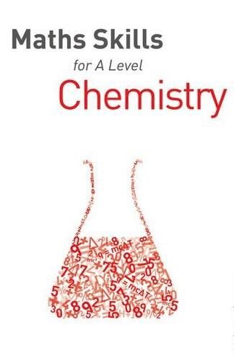
Dan McGowan
This handbook specifically targets the mathematical elements of A Level Science, whichever specification you're following. Includes plenty of practice questions in different contexts to increase confidence, worked examples and model answers for revision and exam preparation. Plus hints and tips for the exam and how to avoid common errors made in mathematical science questions.

Head Start to A Level Chemistry
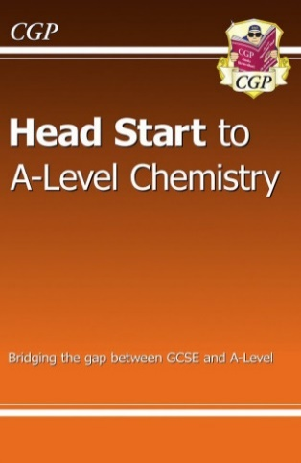
CGP Books
Get ahead of the game in A-Level Chemistry with CGP's unbeatable Head Start book! It goes over crucial topics you’ll need to remember from GCSE, with crystal-clear study notes, examples, and practice questions - plus it’s suitable for all exam boards. What’s more, we’ve included detailed introductions to important A-Level topics, so you can see what you're in for!

The Disappearing Spoon and Other Extraordinary True Tales from the Periodic Table
Sam Kean
Why did Gandhi hate iodine (I, 53)? Why did the Japanese kill Godzilla with missiles made of cadmium (Cd, 48)? How did radium (Ra, 88) nearly ruin Marie Curie's reputation? And why did tellurium (Te, 52) lead to the most bizarre gold rush in history?
The periodic table is one of our crowning scientific achievements, but it's also a treasure trove of passion, adventure, betrayal and obsession. The fascinating tales in The Disappearing Spoon follow carbon, neon, silicon, gold and every single element on the table as they play out their parts in human history, finance, mythology, conflict, the arts, medicine and the lives of the (frequently) mad scientists who discovered them.
Why did a little lithium (Li, 3) help cure poet Robert Lowell of his madness? And how did gallium (Ga, 31) become the go-to element for laboratory pranksters? The Disappearing Spoon has the answers, fusing science with the classic lore of invention, investigation, discovery and alchemy, from the big bang through to the end of time.

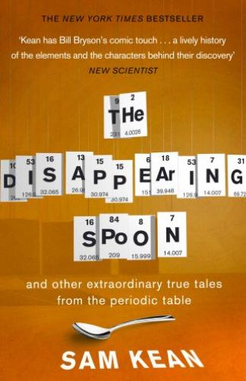

Why Chemical Reactions Happen
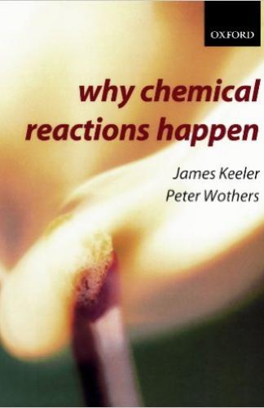
James Keeler

'Why Chemical Reactions Happen is one of nature's secrets.... This insightful book reveals in clear and impressive style what motivates molecules to metamorphose into something new. It supplies all the essentials for understanding entropy and how to choreograph molecular transformations to its music' Times Higher Education Supplement, February 2004.

Periodic Tales: The Curious Lives of the Elements
Hugh Aldersey-Williams
Everything is made of them, from the furthest reaches of the universe to this book that you hold in your hands, including you. Like you, the elements have lives: personalities and attitudes, talents and shortcomings, stories rich with meaning. You may think of them as the inscrutable letters of the periodic table but you know them much better than you realise. Welcome to a dazzling tour through history and literature, science and art. Here you'll meet iron that rains from the heavens and noble gases that light the way to vice. You'll learn how lead can tell your future while zinc may one day line your coffin. You'll discover what connects the bones in your body with the Whitehouse in Washington, the glow of a streetlamp with the salt on your dinner table. From ancient civilisations to contemporary culture, from the oxygen of publicity to the phosphorus in your pee, the elements are near and far and all around us. Unlocking their astonishing secrets and colourful pasts, Periodic Tales will take you on a voyage of wonder and discovery, excitement and novelty, beauty and truth. Along the way, you'll find that their stories are our stories, and their lives are inextricable from our own.
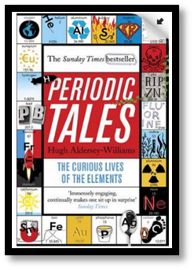

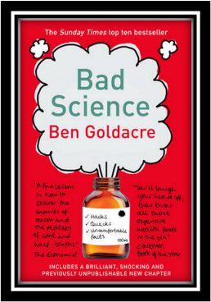
Bad Science
Ben Goldacre

Here Ben Goldacre takes apart anyone who published bad / misleading or dodgy science – this book will make you think about everything the advertising industry tries to sell you by making it sound ‘sciency’.

Books about Elements.
- The Elements- a visual exploration of every know atom in the universe: Theodore Gray 2009
- The Elements- the new guide to the building blocks of our universe: Jack Challoner 2014
- The elements- a very short introduction: Philip Ball 2004
- The Periodic Table: A Very Short Introduction: Eric Scerri 2011
- Nature’s Building blocks An A to Z guide to the Elements: J Emsley 2011
- The Periodic Table: A Field Guide to the Elements: Paul Parsons 2013
- Elements of Murder – A history of poison: J Emsley, 2006
- Periodic Tales: The Curious lives of Elements: Hugh Aldersey-Williams 2012
- The Periodic Table: A visual guide to the elements: Tom Jackson 2017
- Seven Elements That Have Changed The World: Iron, Carbon, Gold, Silver, Uranium, Titanium, Silicon John Browne 2014
- The Disappearing Spoon…and other true tales from the Periodic Table Paperback – 28 Jul 2011 by Sam Kean
Books about Molecules
- Molecules : Peter Atkins 2003
- Molecules at an exhibition: J Emsley, 1999
- Vanity, Vitality and Virility- the science behind the products you love to buy: J Emsley 2004
- Healthy, Wealthy, Sustainable World; J Emsley, 2010
- H₂O – a biography of water; Philip Ball ,2000
- Oxygen- the molecule that made the world; Nick Lane 2003
- Molecules: The Elements and the Architecture of Everything: Nick Mann, Theodore Gray 2014
- Why Does Asparagus Make Your Wee Smell?: And 57 other curious food and drink questions: Andy Brunning 2016
- Stuff matters : the strange stories of the marvellous materials that shape our man-made world : Mark Miodownik. 2014
General Chemistry readers
- Chemistry: A Very Short Introduction; Peter Atkins 2015
- Physical Chemistry: A Very Short Introduction; Peter Atkins 2014
- Reactions: The private life of atoms ; Peter Atkins 2013
- What is Chemistry? ; Peter Atkins 2013
- The joy of chemistry- The amazing science of Familiar things; Cobb, Fetterolf 2010
- The Atom: The building block of everything ; Jack Challoner 2018
- Reactions: An Illustrated Exploration of Elements, Molecules, and Change in the Universe ; Theodore Gray 2017
- 50 Chemistry Ideas You Really Need to Know ; Hayley Birch 2015
- Strange Chemistry: The Stories Your Chemistry Teacher Wouldn’t Tell You ; Steven Farmer 2017
- Elemental: How the Periodic Table Can Now Explain (Nearly) Everything : Tim James 2018
.History of chemistry Books
- Mendeleyev’s dream: the quest for elements; P Strathern 2001
- The big bang – A history of explosives; GI Brown, 1998
- The Periodic Table. Its story and its significance; EF Scerri- a detailed exploration of the development of the periodic table 2006
- A tale of 7 elements. Eric Scerri 2013
- Curious Tales from Chemistry: The Last Alchemist in Paris and Other Episodes Lars Öhrström 2015

