

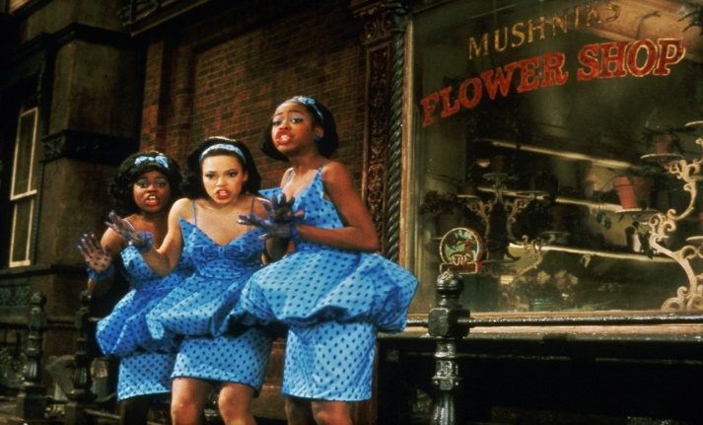
RHYTHM, TEMPO & METRE
- The Prologue is slow whereas Little Shop is fast
- Section A of Little Shop is much more syncopated than Section B
- The time signature (metre) starts as 4/4 but then moves to 12/8 at 3:40
- Generally a lot of syncopation
- At 0:52, very heavy use of quavers help to create a sense of energy and drive
- There is a rit (music slows down) at 0:40 to create anticipation and drama
- There is a backbeat at 0:44
- There is a calypso rhythm at 0:44 = fun

MELODY
- Rising sequence in the Prologue (brass part)
- In Little Shop, the melody is often harmonised in 3rds – 3rds sound pleasant on the ear
- In Little Shop, a pentatonic scale is used
- Heavy use of staccato articulation in the quaver chords

TEXTURE
- The Prologue is chordal
- Little Shop is melody and accompaniment
- Little Shop also has some call and response between the singers

HARMONY & TONALITY
- Based on a common ‘doo wop’ chords of I, IV and V (primary chords)
- In the Prologue, it is Eb major
- In Little Shop, the A section is G major and the B section is in C major
- Minor plagal cadences on ‘oh oh oh oh nooo’
- Sus4 chords in Section B

DYNAMICS
- Forte dynamics to create bold opening
- Dynamics go quieter to allow the narrator to be heard
- Crescendo into ‘Little Shop’ for a smooth transition

INSTRUMENTATION
- Prol – Drum rolls create drama
- Piano, keyboards, bass, guitar, drums

STRUCTURE
- Prologue lasts for 15 bars
- Little Shop is in ABA form (ternary)


RHYTHM, TEMPO & METRE
- Highly syncopated
- Semiquaver triplets in the castanets create a Latin feel
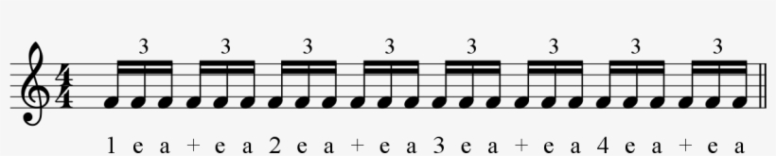
- There is a hemiola on the words ‘own adopted boy’ and ‘up my family tree’
- The following Jewish tango rhythm frequently appears
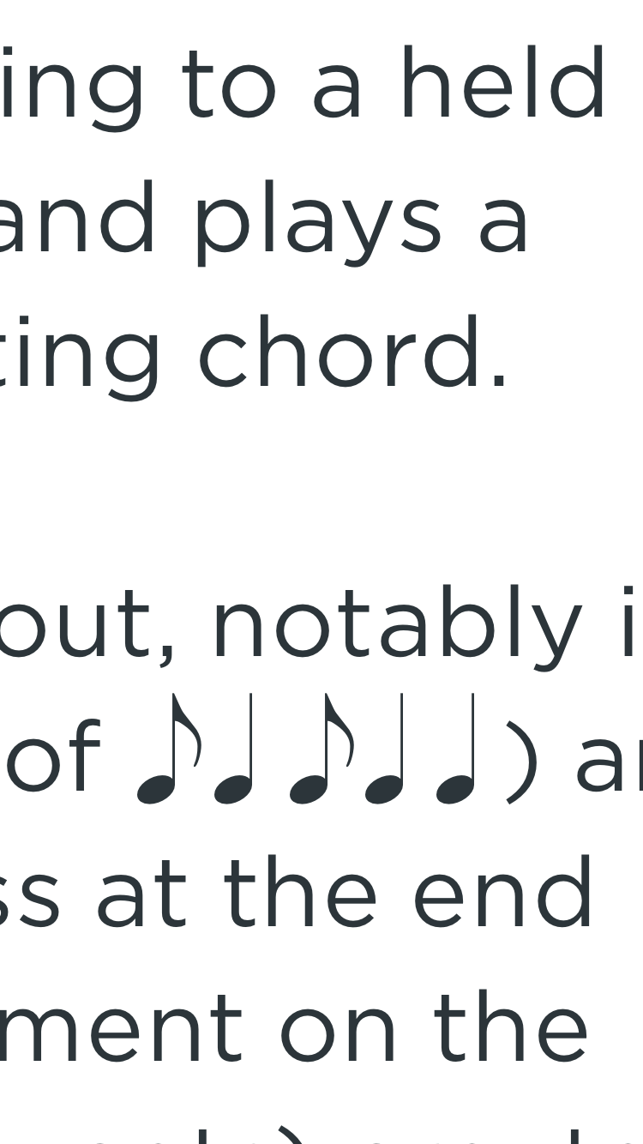
- The heavy use of quavers in the verse creates a sense of panic

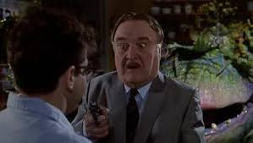
MELODY
- Always has a quaver rest before the first word which creates a sense of desperation
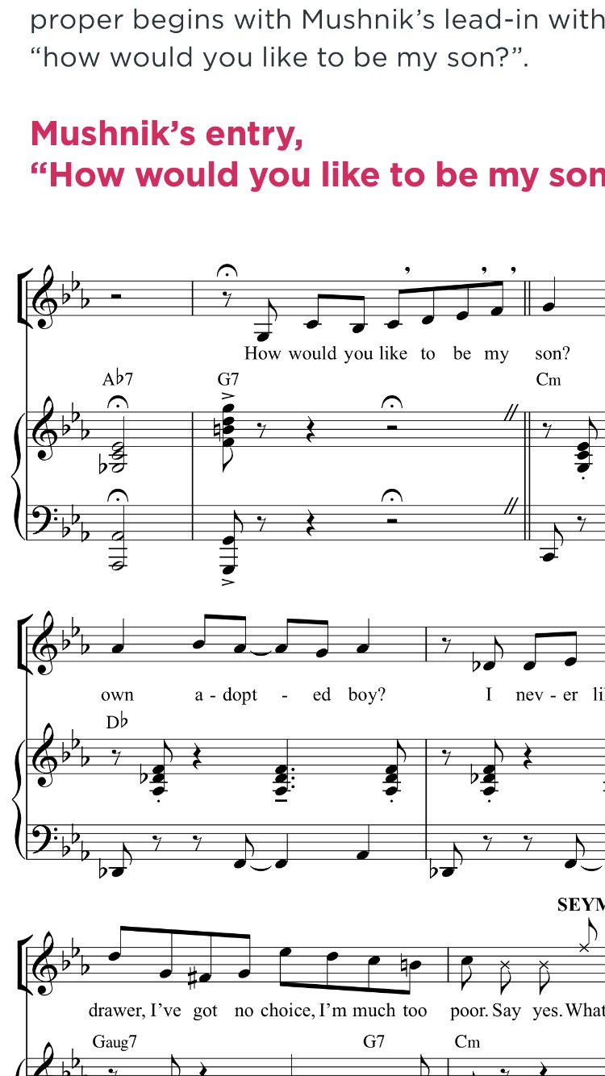
- Melody in the verse is conjunct
- Melody in the chorus is disjunct (e.g. 7ths), showing growing desperation
- The music is based on the Phrygian dominant scale (also known as the Yiddish scale) which gives its distinct sound
- The melody is made up of the first 5 notes of the C minor scale
- Syllabic throughout
- Large vocal range of a minor 13th
- The music ends on a rising chromatic scale = cheeky and mischievous

TEXTURE
- Mostly melody and accompaniment
- Some examples of monophony such as ‘how would you like to be my’– this emphasises Mushnik’s entrance!
- Unison on the words ‘Mushnik and Son’ creates sense of togetherness

INSTRUMENTATION
- Typical Klezmer instruments; clarinet, violin, acoustic guitar and accordion but with modern twist of piano, keys, bass, drums and claves
- Bass guitar is very heavy/loud
- Pitch bends on clarinet typical of Klezmer/playful feel

HARMONY & TONALITY
- The key of C minor creates a mysterious feel
- Chords are quite chromatic (Cm Db Dm) which creates a mischievous feel
- We move to the relative major of Eb major
- The music is based on the Phrygian dominant scale (also known as the Yiddish scale) which gives its distinct sound

DYNAMICS
- Mp and mf in the verse
- Forte in the chorus

STRUCTURE
- Verse chorus form

RHYTHM, TEMPO & METRE
- Time signature is 4/4 but moves to 12/8 on the new section ‘I don’t know, I don’t knoooow’
- Triplet quaver chords when the time signature changes to 12/8
- Syncopation throughout, especially on the chords at 1:22

MELODY
- 2 note riff based on C
- ‘Ad libs’ are marked where the performer can improvise. Highly typical of Blues!
- Glissandos on piano – very Bluesy!
- Parlando style singing – when the singing is designed to sound free and natural (also Blues typical)
- Use of ‘blue’ notes
- Bigger range and more disjunct on ‘I don’t know’ reflects Seymour’s anxiety over what to do

TEXTURE
- Largely melody and accompaniment


---------
INSTRUMENTATION
- Use of the Hammond organ creates a gospel, religious feel
- Glissando on piano to create excitement
- Use of distortion on guitar to create violent/rocky feel



HARMONY & TONALITY
- Use of the 12-bar blues (chords I IV and V)
- C major but moves to A minor on ‘I don’t know’ – example of word painting. Seymour’s doubt is reflected in the change to minor
- Lots of dominant 7th chords – very Bluesy
- Use of perfect cadences
- Secondary dominant chord – D7
- At 4:27, the harmonic rhythm changes to a chord change on every single quaver. This creates excitement and momentum

STRUCTURE
- Through-composed. This means that the song has no set structure – instead, it follows the demands of the storyline

DYNAMICS
- Forte for most of the song; designed to be energetic throughout
- Crescendos to create excitement
- Dynamics come down during the parlando sections

Example Essays
Prologue and LSOH:
- Contrast the’ Prologue’ with ‘Little Shop of Horrors’
- How does the Prologue create a sense of anticipation and excitement?
- Explain why LSOH is an appropriate opening number for the musical

Mushnik & Son:
- How does ‘Mushnik & Son’ showcase elements of Klezmer and Latin music?
- How does ‘Mushnik & Son’ characterise Mushnik as a deceitful and cunning character?

Feed Me:
- How does ‘Feed Me’ showcase influences from Blues and gospel music?
- How does ‘Feed Me’ create a sense of action and danger?

More General Questions Relating to the Elements of Music (AQA has favoured these types of questions in recent years):
- Describe the use of harmony, tempo and rhythm and metre in ‘LSOH’
- Describe the use of melody and texture in ‘Mushnik & Son’
- Describe the use of dynamics, structure and instrumentation in ‘Feed Me’

