How does Mozart develop his Rondo theme?
- The clarinet plays the Rondo theme an octave lower
- Mozart omits rhythms from the Rondo theme
- Mozart fragments the Rondo theme by inserting rests
- The Rondo theme returns in different instruments, such as the flute

Structure
ABACA
A = Rondo Section
B/C = Episode 1/2

Melody
Balanced phrases of antecedent followed by consequent
Heavy use of major scales; there is a descending A major in bar 3
As it’s highly scalic, it is also highly conjunct
Rondo theme starts on anacrusis - lively
Chromatic at times such as in bar 4 – cheeky and colourful
Mixture of articulation between the staccato and legato creates further contrast
The triadic melody in last bar of Rondo theme - affirms the major key
Heavy use of major arpeggios in bar 20 helps to confirm the key
Use of acciaccaturas, tremolos and trills for playfulness
At bar 77, flute plays Rondo theme as clarinet accompanies with a descending sequence
There are tremolos in the strings, which help to create excitement

Mozart Knowledge Organiser
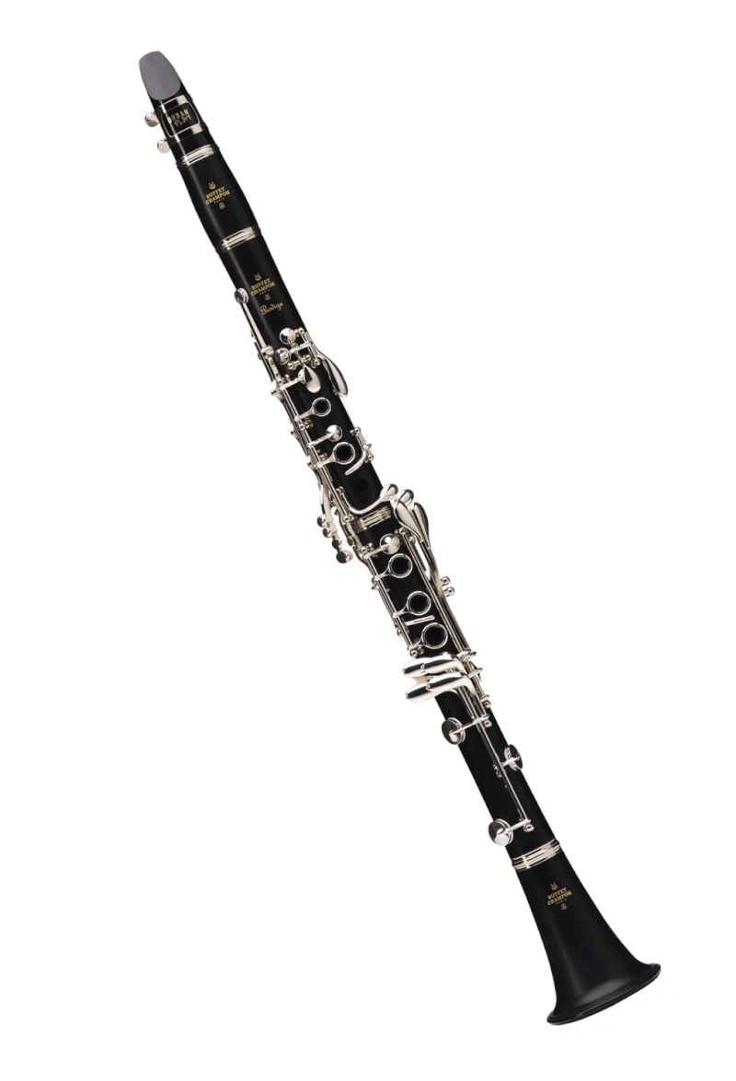
Example of a model answer:
‘Discuss Mozart’s use of melody in the Clarinet Concerto in A’
Mozart employs melody in a way that is highly balanced. Firstly, there is an antecedent phrase in bars 1-4 which is then followed by a consequent phrase in bars 5-8. This creates symmetry and order. Similarly, the Rondo theme showcases rising and descending A major scales, as well as a rising chromatic scale in bar 3. This helps to create melodic contrast. Furthermore, the use of ornaments in the form of trills and acciaccaturas helps to energise the melody and make the clarinet seem playful.

Rhythm, Metre & Tempo
6/8 time signature
Extremely quaver and semiquaver based, creating a lively atmosphere and allowing the clarinet to show off
Waltz-like ‘um-cha-cha’ accompaniment at b84
Allegro tempo
The Rondo theme starts on an anacrusis
Rests and silence often intersperse new sections of music

Instrumentation
At b160, all registers of clarinet are showcased - chalumeau (low), clarion (mid) and altissimo (high)
Clarinet in A, meaning it is transposing and has a different key signature to the other instruments
Scored for violins (C major), cello (C major) flutes (C major), fagotti (C major)

Harmony
A major - happy
Moves to several predictable/related keys such as E major (the dominant), D major (subdominant) and F# minor (relative minor)
Phrases often have an imperfect cadence in the middle, which is then resolved by a perfect cadence
Use of tonic and dominant pedals to confirm the A major key
Use of the Neapolitan 6th chord for colour
At b230, there is dissonance that is quickly resolved – typical of classical music
Uses several dominant 7th chords which are resolved to the tonic

Texture
Tutti sections where everyone plays together are contrasted with solos
Several examples of call and response between the clarinet and orchestra
When clarinet is doing its thing over the orchestra, this is generally homophonic

Structure
Rondo structure ABACADAEA etc… The Rondo theme is 8 bars long
The 3rd movement as a whole is part of a concerto
Silence often marks the beginning of a new section (b127)



A | B | A | C | A | Coda
Bars 1-56 | AKA Episode 1  Bar 57 - 113 | Bar 114 - 137 | AKA Episode 2  Bar 138 - 178 | Bar 247 to 300 | Bar 300 – End (Bar 346)
- A major  - Rondo theme established  - End of A Section has a link section into B | - Clarinet plays down an octave  - Flute solo bar 77  - Augmented 6th chords  - Dramatic dominant 7ths | - Section A ideas are developed via sequences and hemiolas (bar 131-2) | - Modulates to relative minor of F# minor  - Move to subdominant of F major  - Move to dominant of E major  - Big disjunct leaps in clarinet | Returns in full | - Very virtuosic  - Call and response between clarinet and 1st violins  - Broken A major chords at the end to sound finished

