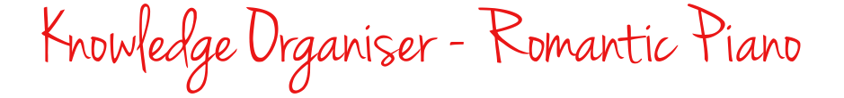
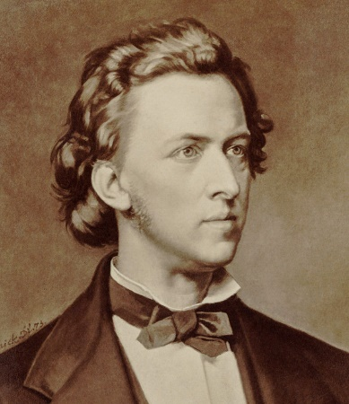
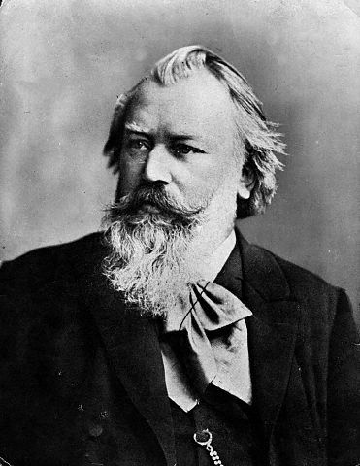
Key General Terms

- Rubato – free tempo
- Appoggiatura – a non-chord note that adds dissonance
- Suspension – tension followed by release (4-3 most common)
- Motif - a recurring musical idea that is often small
- Inversion - turning the music upside down
- Retrograde - playing the music backwards
- Substructure – the structure within sections of the wider structure

Chopin

- Exploiting the character of the piano important for Chopin, eg cantabile legato playing with extensive use of the sustaining pedal, use of rubato, technically demanding
- Focus on structure is not important, less emphasis on motivic development
- Instead he used repetition of melodic ideas, eg sequentially or with delicate ornamentation or more elaborate fioritura (a florid decoration – embellishment – of a melodic line)
- So we can see a more improvisatory approach to composing rather that a carefully thought out method
- Uses acciacaturas to start a melodic phrase
- Contrast in his music from lyrical simplicity to tempestuousness.
- Flexible approach to tempo (rubato) and parlando (free declamatory more speech-like)

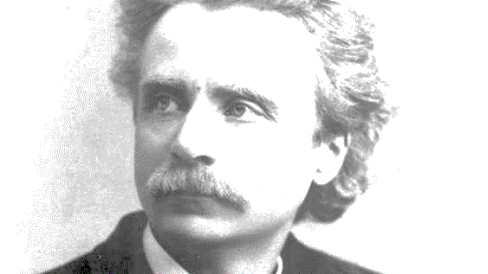
Grieg

- March reflects his Nationalism, and Nocturne his awareness of European harmonic trends with its increased chromaticisms.
- Like Chopin, he prefers repetition either sequentially or with some changes to a more formal approach to structure.
- Nationalism can be seen in 1. Use of open 5ths drones (Hardanger folk fiddle), 2.Dance like quality to his melodies, 3.ornamentation (eg frequent use of mordents),3. Melodies have dominant as the focus rather than the tonic, 4. Modal inflections in the melodies, 5. Frequent changes in tonality
- Chromatic harmony more evident in Notturno – eg half diminished 7ths. Complex chord progressions underpinned by circle of 5ths . Non diatonic chords eg on flattened submediant.
- ‘Grieg’ melodic motif – falling tone/semitone followed by a 3rd – common in his music.
- Rhythms often syncopated with ties obscuring the metre

Brahms

- Extensive and detailed development of melody and motifs consistent with his more Classical approach to form and structure – carefully thought out rather than free-er ‘improvisatory’ approach of Chopin. Very Germanic!
- Therefore stronger emphasis on structure and proportion
- Periodic phrasing more frequently used than eg Chopin, but underlying this is chromatic harmony and cross rhythms. Harmonic rhythm can create a non periodic substructure eg bars 49-56 in the Intermezzo.
- Cross rhythms and cross phrasing
- Split melodies in inner parts between hands

