Lesson 1: Timbre | 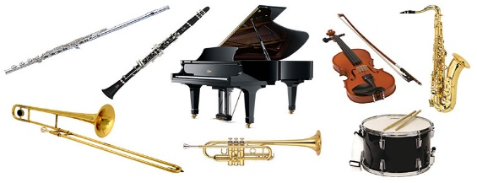  The sound quality of an instrument.  Level 1 – Brass/String/Woodwind/Percussion.  Level 2 – Specific instruments.  What gives a timbre its unique sound?  Size defines its pitch – Larger instruments are lower pitch, smaller instruments are higher pitch. The material used alters the timbre – metallic, brass-y, string-y etc.
Lesson 2: Ostinato | 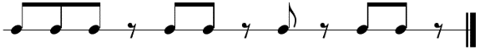  A short, repeated and persistent musical pattern.  Either a rhythm or a melody.
Lesson 3: Texture | 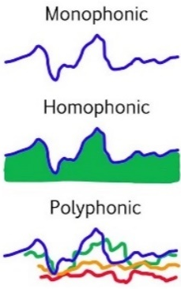  How many layers of sound.  Thick = many layers. Thin = few layers.  Monophonic: A single layer of music (1 instrument).  Homophonic: Layers that move at the same time.  Polyphonic: Many layers that intertwine.  Call and Response – a musical “conversation”  Unison = 2 or more instruments performing the same pitch.
Lesson 4: Structure | Sections of music and how they are arranged e.g. Intro, Verse, Chorus, Verse, Chorus, Outro or A B A C A where each letter is a different section. Through composed – structures do not repeat e.g Bohemian Rhapsody.  Binary - A B 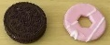  Theme and Variation - A A1 A2 A3 A4 … 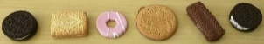  Rondo - A B A C A 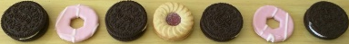
Lesson 5: Dynamics | How loud or quiet (soft) a piece of music is.  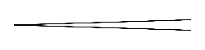  Crescendo (cre-shen-do) Music that gradually gets louder.  Diminuendo when music gradually gets quieter.  Throughout a piece, the dynamics can change several times.  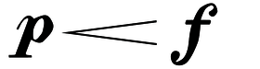  p – shorthand for Piano meaning soft.  f – shorthand for Forte meaning loud.
Who and What Should I Listen To?
The Romantic Era (1750 – 1830) composers were masters at using the elements of music to create highly engaging music.
Tchaikovsky / Grieg / Brahms / Wagner / Mendelssohn
- Listen to their music and make notes on how they change the elements of music over time
- Pick one element at a time and create a timeline
- What effect does this have on the listener?
John Williams’ Olympic Fanfare and Theme is an excellent example of mastery of the elements of music.
Italian Terms
Tempo: largo, adagio, andante, moderato, allegro, presto
Dynamics: pianississimo, pianissimo, piano, mezzo piano/forte, forte, fortissimo, fortississimo

Useful Adjectives to Describe Timbre
rich, bright, warm, mellow, dark, round, sharp, clean,
distorted, breathy, piercing, thin, dull, heavy
vibrant, melodic, reverberating, sustained,
rhythmic, thundering, beat-driven, exotic, resonant

What Will I Be Assessed On?
In this module, you will be asked to compose a short piece of music for the elements Earth Wind Water and Fire. The piece will develop as each lesson progresses, adding various elements of music to create a fully through-composed masterpiece. There will also be a written test to assess your ability to identify and define the elements and key phrases.

