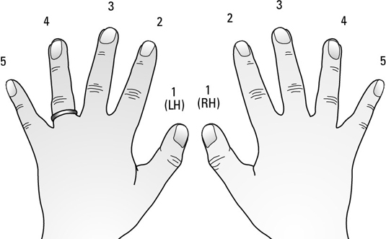
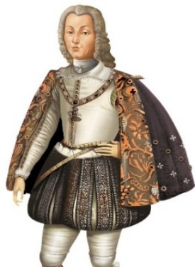
General Knowledge
- The piano (Pianoforte) was invented by Bartolomeo Christofori c.1700
- It came after the harpsichord which is very similar
- It is part of both the string family and percussion family
- Harpsichord uses a plucking mechanism whereas the piano uses a hammer mechanism

Notes: C D E F G A B C
Right Hand Fingers: 1 2 3 1 2 3 4 5
Left Hand Fingers: 5 4 3 2 1 3 2 1
Solfege: Do Re Mi Fa Sol La Ti Do
Sargam: Sa Re Ga Ma Pa Da Ni Sa

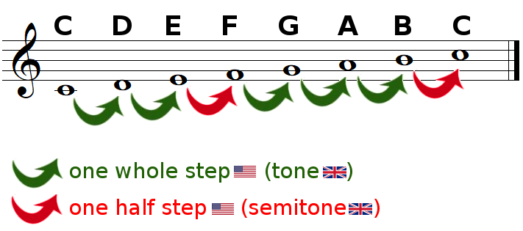

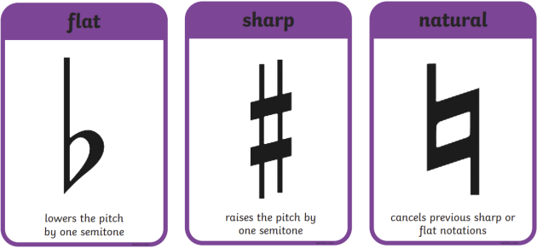
TONE (WHOLE STEP) SEMITONE (HALF STEP)
Starting from the lowest space – F.A.C.E in the Space
Starting from the lowest line – Every Good Boy Deserves Football





