Term | Definition
12 Bar Blues | This is what we call a chordal structure. This repetitive sequence of chords determines the overall structure of the song. The 12 bars are made up of chords I, IV and V. In the key of C major, this would be chords C, F and G major.
Blues Scale | This is a scale that is exclusive to Blues music. We can use the notes of this scale to improvise music. It is different to your standard major scale, because it includes several flats.
Improvisation | This is when an element of the music is spontaneous. It does not simply mean to ‘make up something on the spot’ as the music must stick to rules and be stylistically appropriate. You wouldn’t improvise a rock riff within a jazz song!
The Head | The main melody or theme of the music. This is a term commonly used in Jazz and Blues
Dominant 7th | A type of chord which sounds ‘Blues-y’. It is created by adding a flattened 7th on top of a major chord.
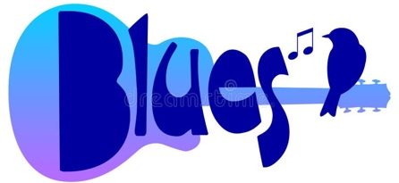

Food for Thought
Why is Blues music still relevant to today’s music?
Why is improvisation not simply just ‘making it up on the spot’?
What other genres of music can you think of which came out of oppression?

How Am I assessed?
You will be assessed via a group performance and a written test. The test will gauge your listening, theoretical and analytical skills.

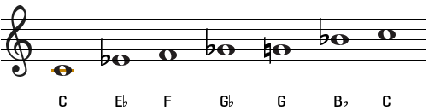
Who should I listen to?
Robert Johnson
B.B. King
Eric Clapton
In the extract from Chapter 7, Orwell clearly conveys the fear and distress of the animals after the violence they have just witnessed. We can see this from the way the animals are standing “huddled about Clover, not speaking.” The verb “huddled” suggests that they are seeking comfort and protection from Clover, a mother figure to the animals in the novel. It makes us feel sympathy for the animals who are shocked and bewildered by the brutality they have just seen. The adverbial phrase “not speaking” makes the reader feel even more sorry for the animals because they aren’t really able to voice what they are feeling, which makes them seem more vulnerable and helpless.

