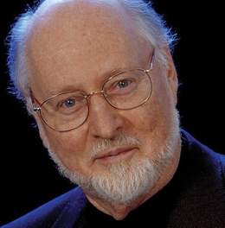
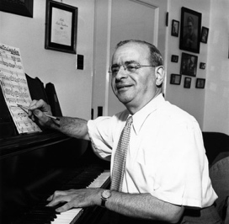
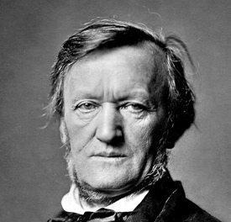
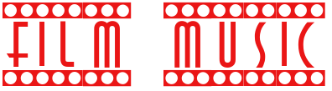


Food for Thought
Can you listen to film music without the film?
Does film music manipulate our responses? If so, is this positive or negative?

Richard Wagner: Father of the leitmotif
Max Steiner: Father of Film Music
John Williams: Master of Film Music

Terminology:
- Major and minor – ‘happy’ and ‘sad’ music determined by the use of a major 3rd or minor 3rd in the scale. For example, C major is C E G whereas C minor is C Eb G
- Leitmotif – German for ‘little idea’, this is a theme tune for character. It can also be used for places and objects, such as The Shire or the ring itself
- Diegetic music – when the music belongs within the story of the film. For example, when Gabriel plays his oboe in ‘The Mission’
- Non-diegetic music – when the music is added later to enhance the film. Most film music fits into this category
- Counterpoint – when the music juxtaposes the actions on screen. This can often make the viewer feel uncomfortable, surprised or confused
- Mickey-mousing – when the music exactly matches the actions on screen

How am I assessed?
Practical: A music composition that is based on the story of Lord of the Rings using GarageBand
Written: A listening, and written test based which will test your knowledge and ability to analyse a scene
In the extract from Chapter 7, Orwell clearly conveys the fear and distress of the animals after the violence they have just witnessed. We can see this from the way the animals are standing “huddled about Clover, not speaking.” The verb “huddled” suggests that they are seeking comfort and protection from Clover, a mother figure to the animals in the novel. It makes us feel sympathy for the animals who are shocked and bewildered by the brutality they have just seen. The adverbial phrase “not speaking” makes the reader feel even more sorry for the animals because they aren’t really able to voice what they are feeling, which makes them seem more vulnerable and helpless.

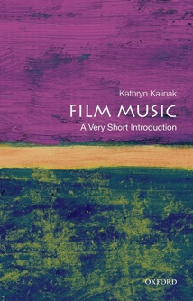
Wider Listening:
- Hans Zimmer
- John Powell
- Thomas Newman
- Bernard Herrmann’s ‘Psycho’

