Classical Music Timeline
Medieval Music  1150 – 1400 | Renaissance  1400 - 1600 | Baroque  1600 -1750 | Classical  1750 - 1830 | Early Romantic  1830 -1860 | Late Romantic  1860-1920 | 20th/21st Century  1920 - Present
Key terminology in this SoW:
Ground Bass | A ground bass is a repeating musical pattern that is played in the bass as other parts play variations of it.​
Alberti Bass | When the notes of the chords are played in the order 1 5 3 5 e.g. C G E G
Binary Form | A musical form with two contrasting sections (A + B). Can also be AABB.
Ternary Form | A musical form with two contrasting sections (A + B + A) and a return to A.
Musical Eras | The evolution of music from 1600 to the 1900s (Baroque, Classical, Romantic). Baroque is calculated and mathematical, whereas Romantic is often expressive, in a minor key and features musical ‘extremes’ in dynamics
Musical contrast and  balance | The idea that ‘good music’ comes from balance and contrast. This may be in the form of major to minor, forte to piano, 4/4 to 3/4, semibreves to semiquavers or allegro to adagio

Classical Music Composers
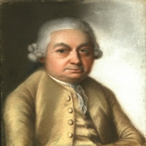 | 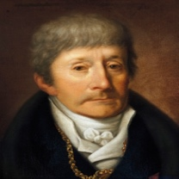 | 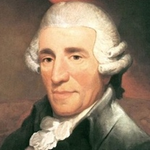 | 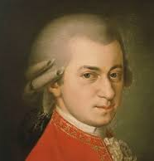 | 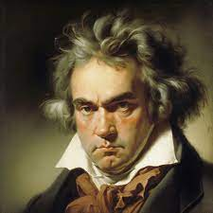 | 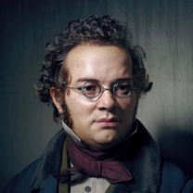
C.P.E Bach  1714 – 1788  Germany | Antonio Salieri  1750 – 1825  Italian | Haydn  1732 – 1809  Austria | Mozart  1756 – 1791  Austria | Beethoven  1770 – 1827  German | Schubert  1797 – 1828  German
Classical Instrumentation
Strings | Woodwind | Brass | Percussion
Violin  Viola  Cello  Double Bass | Piccolo  Flute  Oboe  Clarinet  Bassoon | Cornet  Trumpet  Trombone  Horns | Timpani  Snare Drum  Bass Drum  Cymbals  Xylophone  Harp


