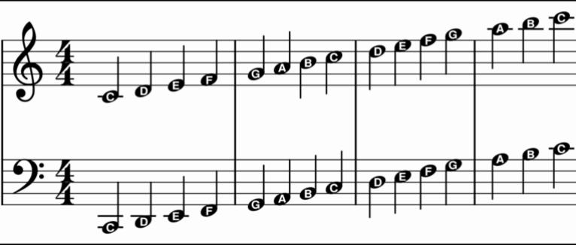
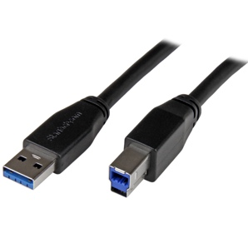

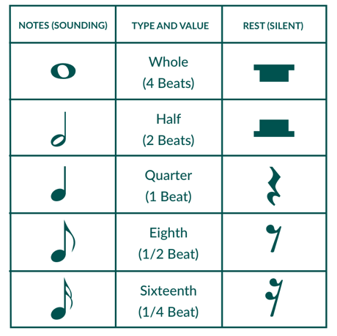
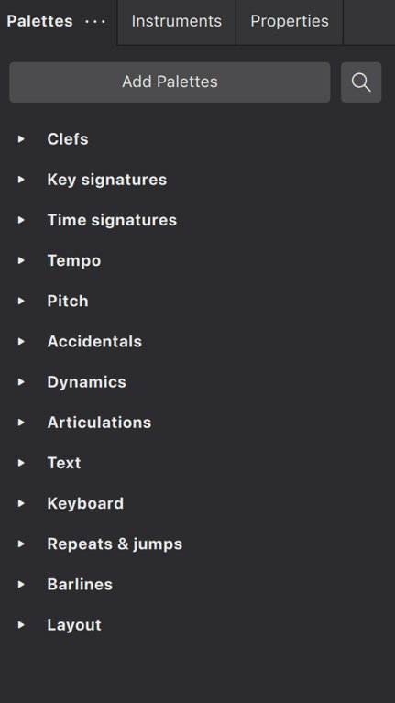
Troubleshooting Audio/Devices:
- Go to ‘MuseScore’ in the top left and select ‘Preferences’
- Select the ‘I/O’ tab on the left and make sure that the audio device is ‘digital keyboard’
- Close down MuseScore
- Using the search tool for Mac, search ‘Sound’ which will take you to setting
- Ensure that the output device is correct
- Double check that your piano keyboard has a USB-B coming out of it
- Only now, restart MuseScore and see if the problem has been resolved

www.musescore.org/en/tutorials

BASS CLEF
TREBLE CLEF
The Toolbar: Here, you select the rhythm you want. You should select this before choosing the pitch.
The Palette:
The ‘menu’ for most musical functions. Remember to use the ‘search’ function if you cannot find the function you want
MuseScore Knowledge Organiser
Why MuseScore?
- Allows you to compose and make music using real-world software
- Prepares you for GCSE Music and improves your ability to read music
- Offers an alternative to GarageBand, which can be quite ‘loops’ and ‘blocks’ based

