Knowledge Organiser
Autumn Term 1 Accelerator Year 10
Topic | Self-Assessment | Independent Learning and  homework tasks
Topic | Self-Assessment | MyMaths | CorbettMaths.com
Pythagoras (5) |  | Shape, Pythagoras, Pythagoras Theorem | Video 257 - 8
Similar Triangles (6) |  | Shape, Scale & Similarity, Similar Triangles | Videos 291 - 2
Trigonometry (6/7) |  | Shape, Trigonometry, Trig Missing Angles & Trig Missing Sides | Videos 329 - 331
Be able to use Pythagoras and Trigonometry to solve 3D problems |  | Shape, Trigonometry, 3D Pythagoras & 3DTrigonometry | Videos 329 - 331
Convert fractions, decimals & percentages (3) |  | Number, Percentages, Frac Dec Perc 2 | FDP  Videos 121 to 131
Converting recurring decimals to fractions (7) |  | Number, Decimals, Fractions, Recurring Decimals 2 | Video 96
Understanding and calculating with ratios (4) |  | Number, Ratio & Proportion – Ratio Dividing & Proportion | Video 269, 271a - d
Using the Unitary method to solve ratio problems |  | Number, Ratio & Proportion – Unitary Method | Video 255a
Writing and using equations for proportionality (7) |  | Number, Ratio & Proportion – Direct Proportion | Video 254
Writing and using equations for indirect proportionality (7) |  | Number, Ratio & Proportion –Indirect Proportion | Video 255
Finding the lower and upper bounds of numbers (5) |  | Number, Estimating & Accuracy, Upper & Lower Bounds 1 | Video 183
Calculating with lower and upper bounds (7) |  | Number, Estimating & Accuracy, Upper & Lower Bounds 2 | Video 184

Stretch and Challenge:
- Practise UKMT Intermediate Maths Challenge Past papers on:
https://www.ukmt.org.uk/competitions/solo/intermediate-mathematical-challenge/archive
- Set up an account on parallel.org.uk website, using your school email address and use teacher code “ha52kh”
- Attend Puzzle Club one lunch time each week

Autumn Term 1 Knowledge
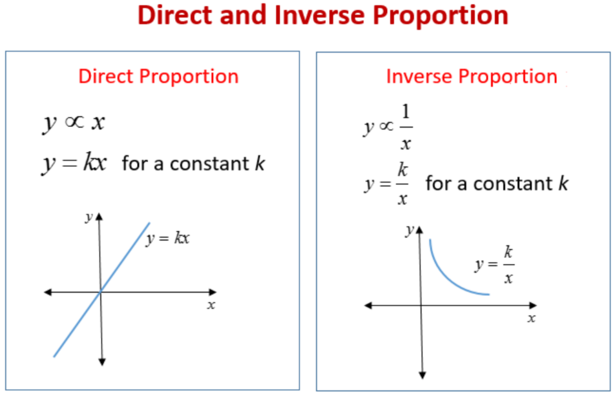
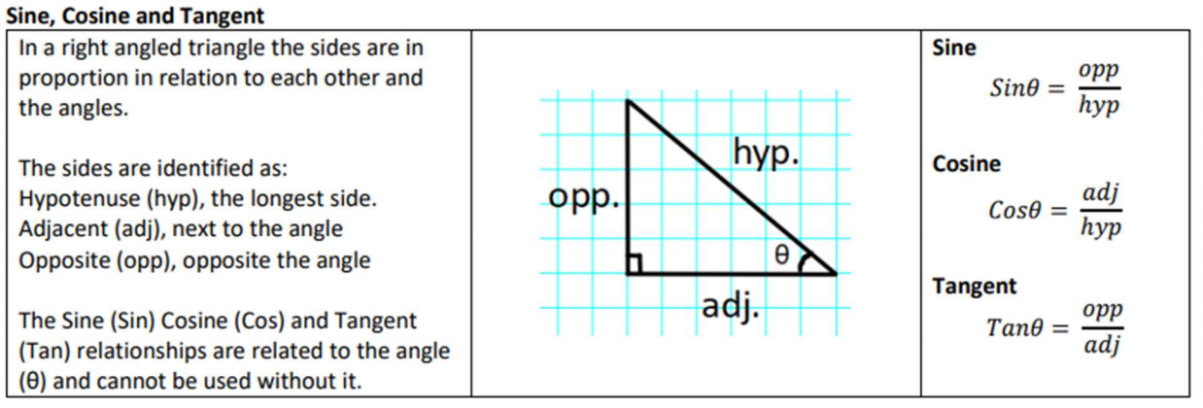

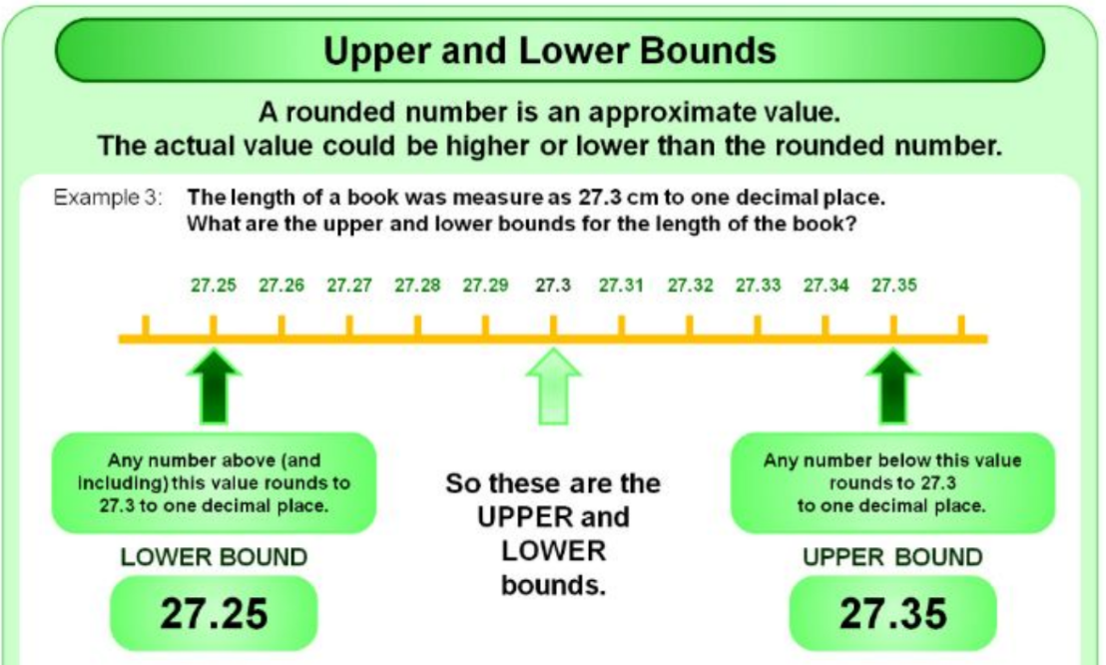

Scan for full list of Maths facts

