Knowledge Organiser
Autumn Term 2 Year 10
Topic | Self-Assessment | Independent Learning and  homework tasks
Topic | Self-Assessment | CorbettMaths.com
Forming linear expressions |  | Video 115
Convert fractions, decimals & percentages |  | FDP  Videos 121 to 131
Converting recurring decimals to fractions |  | Video 96
Finding percentage of a quantity and one quantity as a percentage of another |  | Video 50 - 52
Percentage increase and decrease |  | Percentage Change video 233
Reverse Percentages |  | Percentages: Reverse video 240
Calculate Profit & Loss, and Compound interest |  | Percentages: Compound Interest video 236
Transformations - reflection, rotation, translation |  | Video 272 – 275, 326
Enlarge shapes using positive and negative scales factors |  | Video 104 - 109
Understanding and calculating with ratios and proportion |  | Video 269, 271a – d, 255a
Ratio – simplifying  Sharing  Unitary method  Change in amount |  | Video 269, 271a – d, 255a

Stretch and Challenge:
- Complete XP Booster questions on Sparx Maths

- Practise UKMT Intermediate Maths Challenge Past papers on:
https://www.ukmt.org.uk/competitions/solo/intermediate-mathematical-challenge/archive
- Attend Puzzle Club one lunch time each week

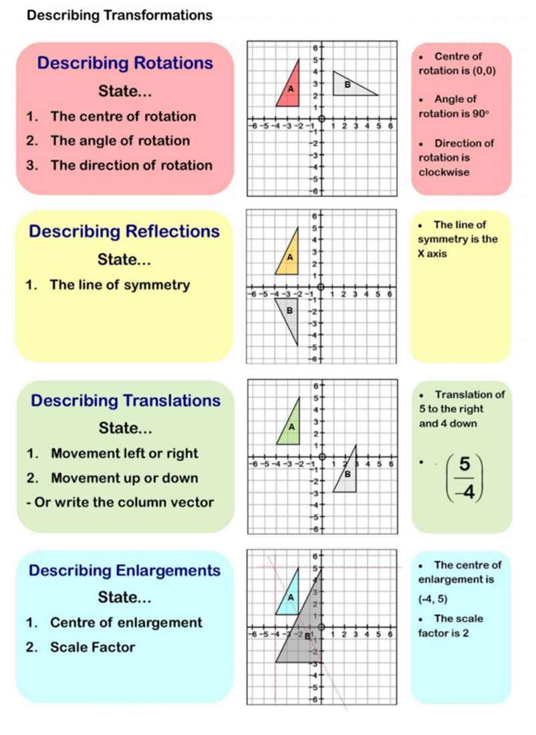
Autumn Term 2 Knowledge


Scan for full list of Maths facts

