Knowledge Organiser
Spring Term Year 10
Topic | Self-Assessment | Independent Learning and  homework tasks
Topic | Self-Assessment | CorbettMaths.com
Calculating averages from a (grouped) frequency table (5) |  | Video 54 - 55
Calculating moving averages (6)
Constructing cumulative frequency tables and graphs (6) |  | Video 153, 154
Calculating the median and interquartile range (6) |  | Video 50 - 52
Constructing box and whisker plots (6) |  | Video 149 - 150
Drawing scatter graphs and identifying types of correlation (4) |  | Video 165 - 166
Drawing and interpreting distance time & velocity time (6/7) |  | Video 171
Be able to calculate using standard form |  | Video 301 - 303
Finding and Calculating with lower and upper bounds (7) |  | Video 183 & 184
Calculate lengths of arcs & areas of sectors (6) |  | Video 58, 63
Calculate volume & surface area of prisms (4/5) |  | Video 355 - 358
Calculate volume & surface area of cones, pyramids & spheres (5/6).  Calculate rates of flow in/out of containers (8). |  | Video 359 - 361
Calculate density and pressure (4) |  | Video 384, 385
Writing and using equations for direct & indirect proportionality (7) |  | Video 255

Stretch and Challenge:
- Complete XP Booster Questions on Sparx Maths

- Practise UKMT Intermediate Maths Challenge Past papers on:
https://www.ukmt.org.uk/competitions/solo/intermediate-mathematical-challenge/archive
- Attend Puzzle Club one lunch time each week
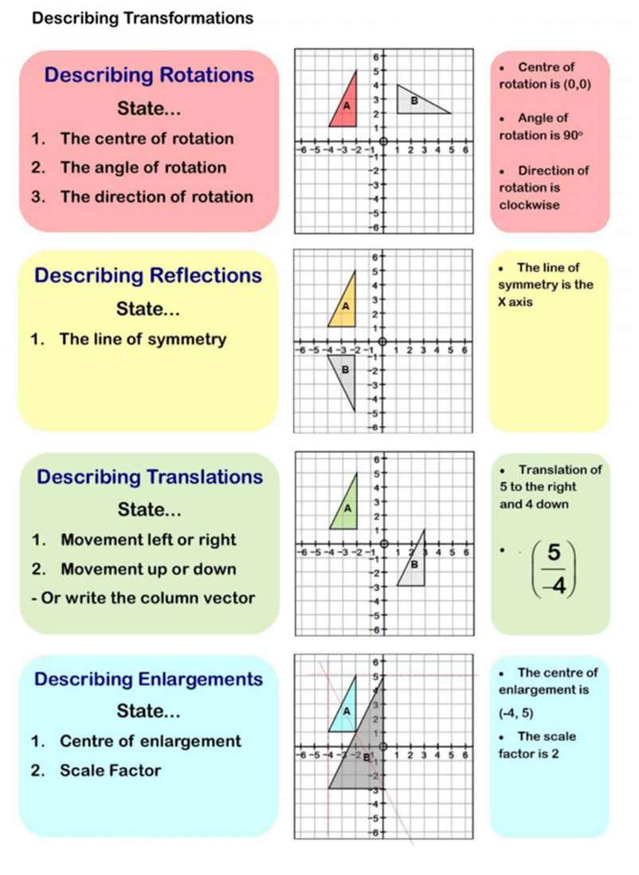
Autumn Term 2 Knowledge

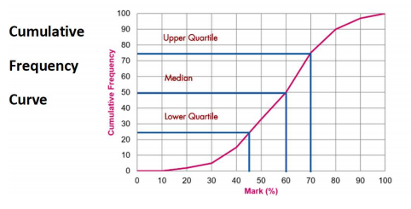

Scan for full list of Maths facts

