Topic | Self-Assessment | Independent Learning and homework tasks
Topic | Self-Assessment | MyMaths | CorbettMaths.com
Understanding the handling data cycle and carrying out effective data collection  Identifying different types of data including qualitative, quantitative, discrete, continuous, primary and secondary data  Understanding different sampling methods and identifying possible bias  Calculating stratified samples. |  | Data / Collecting data…  Types of data  Data / Collecting data…  Sampling | Video 89  Video 281 - 282
Drawing and interpreting histograms (8).  Calculating frequency density. |  | Data/ Presenting data/ Histograms | Videos 157-158
Understanding and writing inequalities.  Solving ‘linear’ inequalities.  Solve quadratic inequalities. |  | Algebra/ Inequalities/ Inequations  Algebra/ Inequalities/ Quadratic Inequalities | Videos 176 - 182
Use algebra to prove number. statements and disprove number statements using a counter example. |  | Algebra/ Proof and Identities/ Proof | Video 385
Add, subtract, multiply and divide algebraic fractions.  Solve equations involving fractions with algebraic denominators . |  | Algebra/ Algebraic Manipulation/ Adding algebraic fractions & Multiplying algebraic fractions | Videos 21 - 24
Re-arranging equations where the new subject appears once;  Re-arranging equations where the new subject appears more than once . |  | Algebra / Expressions and formulae/ Rearranging 1 & 2 | Video 7 & 8
Understanding index notation.  Multiplying, dividing and raising one power to another power  Understanding and using negative indices.  Being able to evaluate fractional indices . |  | Number/ Powers and roots/ Indices 1 - 4 | Videos 172 - 175

Stretch and Challenge:
- Practise UKMT Intermediate Maths Challenge Past papers on:
https://www.ukmt.org.uk/competitions/solo/intermediate-mathematical-challenge/archive
- Set up an account on parallel.org.uk website, using your school email address and use teacher code “ha52kh”

- Attend Puzzle Club one lunch time each week

Summer Term Knowledge
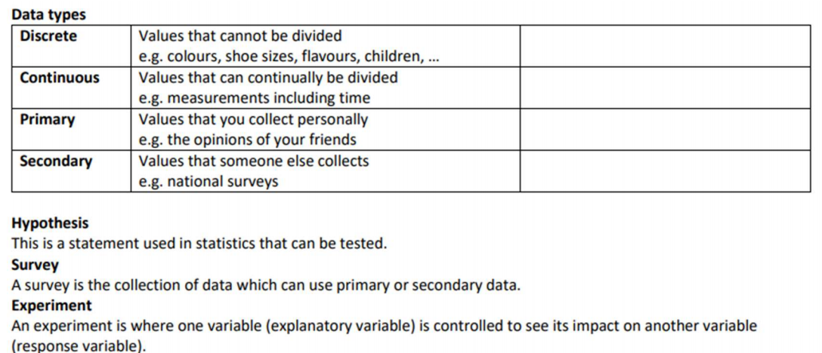

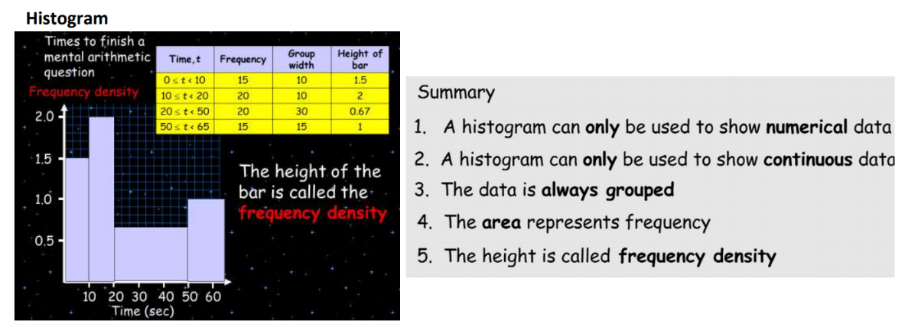

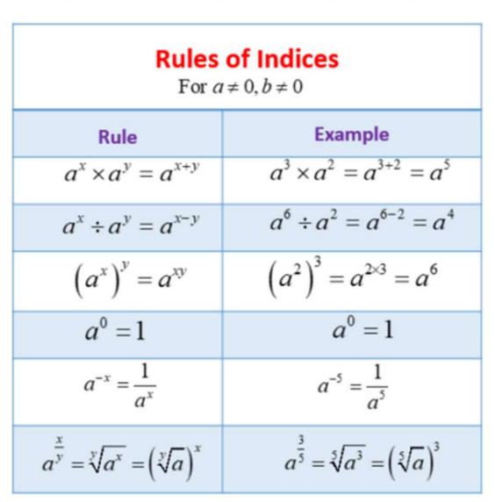
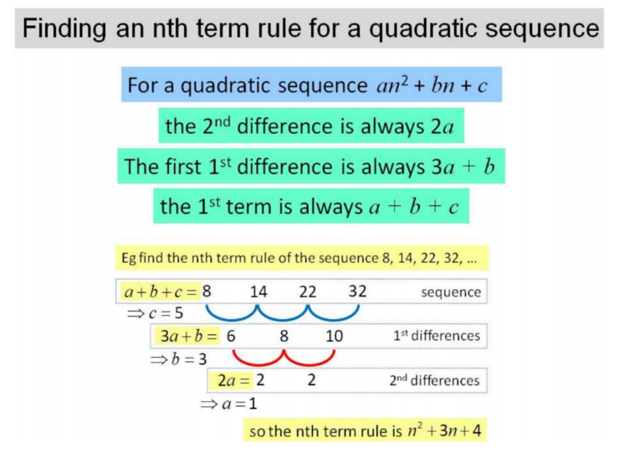

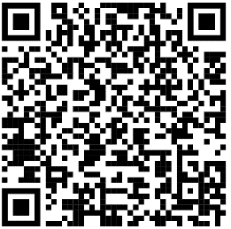
Scan QR Code for Full List of Maths Facts

