Knowledge Organiser
Summer Term Year 10
Topic | Self-Assessment | Independent Learning and homework tasks
Topic | Self-Assessment | CorbettMaths.com
Draw graphs of functions.  Calculate and use gradient.  Determine equation of straight line graphs.  Equation of parallel lines. |  | Video 187 - 195
Equation of perpendicular lines.  Equation of line between two points. |  | Video 196 - 197
Recognise quadratic, cubic, reciprocal and exponential graphs.  Draw graphs of quadratic functions and use them to solve quadratic equations, identify and interpret roots, intercepts and turning points. |  | Video 264 – 265  Video 267c & 267d
Calculate or estimate gradients of graphs and areas under graphs
Use basic angle rules; angles on straight line, angles at a point, vertically opposite angles.  Identify angles on parallel lines. |  | Video 38 - 39
Interior and exterior angles of polygons. |  | Video 32
Identifying the different parts of a circle.  Understand and prove the special rules for angles in circles. |  | Video 64- 65
Identifying triangles are congruent.  Using congruent triangles for geometric proofs. |  | Video 66 & 67
Understanding and writing inequalities.  Solving ‘linear’ inequalities.  Representing and interpreting inequalities on graphs.  Solve quadratic inequalities. |  | Videos 176 - 182
Recognise and use rules for number and pattern sequences, including triangular, square, cube & Fibonacci-type numbers, arithmetic sequences, quadratic sequences and geometric sequences.  Finding the nth term for linear and quadratic sequences. |  | Videos 287a – 290  Videos 374 & 375  Videos 388a - c

Stretch and Challenge:
- Complete XP Booster Questions on Sparx Maths
- Practise UKMT Intermediate Maths Challenge Past papers on:
https://www.ukmt.org.uk/competitions/solo/intermediate-mathematical-challenge/archive
- Attend Puzzle Club one lunch time each week

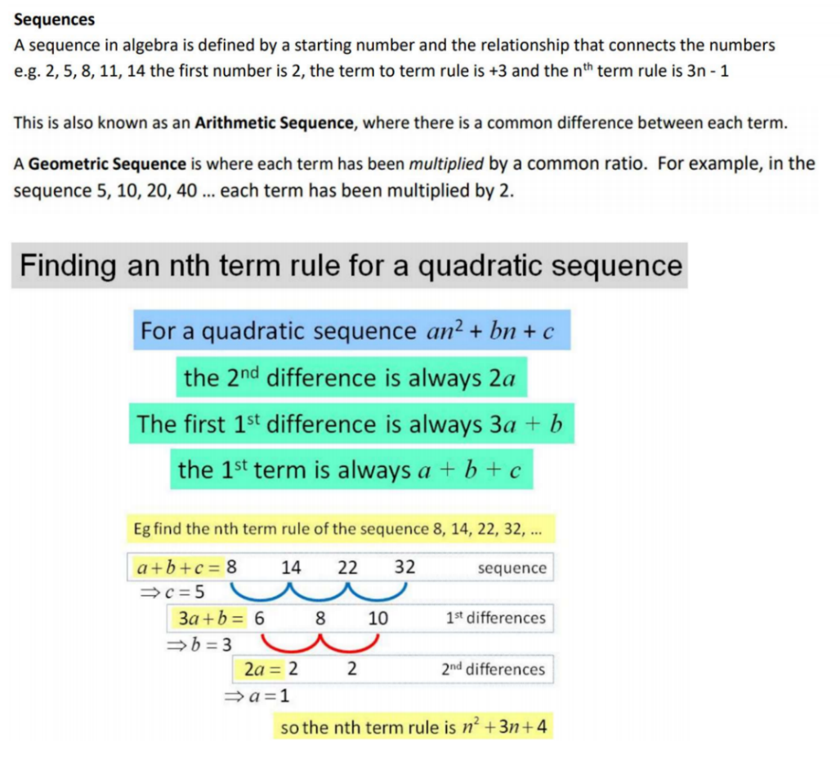
Summer Term Knowledge

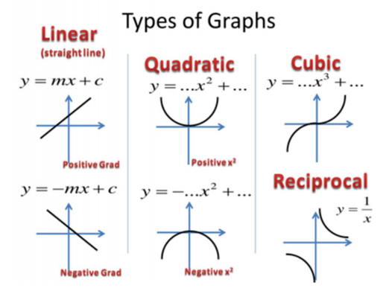


Scan QR Code for Full List of Maths Facts

