Topic |  |  |  | Independent Learning and homework tasks
Topic |  |  |  | CorbettMaths.com
Finding and recognising factors, multiples and primes |  |  |  | Number: factors (Video 216)/multiples (Video 220)/ prime numbers (Video 225)
Finding HCF and LCM |  |  |  | Number: common multiples/LCM/common factors/HCF  Videos 218-219
Forming linear equations |  |  |  | Equations: solving Video 110
Solving linear equations |  |  |  | Equations: solving Video 111
Changing the subject |  |  |  | Algebra/Changing the subject  video 7 & 8
Fractions, decimals and percentages |  |  |  | FDP  Videos 121 to 131
Percentage increase and decrease |  |  |  | Percentage Change video 233
Compound Interest |  |  |  | Percentages: Compound Interest video 236
Reverse Percentages |  |  |  | Percentages: Reverse video 240
Quadrilaterals and Symmetry |  |  |  | 2D Shapes Quadrilaterals video 2;  Symmetry: line and rotational  videos 316 & 317

Maths Support Attend Sparx Maths Clinic every Thursday lunch time in DT for extra help and support.
Stretch and Challenge:
- Practise UKMT Intermediate Maths Challenge Past papers on:
https://www.ukmt.org.uk/competitions/solo/intermediate-mathematical-challenge/archive
- Complete the XP Boost questions on Sparx Maths every week
- Follow the Maths Department on Twitter and Instagram @AmbroseMaths

Autumn Term 1 Knowledge
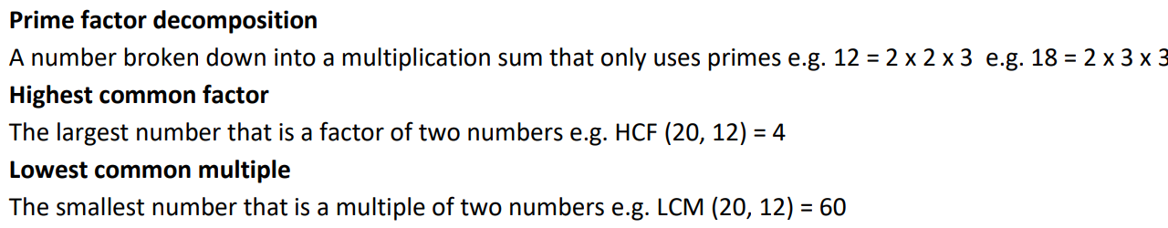

Algebra
‘Changing the Subject’ is another way of describing rearranging formulae.
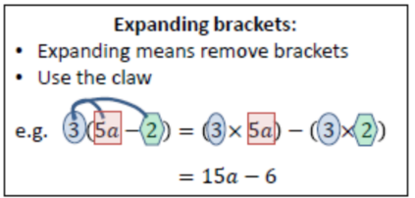
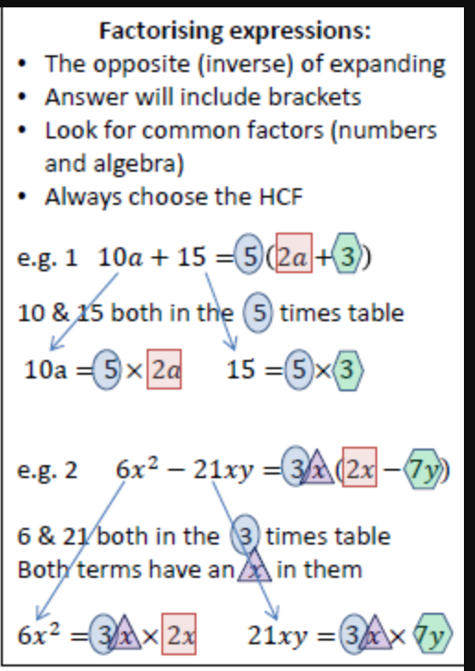
Remember: whatever you do to one side of the formula you have to do the other side to keep it balanced.
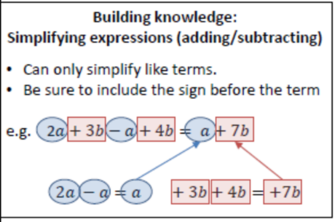
Expanding double brackets
- FOIL Method
(x + 2 )(x + 3) = x² + 3x + 2x + 6
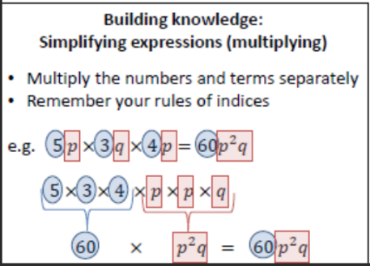
= x² + 5x + 6
Set 1 only*
Expanding triple brackets
- Expand first two brackets
- Multiply result by last bracket
(x + 2)(x + 3)(x + 4)
(x + 2 )(x + 3) = x² + 3x + 2x + 6
= (x² + 5x + 6)(x + 4)
= x³+4x²+5x²+20x+6x+24
= x³+9x²+26x+24

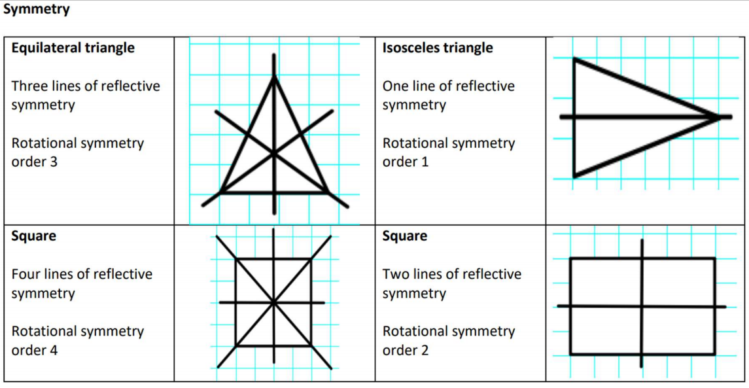


Scan QR Code for
Full List of Year 9 Maths facts

