Topic |  |  |  | Independent Learning and homework tasks
Topic |  |  |  | CorbettMaths.com
Volume of a prism |  |  |  | Videos 355 – 7
Surface Area of a prism |  |  |  | Videos 309 - 312
Finding the length of an arc |  |  |  | Video 58
Finding the area of a sector |  |  |  | Video 63
Converting between different metric units of length, area and volume |  |  |  | Videos 349d, e, f
Compound Measure – speed, density and pressure |  |  |  | Speed Video 299  Density Video 384  Pressure Video 385
Using a calculator for complex calculations |  |  |  | Video 352
Round to a given number of decimal places |  |  |  | Video 276 - 8
Round to a given number of significant figures |  |  |  | Video 279a
Pythagoras’ theorem, solving problems applying the theorem |  |  |  | Video 257 - 8
Using similarity to find lengths of missing sides |  |  |  | Videos 291 - 2
Using trigonometry to find missing sides of right-angled triangles |  |  |  | Videos 329 - 330
Using trigonometry to find missing angles |  |  |  | Video 331
Calculating equations of straight line graphs |  |  |  | Video 189 -190, 194
Finding the equation between 2 points |  |  |  | Video 195
Understanding parallel & perpendicular lines |  |  |  | Video 196 - 7
Knowledge Organiser
Autumn 2nd Half Term Set 1 Year 9

Autumn Term 2 Knowledge


Order of operations (BIDMAS) Scan for full list of Maths knowledge
There is an order to operations:
B (Brackets) - any calculation within a bracket is completed first
I (Indices) – any term with a power is completed second
D (Division) – any division is completed third
M (Multiplication) – any multiplication is completed next
A (Addition) – any addition is completed next in a left to right order
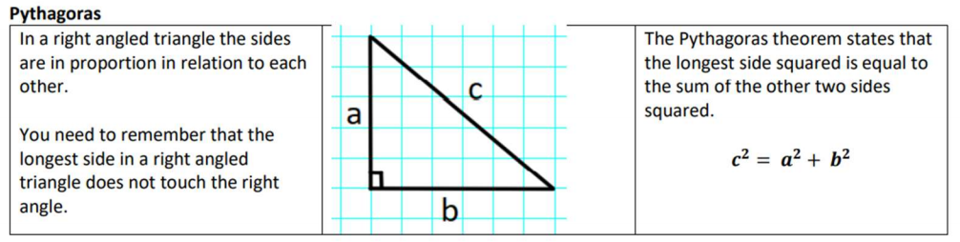
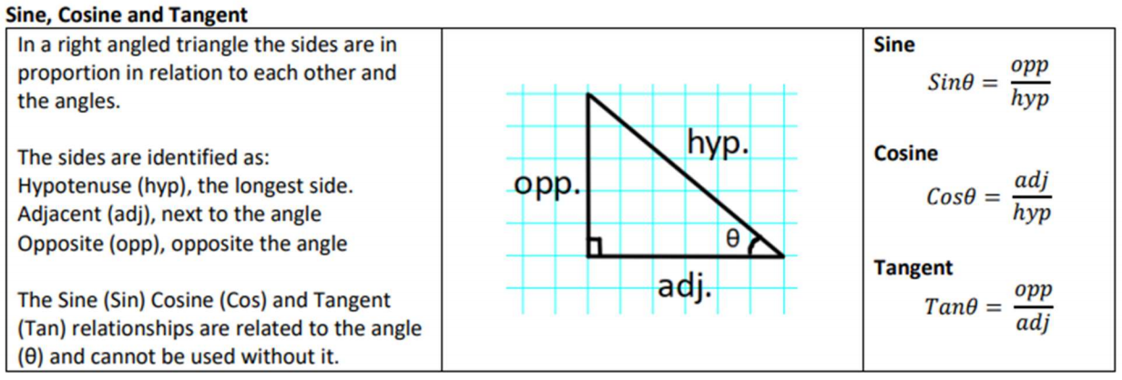
S (Subtraction) – any subtraction is completed last and in a left to right order

Maths Support
Attend Sparx Maths Clinic every Thursday lunch time in DT for extra help and support.
Stretch and Challenge:
- Practise UKMT Intermediate Maths Challenge Past papers on:
https://www.ukmt.org.uk/competitions/solo/intermediate-mathematical-challenge/archive
- Complete the XP Boost questions on Sparx Maths every week

