Topic |  |  |  | Independent Learning and homework tasks
Topic |  |  |  | CorbettMaths.com
Expand double and triple brackets |  |  |  | Algebra: expanding two brackets and expanding three brackets  Video 14 & 15
Removing brackets and factorising |  |  |  | Factorisations  Video 117 & 118
Factorising and Solving Quadratics |  |  |  | Video 266
Volume of a prism |  |  |  | Videos 355 – 7
Surface Area of a prism |  |  |  | Videos 309 - 312
Finding the length of an arc |  |  |  | Video 58
Finding the area of a sector |  |  |  | Video 63
Converting between different metric units of length, area and volume |  |  |  | Videos 349d, e, f
Removing brackets and factorising |  |  |  | Factorisations  Video 117 & 118
Compound Measure – speed, density and pressure |  |  |  | Speed Video 299  Density Video 384  Pressure Video 385
Interior and Exterior angles of a polygon |  |  |  | Video 32
Using BODMAS for order of operation |  |  |  | Video 211
Using a calculator for complex calculations |  |  |  | Video 352
Round to a given number of decimal places |  |  |  | Video 276 - 8
Round to a given number of significant figures |  |  |  | Video 279a
Autumn Term 2 Knowledge

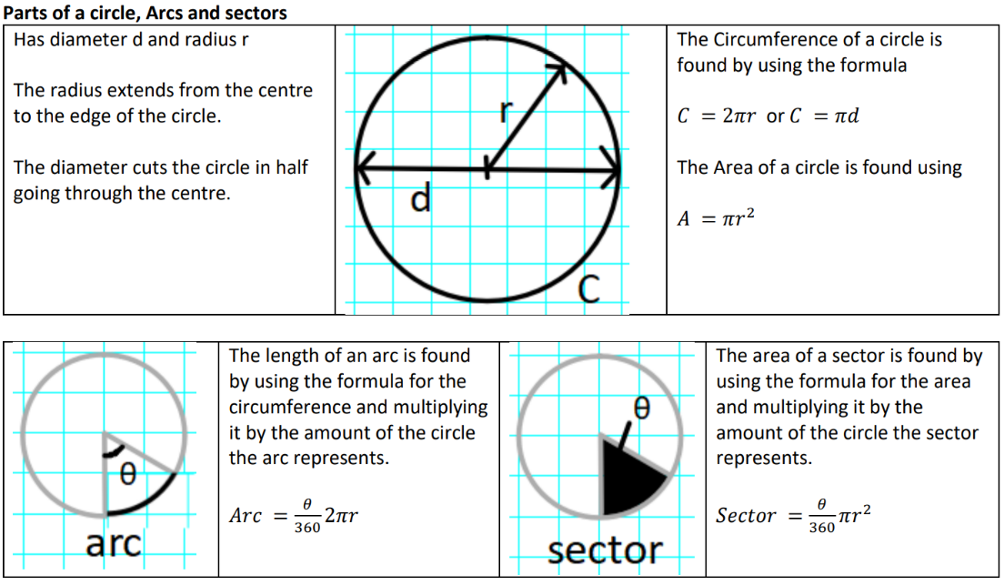

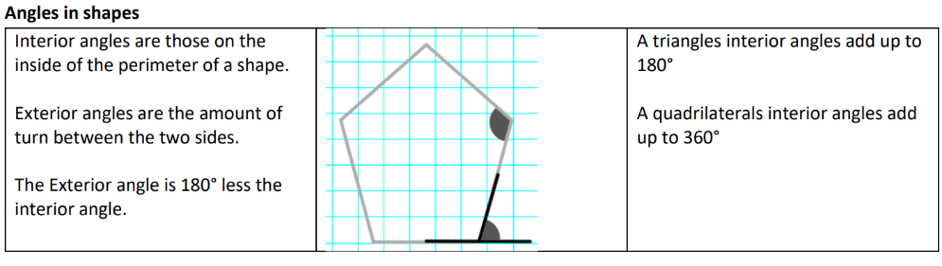

Maths Support Attend Sparx Maths Clinic every Thursday lunch time in DT for extra help and support.
Stretch and Challenge:
1) Practise UKMT Intermediate Maths Challenge Past papers on ukmt.org.uk
2) Complete the XP Boost questions on Sparx Maths every week


Scan for full list of Maths Knowledge

