Topic |  |  |  | Independent Learning and homework tasks
Topic |  |  |  | CorbettMaths.com
Pythagoras’ theorem, solving problems applying the theorem |  |  |  | Video 257 - 8
Using similarity to find lengths of missing sides |  |  |  | Videos 291 - 2
Using trigonometry to find missing sides of right-angled triangles |  |  |  | Videos 329 - 330
Using trigonometry to find missing angles |  |  |  | Video 331
Calculating equations of straight line graphs |  |  |  | Video 189 -190, 194
Finding the equation between 2 points |  |  |  | Video 195
Understanding parallel & perpendicular lines |  |  |  | Video 196 - 7
Solving Simultaneous equations by elimination / substitution |  |  |  | Video 295, 296
Solving Simultaneous equations graphically |  |  |  | Video 297
Forming then Solving Simultaneous equations |  |  |  | Video 295, 296
Knowledge Organiser
Lent Term 1 Set 2 Year 9

Lent Term 1 Knowledge

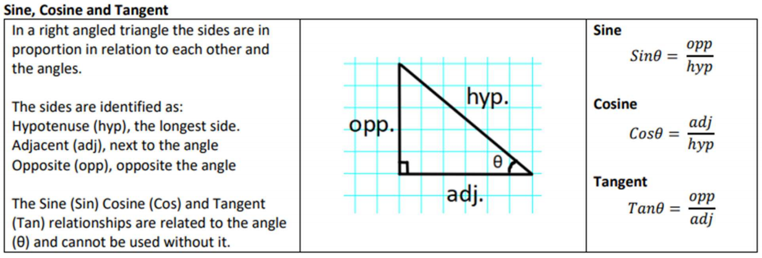
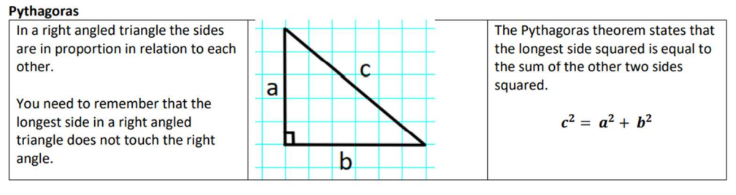
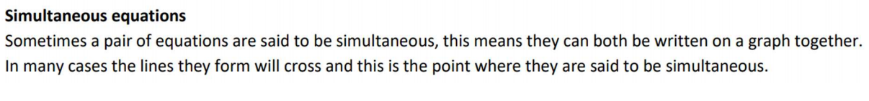


Scan for full list of Year 9 Maths facts

Maths Support Attend Sparx Maths Clinic every Thursday lunch time in DT for extra help and support.
Stretch and Challenge:
1) Practise UKMT Intermediate Maths Challenge Past papers on ukmt.org.uk
2) Complete the XP Boost questions on Sparx Maths every week

