Topic |  |  |  | Independent Learning and homework tasks
Topic |  |  |  | CorbettMaths.com
Solving Simultaneous equations by elimination / substitution |  |  |  | Video 295, 296
Solving Simultaneous equations graphically |  |  |  | Video 297
Forming then Solving Simultaneous equations |  |  |  | Video 295, 296
Multiplying, dividing using indices |  |  |  | Video 174
Understanding and using negative indices |  |  |  | Video 175
Understanding and using fractional indices |  |  |  | Video 173
Writing very large and small numbers in standard form, and vice-versa |  |  |  | Video 300
Performing calculations in standard form |  |  |  | Video 301-3
Simplifying ratio |  |  |  | Video 271a - d
Sharing quantities in a given ratio |  |  |  | Video 269
Solving problems using unitary method |  |  |  | Video 255a
Constructing and interpreting pie charts |  |  |  | Video 163 & 164
Constructing and interpreting frequency polygons |  |  |  | Video 155 & 156
Knowledge Organiser
Lent Term Set 1 Year 9

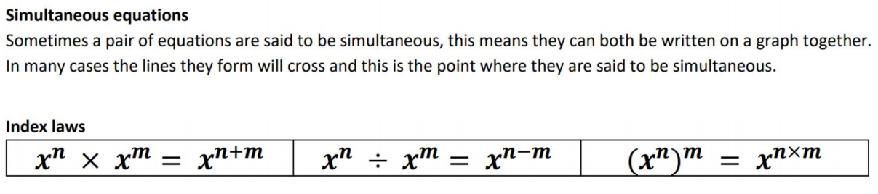
Lent Term 1 Knowledge
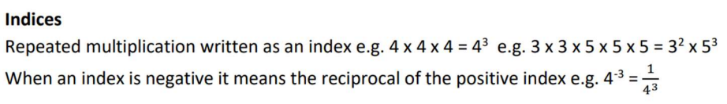

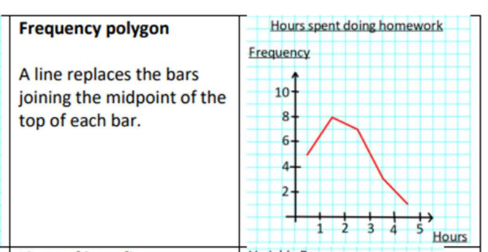

Maths Support Attend Sparx Maths Clinic every Thursday lunch time in DT for extra help and support.
Stretch and Challenge:
1) Practise UKMT Intermediate Maths Challenge Past papers on ukmt.org.uk
2) Complete the XP Boost questions on Sparx Maths every week


Scan for full list of Year 9 Maths facts

