Topic |  |  |  | Independent Learning and  homework tasks
Topic |  |  |  | CorbettMaths.com
Understanding data handling cycle, and different data types |  |  |  | Video 89
Understanding sampling methods including stratified random sampling |  |  |  | Video 281
Calculating probabilities |  |  |  | Video 245
Estimating relative frequencies |  |  |  | Video 248
Understanding and using two-way tables and frequency trees |  |  |  | Video 246
Understanding mutually exclusive, independent and dependent events |  |  |  | Video 244
Representing probabilities using tree diagrams |  |  |  | Video 246
Representing probabilities using Venn diagrams |  |  |  | Video 380
Knowledge Organiser
Trinity Term 1 Set 2 Year 9

Maths Support Attend Sparx Maths Clinic every Thursday lunch time in DT for extra help and support.
Stretch and Challenge:
1) Practise UKMT Intermediate Maths Challenge Past papers on ukmt.org.uk
2) Complete the XP Boost questions on Sparx Maths every week


Scan for full list of Year 9 Maths facts

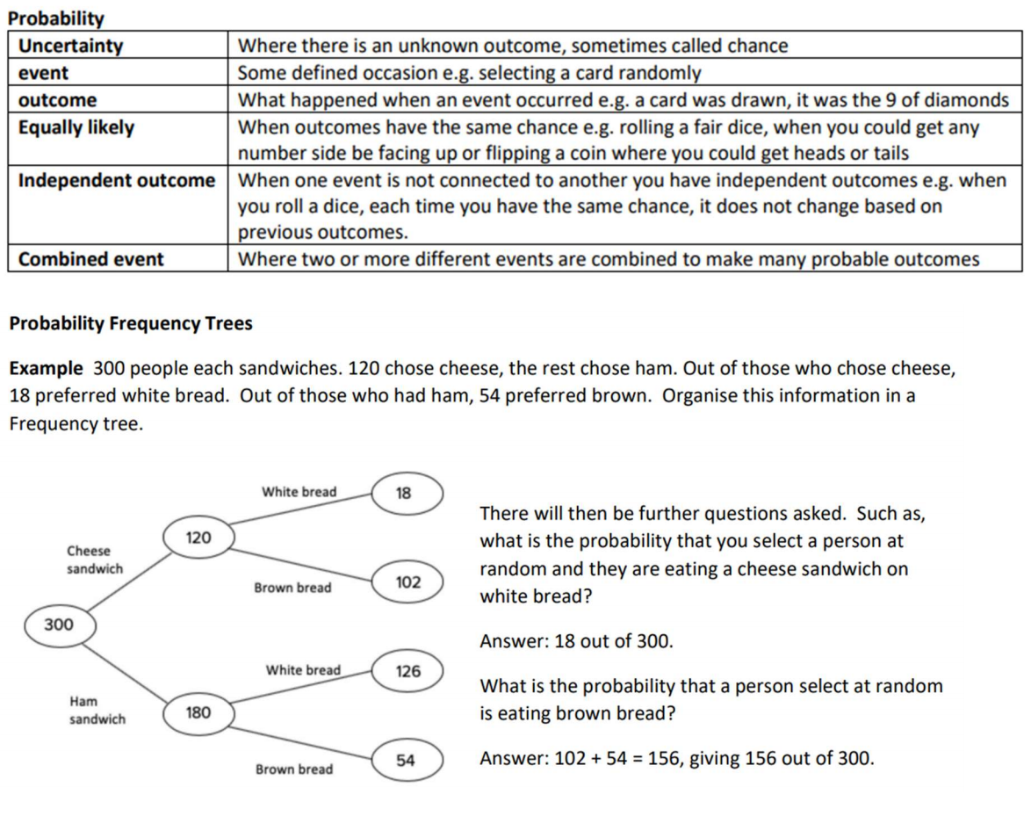
Trinity Term 1 Knowledge


