Topic |  |  |  | Independent Learning and  homework tasks
Topic |  |  |  | CorbettMaths.com
Identify congruent triangles and shapes |  |  |  | Video 66- 7
Using congruent triangles for geometric proof |  |  |  | Video 66- 7
Calculating speed, distance, time |  |  |  | Video 299
Constructing and interpreting distance time graphs |  |  |  | Video 171
Constructing and interpreting other real life graphs, including rate being gradient of a linear graph |  |  |  | Video 288, 388a
Solving problems involving rate of change |  |  |  | Video 81 - 83
Knowledge Organiser
Trinity Term 2 Set 1 Year 9

Maths Support Attend Sparx Maths Clinic every Thursday lunch time in DT for extra help and support.
Stretch and Challenge:
1) Practise UKMT Intermediate Maths Challenge Past papers on ukmt.org.uk
2) Complete the XP Boost questions on Sparx Maths every week

Trinity Term 2 Knowledge Scan for full list of Year 9 Maths facts

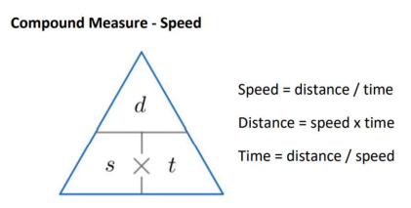

Knowledge Organiser

Trinity Term 2 Set 1 Year 9

Topic |  |  |  | Independent Learning and  homework tasks
Topic |  |  |  | CorbettMaths.com
Identify congruent triangles and shapes |  |  |  | Video 66- 7
Using congruent triangles for geometric proof |  |  |  | Video 66- 7
Calculating speed, distance, time |  |  |  | Video 299
Constructing and interpreting distance time graphs |  |  |  | Video 171
Constructing and interpreting other real life graphs, including rate being gradient of a linear graph |  |  |  | Video 288, 388a
Solving problems involving rate of change |  |  |  | Video 81 - 83
Maths Support Attend Sparx Maths Clinic every Thursday lunch time in DT for extra help and support.
Stretch and Challenge:
1) Practise UKMT Intermediate Maths Challenge Past papers on ukmt.org.uk
2) Complete the XP Boost questions on Sparx Maths every week

Trinity Term 2 Knowledge Scan for full list of Year 9 Maths facts

