Autumn 1 Half Term
Knowledge Organiser Year 8

Topic |  |  |  | Independent Learning and homework tasks
Topic |  |  |  | CorbettMaths.com
Using a calculator effectively |  |  |  | Use of a calculator – video 352
Revision of multiplying / dividing by powers of 10 |  |  |  | Division by 10, 100, 1000/Division by powers of 10 – videos 99 & 100  Multiplication: by 10,100 etc/ Multiplication: powers of 10 – videos 201 & 202
Rules of indices (not fractional) |  |  |  | Algebra: indices – video 17
Write ordinary numbers in standard form and vice-versa |  |  |  | Standard form – video 300
(Set 1) Basic calculations in standard form |  |  |  | Standard form: addition/multiplication/division  Videos 301-303
Calculate percentages of amounts |  |  |  | Percentages: of an amount (non-calc)/of an amount (calc)  Videos 234 - 235
Increase/decrease an amount by given percentage |  |  |  | Percentages: increasing/decreasing  Video 238
Calculate Percentage increase / decrease |  |  |  | Percentages: increasing/decreasing/multipliers  Videos 238-239
(Set 1) Reverse Percentages |  |  |  | Percentages: reverse – Video 240
Interior and exterior angles of polygons |  |  |  | Angles: polygons – Video 32

Autumn 1 Knowledge
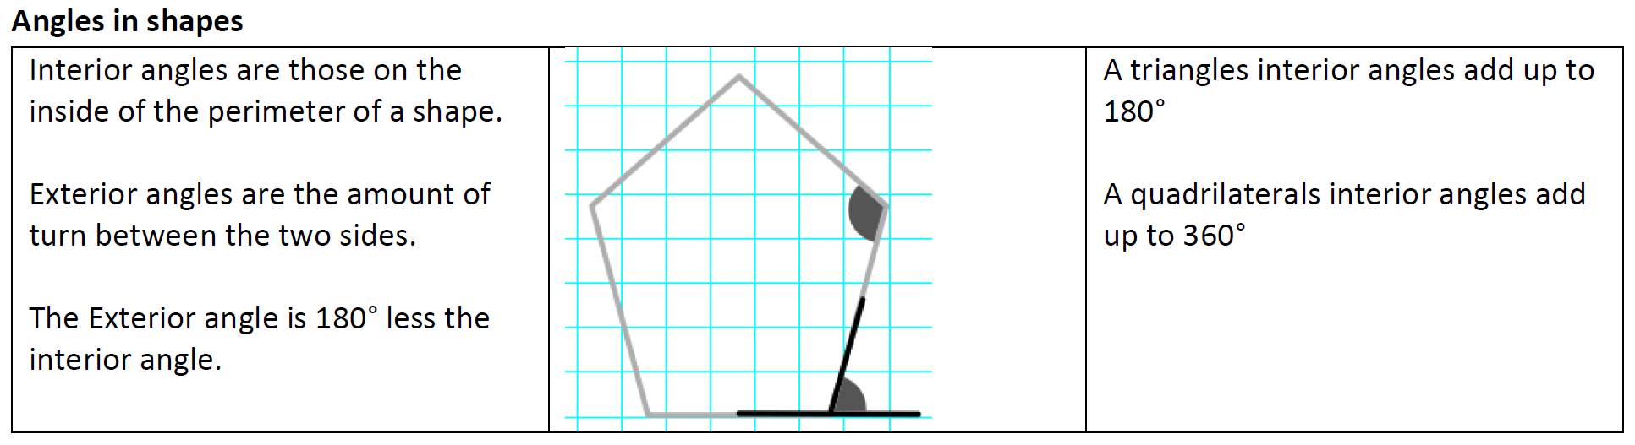
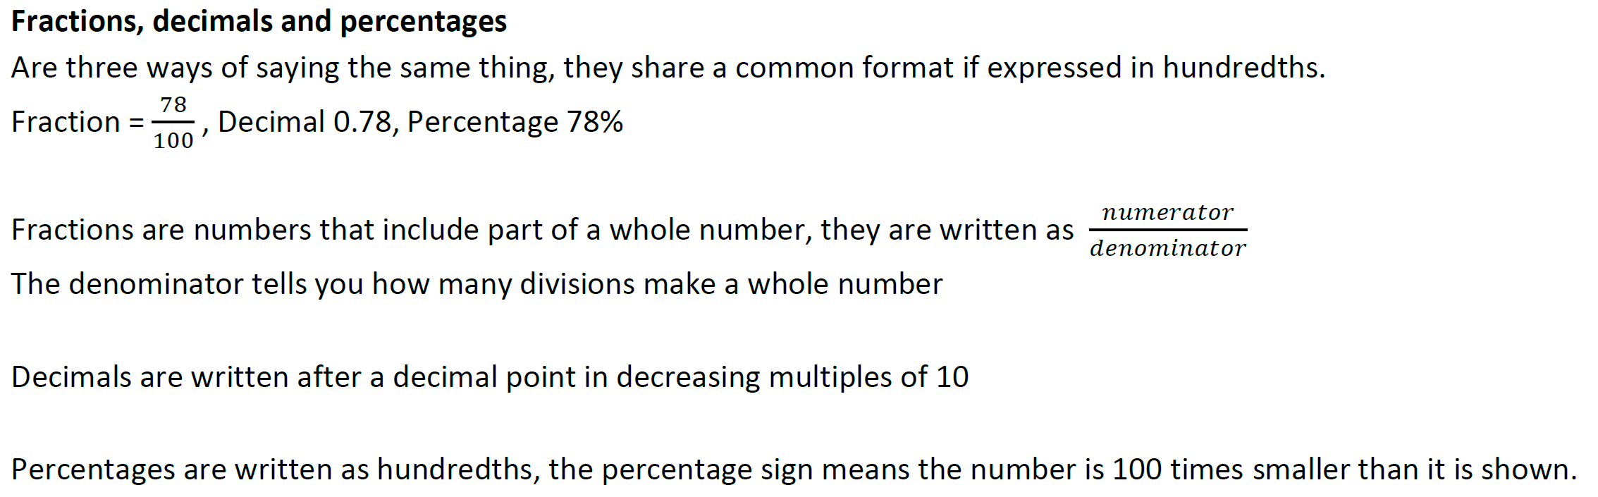
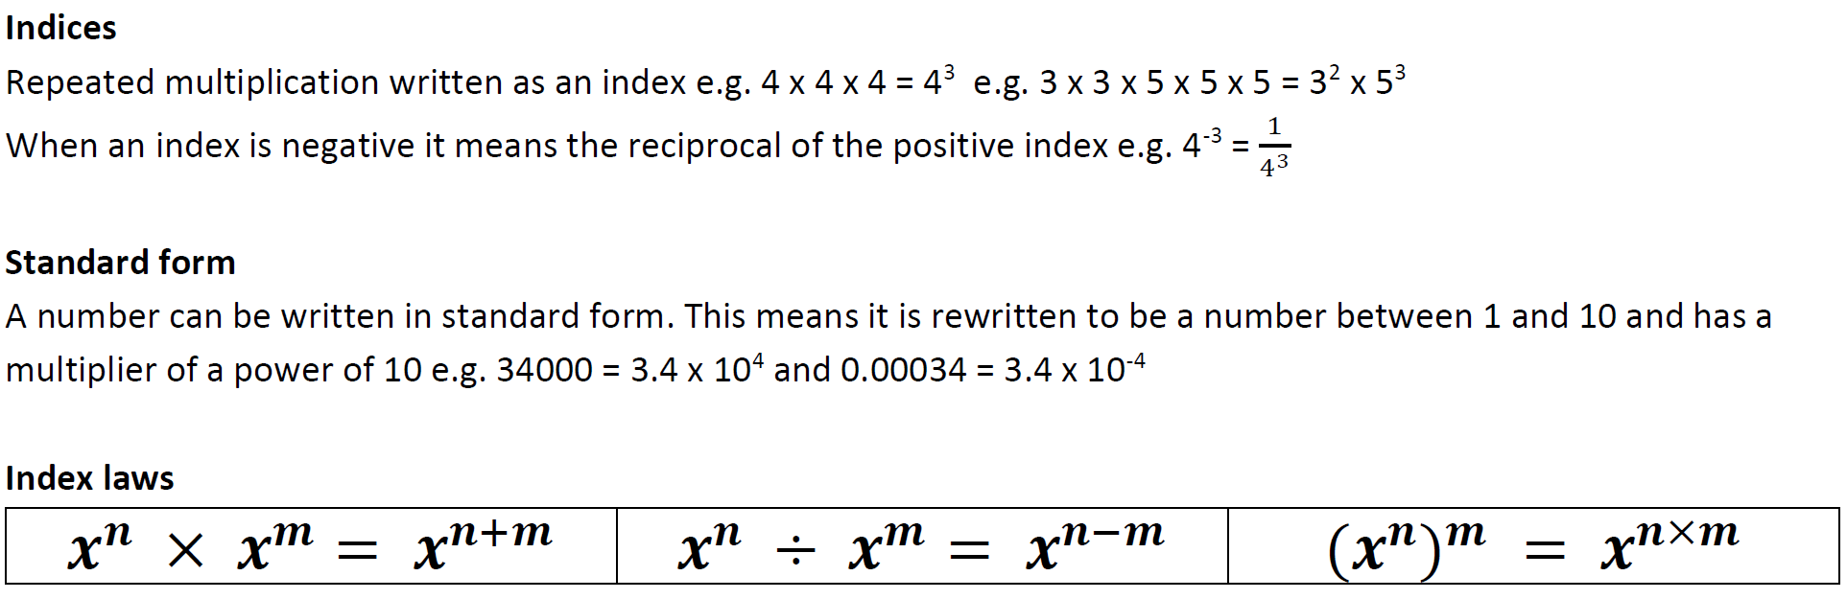
Stretch and Challenge:
- Practise UKMT Junior Maths Challenge Past papers on:
https://www.ukmt.org.uk/competitions/solo/junior-mathematical-challenge/archive
- Complete the XP Boost questions on Sparx Maths every week


Scan for full list of Year 8 Topics

