Knowledge Organiser
Lent Half Term 2 Year 12
Topic | Self-Assessment | Independent Learning and  homework tasks https://www.revisely.co.uk/alevel/maths/edexcel/stats
Topic | Self-Assessment | Objectives | Pearson & Exam Solns videos
Single Variable Data |  | - Be able to interpret tables and diagrams for single-variable data. e.g. vertical line charts, dot plots, bar charts, stem-and-leaf diagrams, box-and-whisker plots, cumulative frequency diagrams and histograms (with either equal or unequal class intervals). Includes non-standard representations. | https://www.revisely.co.uk/video/6cm  https://www.revisely.co.uk/video/dyj  https://www.revisely.co.uk/video/xM6  https://www.revisely.co.uk/video/kCZ
Outliers and Cleaning Data |  | - Recognise and be able to interpret possible outliers in data sets and statistical diagrams.  - Be able to clean data, including dealing with missing data, errors and outliers.
Probability: Mutually Exclusive and Independent Events |  | - Understand and be able to use mutually exclusive and independent events when calculating probabilities. Includes understanding and being able to use the notation.  - Includes linking their knowledge of probability to probability distributions.  - Be able to use appropriate diagrams to assist in the calculation of probabilities.  - Includes tree diagrams, sample space diagrams, Venn diagrams. | https://www.revisely.co.uk/video/iCG  https://www.revisely.co.uk/video/hHQ  https://www.revisely.co.uk/video/pL5
Discrete Probability Distributions |  | - Understand and be able to use simple, finite, discrete probability distributions, defined in the form of a table or a formula.  - Be able to calculate probabilities using the binomial distribution, using appropriate calculator functions
Forces and Newtons 1st Law |  | - Understand the vector nature of force and use directed line segments to represent forces in two dimensions.  - Be able to identify the forces acting on a system and represent them in a forces diagram.  - Use vector addition to find the resultant of two or more forces.  - Be able to split a force into two perpendicular resolved forces.  - Understand and be able to use Newton’s 1st Law: ‘A particle that is at rest (or moving with constant velocity) will remain at rest (or moving with constant velocity) until acted upon by an external force.’ | https://www.revisely.co.uk/video/KXA  https://www.revisely.co.uk/video/UuT  https://www.revisely.co.uk/video/Yse  https://www.revisely.co.uk/video/1Qo  https://www.revisely.co.uk/video/3br
Newtons 2nd Law |  | - Understand and be able to use Newton’s second law (F=ma) for motion in a straight line for bodies of constant mass moving under the action of constant forces.  Represent the contact force between two rough surfaces, the ‘normal force’ and ‘frictional force’. Understand and use the concept of limiting friction and limiting equilibrium. | https://www.revisely.co.uk/video/MHP  https://www.revisely.co.uk/video/g7L  https://www.revisely.co.uk/video/jwB  https://www.revisely.co.uk/video/MWf  https://www.revisely.co.uk/video/MWf
Newtons 3rd Law |  | - Apply Newton’s 3rd Law to particles that are both at rest and moving with constant acceleration: ‘Every action has an equal and opposite reaction’.  - Solve problems which may be modelled as the motion of two particles connected by a light inextensible string.  - Be able to solve problems involving simple cases of equilibrium of forces on a particle in two dimensions. | https://www.revisely.co.uk/video/aV6  https://www.revisely.co.uk/video/jD3
Friction |  | - Resolve forces into components.  - Solve problems involving smooth or rough inclined planes.  - Understand friction and the coefficient of friction. | https://www.revisely.co.uk/video/iJw  https://www.revisely.co.uk/video/jwB  https://www.revisely.co.uk/video/UBv
Applications of Forces |  | - Find an unknown force when a system is in equilibrium.  - Solve statics problems involving weight, tension and pulleys.  - Understand and solve problems involving limiting equilibrium.  - Solve problems involving motion on rough or smooth inclined planes.  - Solve problems involving connected particles that require the resolution of forces.
Large Data Set:
https://qualifications.pearson.com/content/dam/pdf/A%20Level/Mathematics/2017/specification-and-sample-assesment/Pearson%20Edexcel%20GCE%20AS%20and%20AL%20Mathematics%20data%20set%20-%20Issue%201%20(1).xls
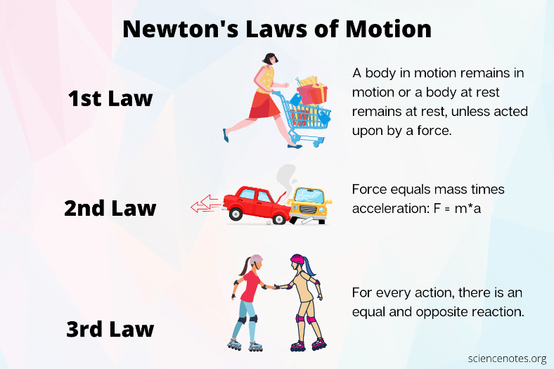
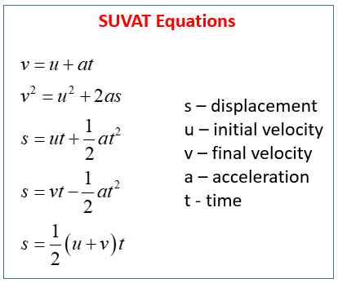
Key Information:



