Knowledge Organiser
Autumn Term 1 Year 10
Topic | Self-Assessment | Independent Learning and  homework tasks
Topic | Self-Assessment | CorbettMaths.com
Rounding to decimal places and significant figures |  | Video 279a
Estimating - including square roots  Error intervals |  | Video 215
Using BODMAS to determine the order of operations |  | Video 211
Pythagoras |  | Video 257 - 8
Similar Triangles |  | Videos 291 - 2
Trigonometry  Calculating missing sides and missing angles of right-angled triangles |  | Videos 329 - 331
Simplify algebraic expressions |  | Video 9
Expand single brackets and double brackets |  | Video 13, 14
Expand triple brackets |  | Video 15
Factorising expressions |  | Video 117
Factorising quadratic expressions and solving quadratic equations by factorising, sketching quadratic graphs |  | Video 266
Algebraic Substitution |  | Video 20
Solving linear equations |  | Video 110
Solving linear equations with fractions |  | Video 111

Stretch and Challenge:
- Complete XP Booster Questions on Sparx Maths

- Practise UKMT Intermediate Maths Challenge Past papers on:
https://www.ukmt.org.uk/competitions/solo/intermediate-mathematical-challenge/archive
- Attend Puzzle Club one lunch time each week

Autumn Term 1 Knowledge

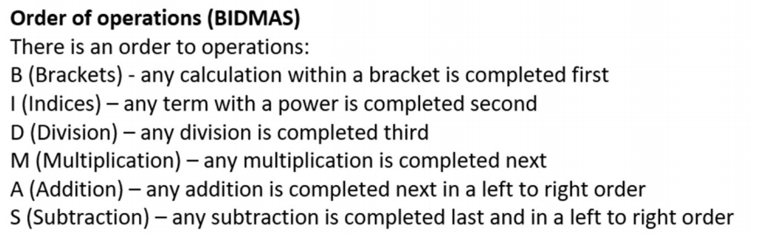

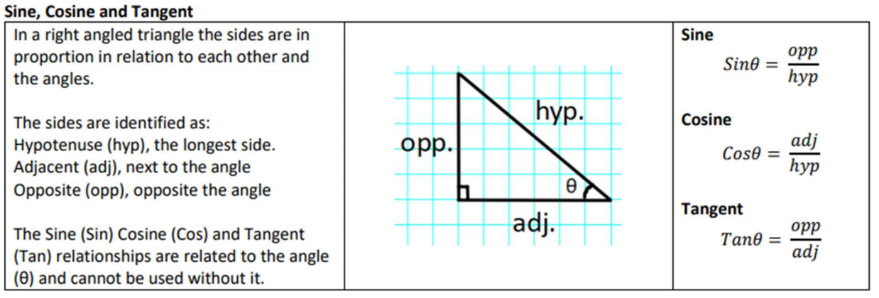
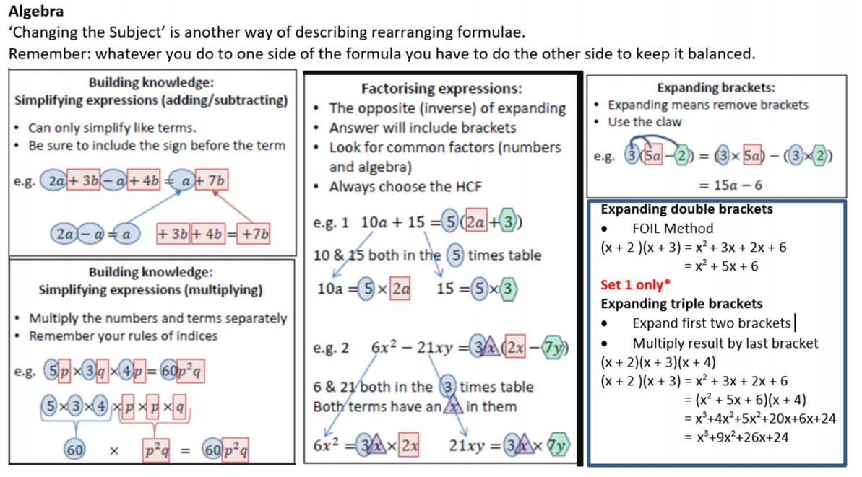

Scan for full list of Maths facts

