Knowledge Organiser
Autumn Term 1 Accelerator Year 11
Topic | Self-Assessment | Independent Learning and  homework tasks
Topic | Self-Assessment | CorbettMaths.com
Recognise and use rules for number and pattern sequences, including triangular, square, cube & Fibonacci-type numbers, arithmetic sequences, quadratic sequences* and geometric sequences.  Finding the nth term for linear and quadratic sequences. |  | Videos 287a – 290  Videos 374 & 375  Videos 388a - c
Recognise and use the equation of a circle to find circle centre and radius, equation of tangent |  | Video 372
Finding the equation of any circle given centre and radius  Find the equation of tangents to a circle with a non-origin centre* |  | Further Maths GCSE – Coordinate Geometry  Equation of a circle
Use coordinates in 3D |  | Video 86
Understanding vectors and solving geometric problems using vectors |  | Video 353
Drawing trig graphs for sin, cos and graph functions |  | Video 338 - 340
Use trig graphs to find angles greater than 90 degrees |  | Video 338 - 340
Using sine and cosine rule to find missing angles and lengths of triangles |  | Video 333 - 336
Using trig formula to find area of a triangle |  | Video 337
Be able to use of f(x), fg(x) and f⁻¹(x) notation |  | Further Maths GCSE –Algebra  Function notation
Understanding ‘inverse function’ and ‘composite function’ |  | Video 369 – 370  Plus Further Maths GCSE – Algebra  Composite / Inverse Functions
Understand domain and range of a function* |  | Further Maths GCSE –Algebra  Domains and Range
Draw and Interpret graphs of functions with up to 3 parts to their domain* |  | Further Maths GCSE –Algebra  Drawing Functions
Find approximate solutions to equations numerically using iteration |  | Video 373
Sketch graphs of y=af(x), y =f(ax), y=f(x)+a, y=f(x+a) given the graph of y=f(x) |  | Video 323 - 4

Maths Support Attend Sparx Maths Clinic every Thursday lunch time in DT for extra help and support.
Stretch and Challenge:
1) Practise UKMT Intermediate Maths Challenge Past papers on ukmt.org.uk
2) Complete the XP Boost questions on Sparx Maths every week

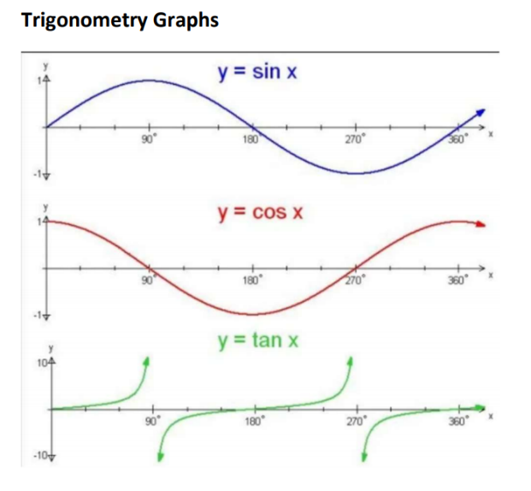
Autumn Term 1 Knowledge
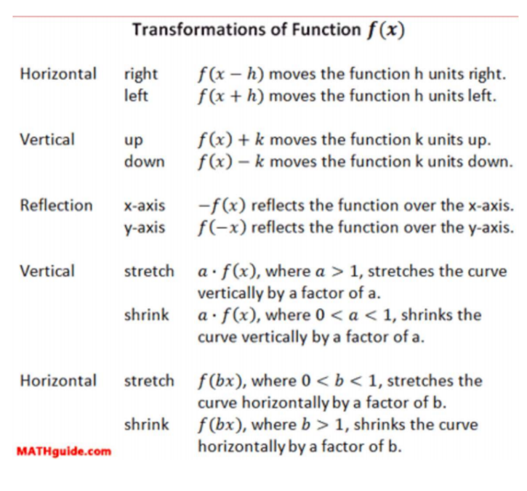
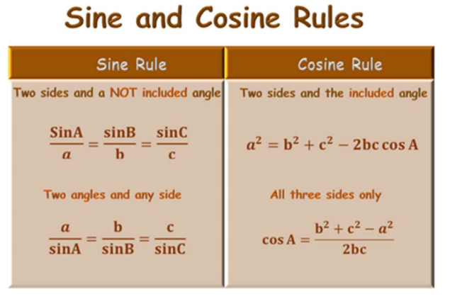

Scan for full list of Maths facts


