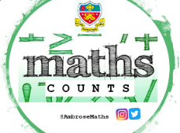
Knowledge Organiser
Autumn Term 1 Classes A - D Year 11
Topic | Self-Assessment | Independent Learning and  homework tasks
Topic | Self-Assessment | CorbettMaths.com
Removing brackets and factorising. |  | Video 13, 14
Factorising quadratic expressions, of the form ax²+bx+c, including the difference of two squares. |  | Video 118
Solving quadratic equations by factorising |  | Video 266
Solving simultaneous equations by elimination and substitution. |  | Videos 295 - 6
Solving simultaneous equations graphically. |  | Video 297
Forming, then solving simultaneous equations. |  | See Sparx Maths
Solving quadratic equations by completing the square and using the quadratic formula. |  | Video 267, 267a
Deduce turning points and the symmetrical property of a quadratic by completing the square. |  | Video 267a
Solve problems by first forming quadratic equations. |  | See Sparx Maths
Solve simultaneous equations consisting of one quadratic and one linear equation. |  | Video 298
Use algebra to prove number statements and disprove number statements using a counter example. |  | Video 365
Understanding the handling data cycle and carrying out effective data collection. |  | Video 89
Identifying different types of data including qualitative, quantitative, discrete, continuous, primary and secondary data. |  | See Sparx Maths
Understanding different sampling methods and identifying possible bias. |  | Video 282
Calculating stratified samples. |  | Video 281
Drawing and interpreting histograms.  Calculating frequency density |  | Video 157 - 8

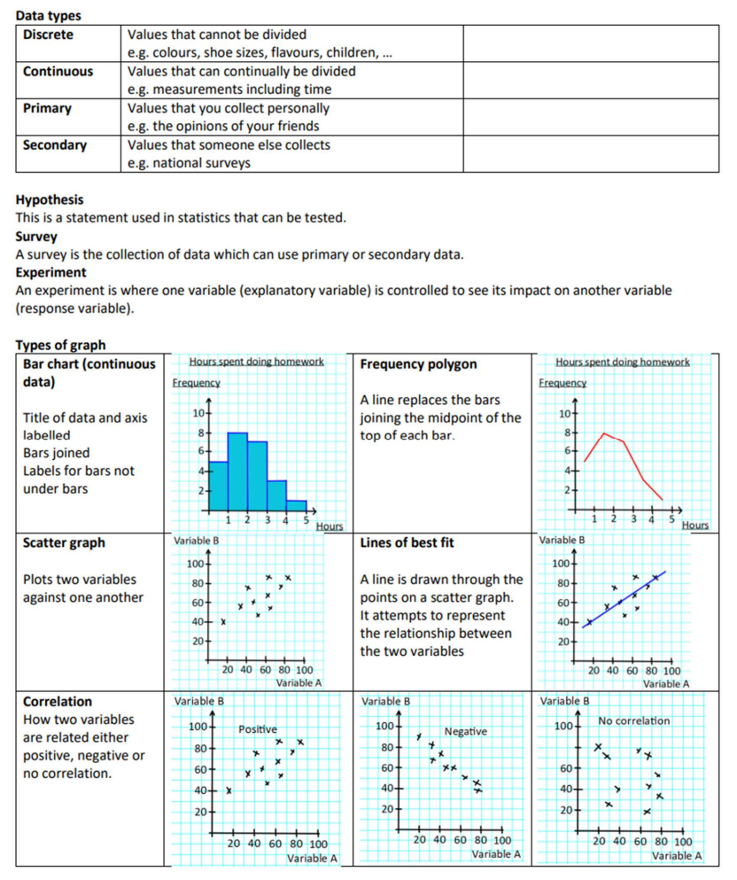
Autumn Term 1 Knowledge


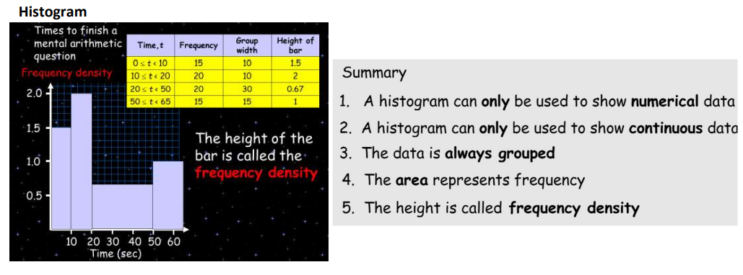
Scan for full list of Maths facts

Maths Support Attend Sparx Maths Clinic every Thursday lunch time in DT for extra help and support.
Stretch and Challenge:
1) Practise UKMT Intermediate Maths Challenge Past papers on ukmt.org.uk
2) Complete the XP Boost questions on Sparx Maths every week

