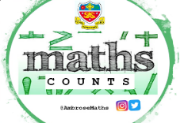
Knowledge Organiser
Autumn Term 2 Classes A - D Year 11
Topic | Self-Assessment | Independent Learning and  homework tasks
Topic | Self-Assessment | CorbettMaths.com
Changing the subject where the new subject appears once |  | Algebra/Changing the subject  video 8
Changing the subject where the new subject appears more than once |  | Algebra/Changing the subject  video 8
Understanding index notation |  | Video 174
Multiplying, dividing and raising one power to another power. |  | Video 175
Understanding and using negative indices |  | Video 173
Being able to evaluate fractional indices |  | Video 173
Finding a fraction of a quantity, ordering fractions and simplifying fractions. |  | Video 137 / 144
Adding, subtracting & multiplying fractions. |  | Video 132 - 137
Understanding reciprocals and dividing fractions |  | Video 134
Add, subtract, multiply and divide algebraic fractions |  | Video 21 - 24
Solve equations involving fractions with algebraic denominators |  | Video 110 - 112

Maths Support Attend Sparx Maths Clinic every Thursday lunch time in DT for extra help and support.
Stretch and Challenge:
1) Practise UKMT Intermediate Maths Challenge Past papers on ukmt.org.uk
2) Complete the XP Boost questions on Sparx Maths every week

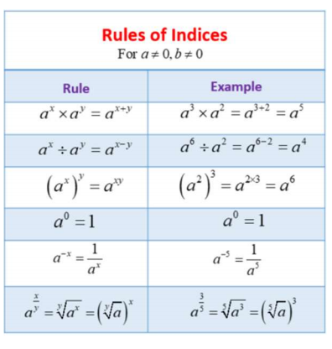
Autumn Term 2 Knowledge

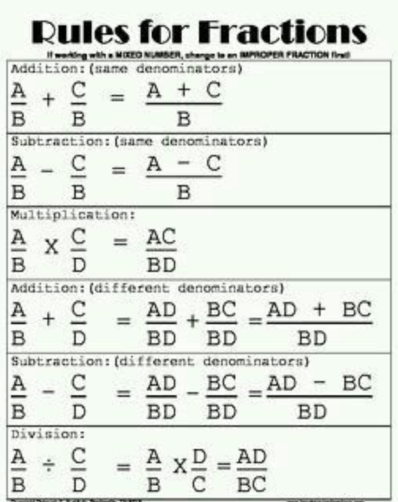


Scan for full list of Maths facts

