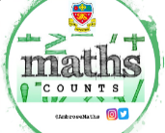
Knowledge Organiser
Lent Term Classes A - D Year 11
Topic | Self-Assessment | Independent Learning and  homework tasks
Topic | Self-Assessment | CorbettMaths.com
Use co-ordinates in 3D |  | Video 86
Use Pythagoras and Trigonometry to solve in 3D |  | Video 259
Recognise and use the equation of a circle with centre at the origin, equation of a tangent to a circle |  | Video 372
Express positions and lines in terms of vectors. |  | Video 353
Solve geometric problems using vectors. |  | Video 353
Be able to calculate sine, cosine and tangent of angles greater than 90° |  | Video 338 - 340
Be able to draw graphs sine, cosine and tangent. |  | Video 338 - 340
Know the exact values of sinθ and cosθ and tanθ for θ = 0°, 30°, 45° , 60° and 90° |  | Video 338 - 340
Use the sine and cosine rules to find unknown lengths and angles of any triangle |  | Video 333 - 336
Find the area of any triangle |  | Video 337
Be able to use of f(x), fg(x) and f⁻¹(x) notation
Understanding ‘inverse function’ and ‘composite function’ |  | Video 369 - 370
Find approximate solutions to equations numerically using iteration |  | Video 373
Be able to use function notation.  Sketch graphs of y=af(x), y =f(ax), y=f(x)+a, y=f(x+a) given the graph of y=f(x) (7/8). |  | Video 323 - 4
Simplify surds and rationalise their denominator |  | Video 305 - 8

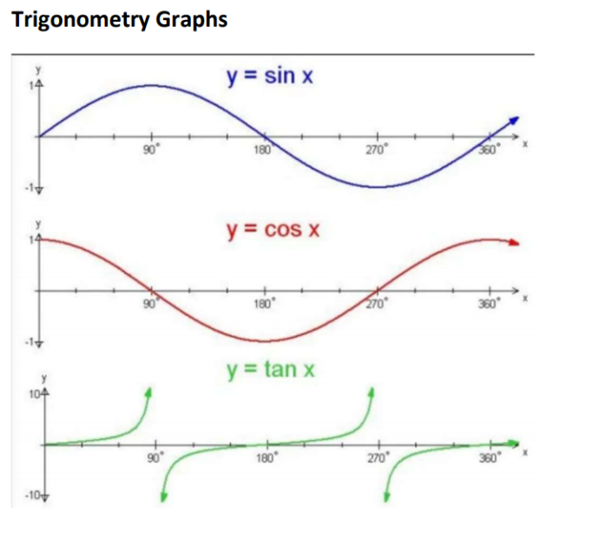
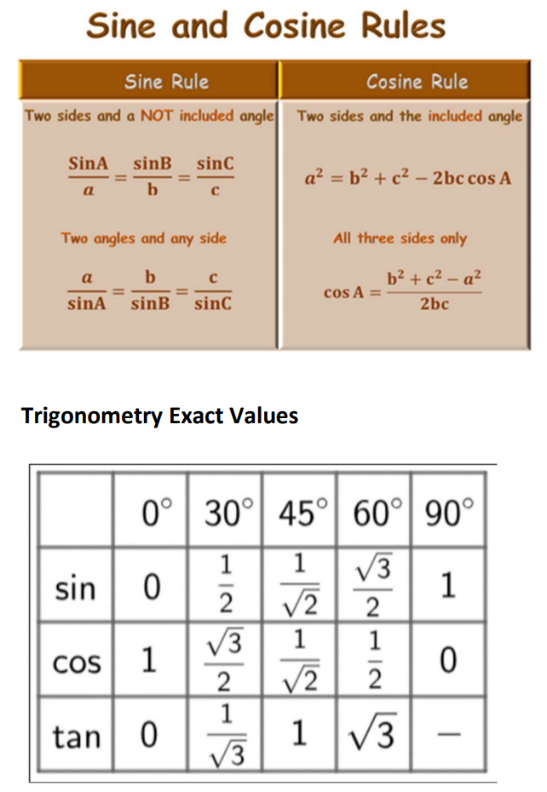
Lent Term Knowledge

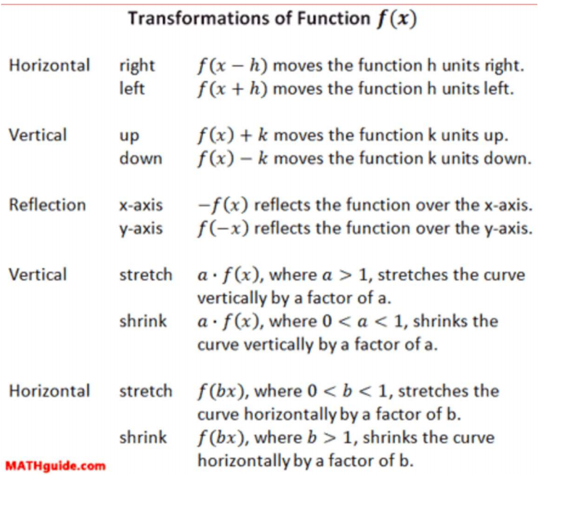

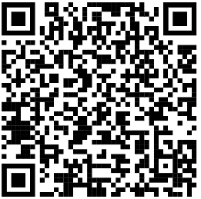
Scan for full list of Maths facts

