 GCSE to A-Level Transition Work: BIOLOGY

This document contains a programme of activities and resources to prepare you to start A level in Biology in September.

The A Level course followed at St. Ambrose College is AQA Biology A Level (7402). The course is taught over two years and is fully assessed by three written papers at the end of the course. If you would like to read more about the course you can access the full specification on the AQA website
https://www.aqa.org.uk/subjects/science/as-and-a-level/biology-7401-7402/introduction

A Level biology consolidates and extends GCSE knowledge. It is therefore imperative that you strengthen your understanding of GCSE topics to give yourself the strongest foundations to build on.

You should already have created a full set of revision notes for your GCSE topics. Online revision resources such as those listed below should be used to cement your understanding
Digital textbook on Kerboodle
https://www.kerboodle.com/users/login
BBC bitesize OCR Gateway GCSE Biology
https://www.bbc.co.uk/bitesize/examspecs/z3dj82p
Seneca Learning (OCR Gateway GCSE Biology)
https://www.senecalearning.com/blog/free-ocr-gateway-a-biology-gcse-higher-revision/
GCSEpod
https://www.gcsepod.com/gcse-learning-and-revision-pods/
Completing the following tasks will make sure your GCSE knowledge is up to date and you are ready for the step up to A Level Biology:

DNA and the Genetic Code
In living organisms nucleic acids (DNA and RNA have important roles and functions related to their properties. The sequence of bases in the DNA molecule determines the structure of proteins, including enzymes. The double helix and its four bases store the information that is passed from generation to generation. The sequence of the base pairs adenine, thymine, cytosine and guanine tell ribosomes in the cytoplasm how to construct amino acids into polypeptides and produce every characteristic we see. DNA can mutate leading to diseases including cancer and sometimes anomalies in the genetic code are passed from parents to babies in disease such as cystic fibrosis, or can be developed in unborn foetuses such as Downs Syndrome.
Read the information on these websites:
http://www.bbc.co.uk/education/guides/z36mmp3/revision
http://www.s-cool.co.uk/a-level/biology/dna-and-genetic-code
And take a look at these videos:
http://ed.ted.com/lessons/the-twisting-tale-of-dna-judith-hauck
http://ed.ted.com/lessons/where-do-genes-come-from-carl-zimmer
Tasks:
Produce a wall display to put up in your classroom in September. You might make a poster or do this using PowerPoint or similar Your display should use images, keywords and simple explanations to:
Define gene, chromosome, DNA and base pair
Describe the structure and function of DNA and RNA
Explain how DNA is copied in the body
Outline some of the problems that occur with DNA replication and what the consequences of this might be.

Evolution
Transfer of genetic information from one generation to the next can ensure continuity of species or lead to variation within a species and possible formation of new species. Reproductive isolation can lead to accumulation of different genetic information in populations potentially leading to formation of new species (speciation). Sequencing projects have read the genomes of organisms ranging from microbes and plants to humans. This allows the sequences of the proteins that derive from the genetic code to be predicted. Gene technologies allow study and alteration of gene function in order to better understand organism function and to design new industrial and medical processes.
Read the information on these websites
https://www.bbc.co.uk/bitesize/guides/zt4f8mn/revision/2
http://www.s-cool.co.uk/a-level/biology/evolution
And take a look at these videos:
http://ed.ted.com/lessons/how-to-sequence-the-human-genome-mark-j-kiel
http://ed.ted.com/lessons/the-race-to-sequence-the-human-genome-tien-nguyen
Tasks:
Produce a one page revision guide for an AS Biology student that recaps the key words and concepts in this topic. Your revision guide should:
Describe speciation
Explain what a genome is
Give examples of how this information has already been used to develop new treatments and technologies.

Biodiversity
The variety of life, both past and present, is extensive, but the biochemical basis of life is similar for all living things. Biodiversity refers to the variety and complexity of life and may be considered at different levels. Biodiversity can be measured, for example within a habitat or at the genetic level. Classification is a means of organising the variety of life based on relationships between organisms and is built around the concept of species. Originally classification systems were based on observable features but more recent approaches draw on a wider range of evidence to clarify relationships between organisms. Adaptations of organisms to their environments can be behavioural, physiological and anatomical. Adaptation and selection are major factors in evolution and make a significant contribution to the diversity of living organisms.
Read the information on these websites:
http://www.s-cool.co.uk/a-level/biology/ecological-concepts
http://www.s-cool.co.uk/a-level/biology/classification
And take a look at these videos:
http://ed.ted.com/lessons/why-is-biodiversity-so-important-kim-preshoff
http://ed.ted.com/lessons/can-wildlife-adapt-to-climate-change-erin-eastwood
Task:
Write a persuasive letter to an MP, organisation or pressure group promoting conservation to maintain biodiversity.
Your letter should:
Define what is meant by species and classification
Describe how species are classified
Explain one way scientists can collect data about a habitat, giving an example
Explain adaptation and how habitat change may pose a threat to niche species
Exchange and Transport
Organisms need to exchange substances selectively with their environment and this takes place at exchange surfaces. Factors such as size or metabolic rate affect the requirements of organisms and this gives rise to adaptations such as specialised exchange surfaces and mass transport systems. Substances are exchanged by passive or active transport across exchange surfaces. The structure of the plasma membrane enables control of the passage of substances into and out of cells
Read the information on these websites:
http://www.s-cool.co.uk/a-level/biology/gas-exchange
http://www.s-cool.co.uk/a-level/biology/nutrition-and-digestion/revise-it/human-digestive-system
And take a look at these videos:
http://ed.ted.com/lessons/insights-into-cell-membranes-via-dish-detergent-ethan-perlstein
http://ed.ted.com/lessons/what-do-the-lungs-do-emma-bryce
Task:
Create a poster or display to go in your classroom in September. Your poster should either: compare exchange surfaces in mammals and fish or compare exchange surfaces in the lungs and the intestines. You could use a Venn diagram to do this. Your poster should:
Describe diffusion, osmosis and active transport
Explain why oxygen and glucose need to be absorbed and waste products removed
Compare and contrast your chosen focus.

Cells
The cell is a unifying concept in biology, you will come across it many times during your two years of A level study. Prokaryotic and eukaryotic cells can be distinguished on the basis of their structure and ultrastructure. In complex multicellular organisms’ cells are organised into tissues, tissues into organs and organs into systems. During the cell cycle genetic information is copied and passed to daughter cells. Daughter cells formed during mitosis have identical copies of genes while cells formed during meiosis are not genetically identical
Read the information on this website:
http://www.s-cool.co.uk/a-level/biology/cells-and-organelles

And take a look at these videos:
https://www.youtube.com/watch?v=gcTuQpuJyD8
https://www.youtube.com/watch?v=L0k-enzoeOM
https://www.youtube.com/watch?v=qCLmR9-YY7o

Task:
Produce a one-page revision guide to share with your class in September summarising one of the following topics: Cells and Cell Ultrastructure, Prokaryotes and Eukaryotes, or Mitosis and Meiosis.
Whichever topic you choose, your revision guide should include:
Key words and definitions
Clearly labelled diagrams
Short explanations of key ideas or processes.

Biological Molecules
Biological molecules are often polymers and are based on a small number of chemical elements. In living organisms carbohydrates, proteins, lipids, inorganic ions and water all have important roles and functions related to their properties. DNA determines the structure of proteins, including enzymes. Enzymes catalyse the reactions that determine structures and functions from cellular to whole-organism level. Enzymes are proteins with a mechanism of action and other properties determined by their tertiary structure. ATP provides the immediate source of energy for biological processes.
Read the information on this website:
http://www.s-cool.co.uk/a-level/biology/biological-molecules-and-enzymes
And take a look at these videos:
https://www.youtube.com/watch?v=H8WJ2KENlK0
http://ed.ted.com/lessons/activation-energy-kickstarting-chemical-reactions-vance-kite
Task:
Krabbe disease occurs when a person doesn’t have a certain enzyme in their body. The disease effects the nervous system. Write a letter to a GP or a sufferer to explain what an enzyme is.
Your poster should:
Describe the structure of an enzyme
Explain what enzymes do inside the body

Ecosystems
Ecosystems range in size from the very large to the very small. Biomass transfers through ecosystems and the efficiency of transfer through different trophic levels can be measured. Microorganisms play a key role in recycling chemical elements. Ecosystems are dynamic systems, usually moving from colonisation to climax communities in a process known as succession. The dynamic equilibrium of populations is affected by a range of factors. Humans are part of the ecological balance and their activities affect it both directly and indirectly. Effective management of the conflict between human needs and conservation help to maintain sustainability of resources.
Read the information on this website:
http://www.s-cool.co.uk/a-level/biology/ecological-concepts
And take a look at these videos:
https://www.youtube.com/watch?v=jZKIHe2LDP8
https://www.youtube.com/watch?v=E8dkWQVFAoA
Task:
Produce a newspaper or magazine article about one ecosystem (e.g. the arctic, the Sahara, the rainforest, or something closer to home like your local woodland, nature reserve or shore line).
Your article should include:
Key words and definitions
Pictures or diagrams of your chosen ecosystem.
A description of the changes that have occurred in this ecosystem
An explanation of the threats and future changes that may further alter this ecosystem.

Control Systems
Homeostasis is the maintenance of a constant internal environment. Negative feedback helps maintain an optimal internal state in the context of a dynamic equilibrium. Positive feedback also occurs. Stimuli, both internal and external, are detected leading to responses. The genome is regulated by a number of factors. Coordination may be chemical or electrical in nature
Read the information on this website:
http://www.s-cool.co.uk/a-level/biology/homeostasis
And take a look at these videos:
https://www.youtube.com/watch?v=x4PPZCLnVkA
https://www.youtube.com/watch?v=x4PPZCLnVkA
Task:
Produce a poster to display in your classroom in September summarising one of the following topics: Temperature Control, Water control and the Kidneys, Glucose Control, or The Liver.
Whichever topic you choose, your poster or display should include:
Key words and definitions
Clearly labelled diagrams
Short explanations of key ideas or processes.

Energy for Biological Processes
In cellular respiration, glycolysis takes place in the cytoplasm and the remaining steps in the mitochondria. ATP synthesis is associated with the electron transfer chain in the membranes of mitochondria and chloroplasts in photosynthesis energy is transferred to ATP in the light- dependent stage and the ATP is utilised during synthesis in the light-independent stage.
Read the information on this website:
http://www.s-cool.co.uk/a-level/biology/respiration
And take a look at these videos:
https://www.youtube.com/watch?v=00jbG_cfGuQ
https://www.youtube.com/watch?v=2f7YwCtHcgk
Task:
Produce an A3 annotated information poster that illustrates the process of cellular respiration and summarises the key points.
Your poster should include:
Both text and images
Be visually stimulating
Key words and definitions
Clearly labelled diagrams
Short explanations of key ideas or processes.

Scientific and Investigative Skills
As part of your A level you will complete a practical assessment. This will require you to carry out a series of practical activities as well as planning how to do them, analysing the results and evaluating the methods.
Task:
Produce a glossary for the following key words:
accuracy, anomaly, calibration, causal link, chance, confounding variable, control experiment, control group, control variable,
correlation, dependent variable, errors, evidence, fair test, hypothesis, independent, null hypothesis, precision, probability,
protocol, random distribution, random error, raw data, reliability, systematic error, true value, validity, zero error,

Book recommendations
Wider reading outside of GCSE textbooks and revision guides is a great way to prepare for A Level and to deepen your interest in the subject. The final written exam for A Level biology includes a 25mark essay; to achieve the highest marks on this essay you need to demonstrate knowledge/interest in biology outside of the A Level specification!
The books below are all popular science books and great for extending your understanding of Biology...

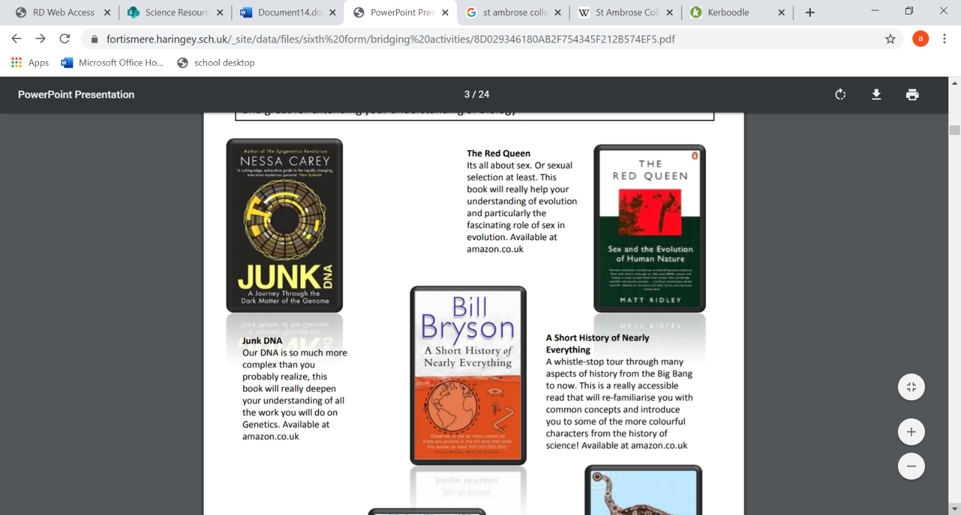
Junk DNA Our DNA is so much more complex than you probably realize, this book will really deepen your understanding of all the work you will do on Genetics. Available at amazon.co.uk

A Short History of Nearly Everything A whistle-stop tour through many aspects of history from the Big Bang to now. This is a really accessible read that will re-familiarise you with common concepts and introduce you to some of the more colourful characters from the history of science! Available at amazon.co.uk

The Red Queen It's all about sex. Or sexual selection at least. This book will really help your understanding of evolution and particularly the fascinating role of sex in evolution. Available at amazon.co.uk

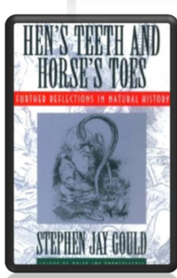
Hoping to study Geography as well? Hen’s teeth and horse‘s toes Stephen Jay Gould is a great Evolution writer and this book discusses lots of fascinating stories about Geology and evolution. Available at amazon.co.uk

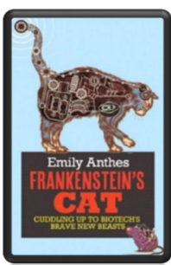
An easy read.. Frankenstein’s cat Discover how glow in the dark fish are made and more great Biotechnology breakthroughs. Available at amazon.co.uk

Film recommendations
Here are a few suggestions for films based on real life scientists and discoveries, great watching for a rainy day.
Looking back over the last 50 years there are a few films you might not have seen before.

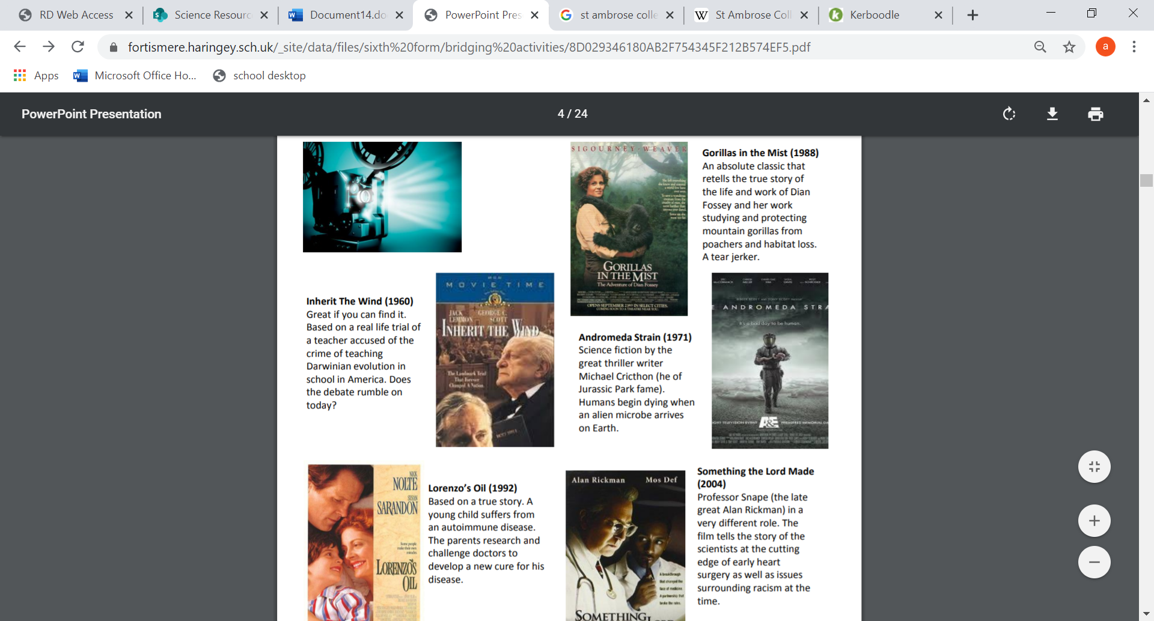
Inherit The Wind (1960) Great if you can find it. Based on a real life trial of a teacher accused of the crime of teaching Darwinian evolution in school in America. Does the debate rumble on today?
Gorillas in the Mist (1988) An absolute classic that retells the true story of the life and work of Dian Fossey and her work studying and protecting mountain gorillas from poachers and habitat loss. A tear jerker.
Andromeda Strain (1971) Science fiction by the great thriller writer Michael Cricthon (he of Jurassic Park fame). Humans begin dying when an alien microbe arrives on Earth.
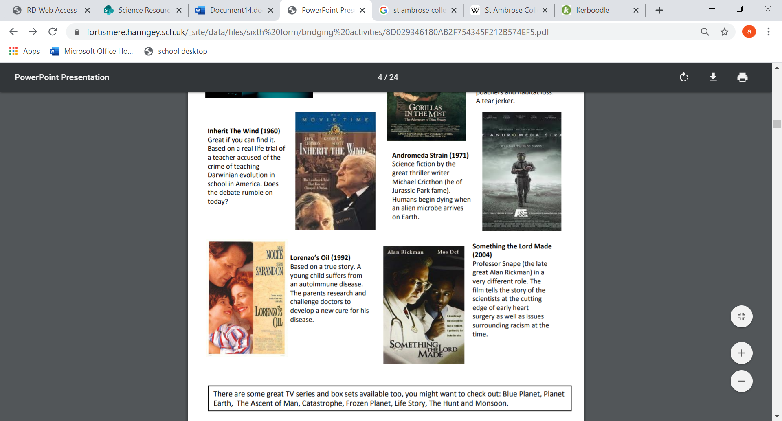

Something the Lord Made (2004) Professor Snape (the late great Alan Rickman) in a very different role. The film tells the story of the scientists at the cutting edge of early heart surgery as well as issues surrounding racism at the time.

Lorenzo’s Oil (1992) Based on a true story. A young child suffers from an autoimmune disease. The parents research and challenge doctors to develop a new cure for his disease.

There are some great TV series and box sets available too. Check out: Blue Planet, Planet Earth, The Ascent of Man, Catastrophe, Frozen Planet, Life Story, The Hunt and Monsoon.

Ted talks
If you don’t quite have time for a full film but perhaps 30 minutes to spare, there are some great presentations from world leading scientists and researchers on a variety of topics (for FREE too!). They provide some interesting answers and ask some thought-provoking questions. Below are a couple of suggestions to check out first…
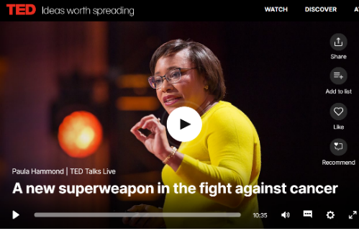
A New Superweapon in the Fight Against Cancer

Cancer is a very clever, adaptable disease. To defeat it, says medical researcher and educator Paula Hammond, we need a new and powerful mode of attack. https://www.ted.com/talks/paula_hammond_a_new_superweapon_in_the_fight_against_cancer?language=en
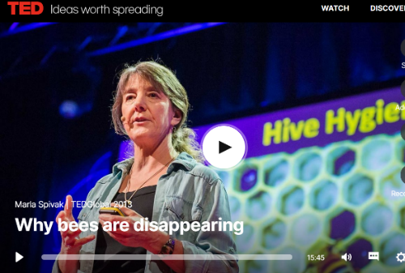
Why Bees are Disappearing

Honeybees have thrived for 50 million years, each colony 40 to 50,000 individuals coordinated in amazing harmony. So why, seven years ago, did colonies start dying en-masse?
https://www.ted.com/talks/marla_spivak_why_bees_are_disappearing?language=en
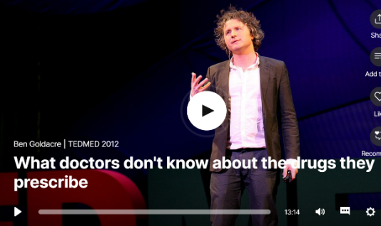
Why Doctors Don’t Know About the Drugs They Prescribe

When a new drug gets tested, the results of the trials should be published for the rest of the medical world — except much of the time, negative or inconclusive findings go unreported, leaving doctors and researchers in the dark.

https://www.ted.com/talks/ben_goldacre_what_doctors_don_t_know_about_the_drugs_they_prescribe?language=tlh
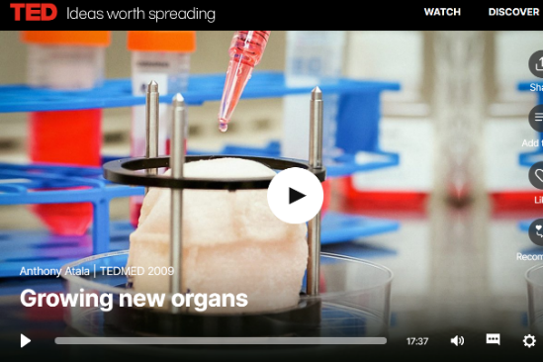
Growing New Organs

Anthony Atalla's state-of-the-art lab grows human organs — from muscles to blood vessels to bladders, and more.

https://www.ted.com/talks/anthony_atala_growing_new_organs
Further extension
Gresham College website has lots of lectures (all different subjects, many for science topics) that will enable you to explore A-level topics/career ideas https://www.gresham.ac.uk/lectures
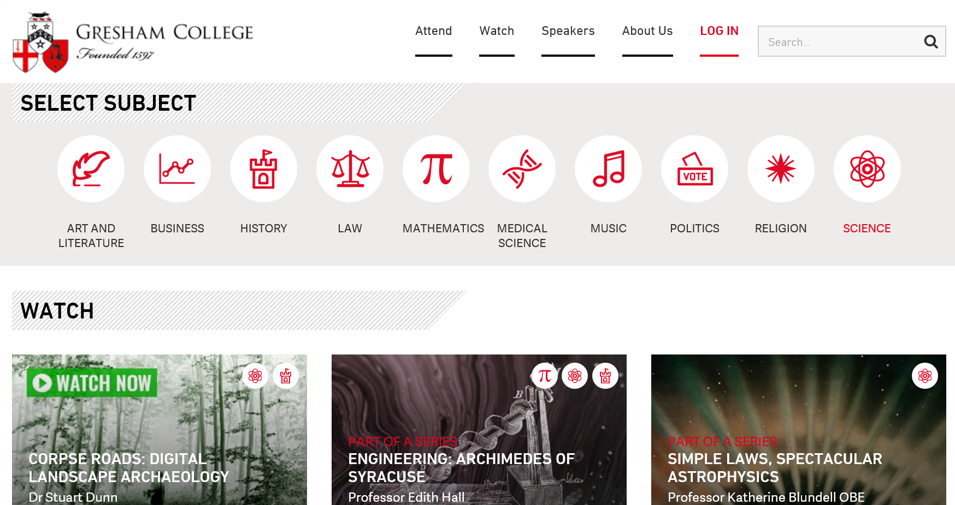
The Open University has lots of free online courses to try, many that are related to the A Level biology course https://www.open.edu/openlearn/free-courses/full-catalogue
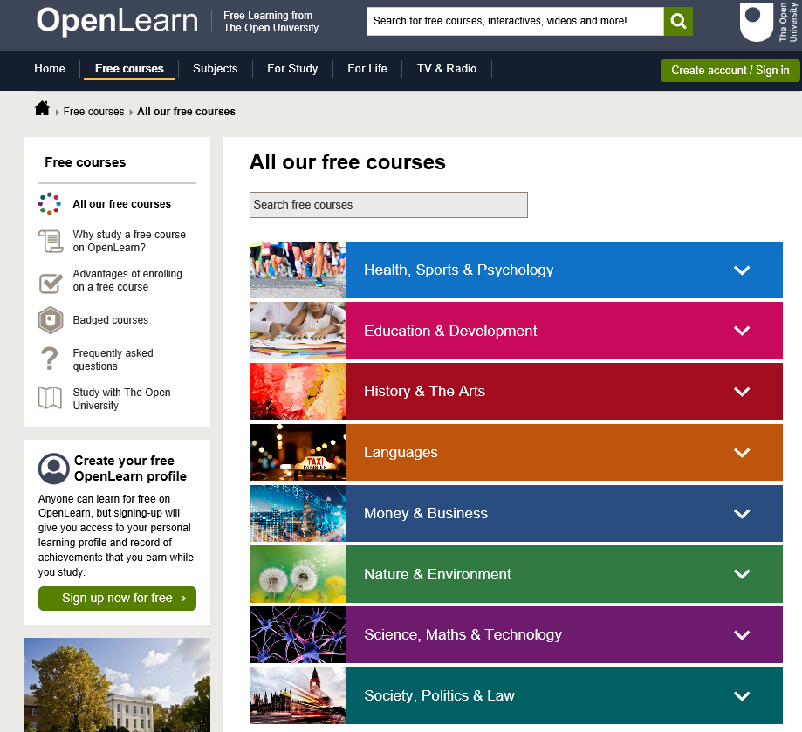
Similarly the EdX.org website provides online courses that are accredited by top universities…a great way to add depth to your own university application in the future, showing genuine interest in your chosen subject outside of the GCSE and A Level specifications! https://www.edx.org/

Research activities
Research, reading and note making are essential skills for A level Biology study. For the following tasks you should produce ‘Cornell Notes’ to summarise your reading/research.
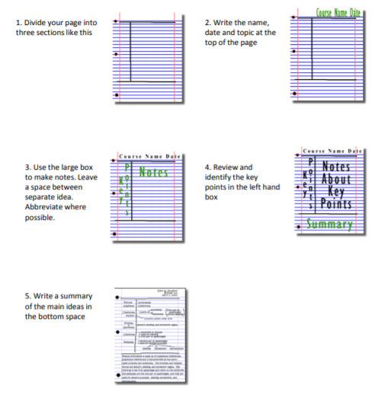

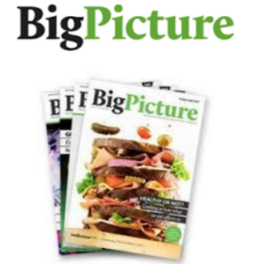
The Big Picture is an excellent publication from the Wellcome Trust.
Along with a magazine, the company produces posters, videos and other resources aimed at students studying for GCSEs and A level.
https://www.stem.org.uk/big-picture/resource-collection
For each of the following topics, you should use the ‘Big Picture’ resources to produce one page of Cornell style notes.

Topic 1: The Cell https://www.stem.org.uk/resources/elibrary/resource/34589/cell-suitable-home-teaching
The cell is the building block of life. Each of us starts from a single cell, a zygote, and grows into a complex organism made of trillions of cells. In this issue, we explore what we know – and what we don’t yet know – about the cells that are the basis of us all and how they reproduce, grow, move, communicate and die.

Topic 2: The Immune System https://www.stem.org.uk/resources/elibrary/resource/35694/immune-system
The immune system is what keeps us healthy in spite of the many organisms and substances that can do us harm. In this issue, explore how our bodies are designed to prevent potentially harmful objects from getting inside, and what happens when bacteria, viruses, fungi or other foreign organisms or substances breach these barriers.

Topic 3: Drugs https://www.stem.org.uk/resources/elibrary/resource/26575/drugs-suitable-home-teaching
Although they provide immense benefits, drugs aren't a perfect solution: they can be expensive, they only help a proportion of patients, sometimes they harm us, and we’re not very good at taking them as we should. These articles help us investigate what part pharmaceuticals play in modern life and ask where we might go in the future.

Topic 4: Populations https://www.stem.org.uk/resources/elibrary/resource/35113/populations
What’s the first thing that pops into your mind when you read the word population? Most likely it’s the ever-increasing human population on earth. You’re a member of that population, which is the term for all the members of a single species living together in the same location. The term population isn’t just used to describe humans; it includes other animals, plants and microbes too. In this issue, we learn more about how populations grow, change and move, and why understanding them is so important.

Topic 5: Health and climate change https://www.stem.org.uk/resources/elibrary/resource/26573/health-and-climate-change
The Earth’s climate is changing. In fact, it has always been changing. What is different now is the speed of change and the main cause of change – human activities. This issue asks: What are the biggest threats to human health? Who will suffer as the climate changes? What can be done to minimise harm? And how do we cope with uncertainty?

Biology Websites
These websites all offer an amazing collection of resources that you should use again and again throughout your A-Level course.

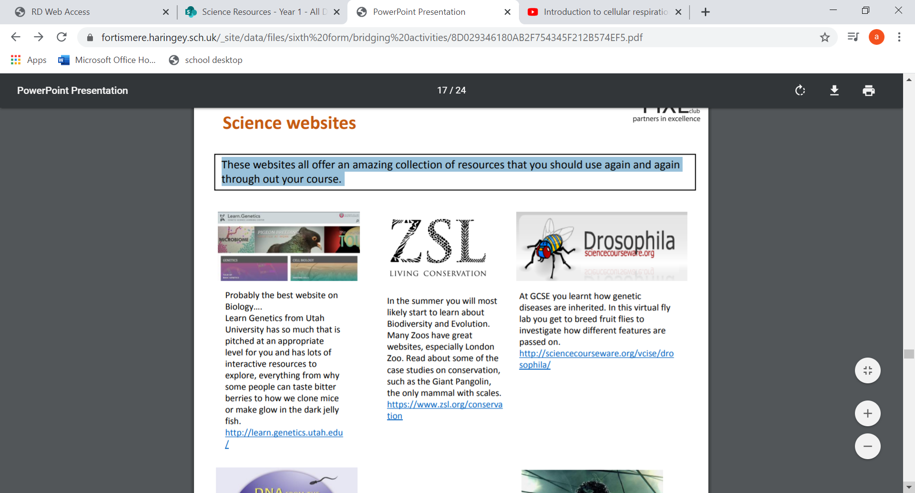
Probably the best website on Biology…. Learn Genetics from Utah University has so much that is pitched at an appropriate level for you and has lots of interactive resources to explore, everything from why some people can taste bitter berries to how we clone mice or make glow in the dark jelly fish. https://learn.genetics.utah.edu/

Many Zoos have great websites to help you learn about Biodiversity and Evolution, especially London Zoo. Read about some of the case studies on conservation, such as the Giant Pangolin, the only mammal with scales.
https://www.zsl.org/conservation

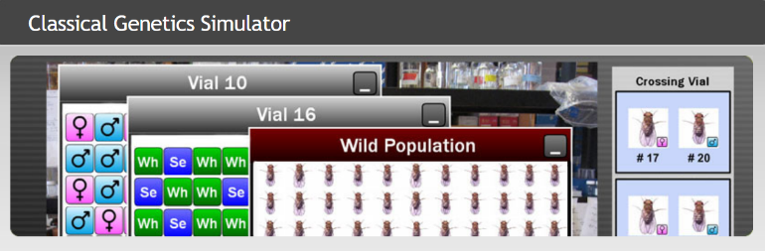
At GCSE you learnt how genetic diseases are inherited. In this virtual fly lab you get to breed fruit flies to investigate how different features are passed on.
http://cgslab.com/drosophila/
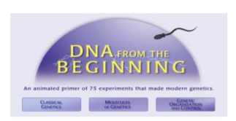
DNA from the beginning is full of interactive animations that tell the story of DNA from its discovery through to advanced A-Level concepts.
http://www.dnaftb.org/

Ok, so not a website, but a video you definitely want to watch. One of the first topics you will learn about is the amazing structure of the cell. This BBC film shows the fascinating workings of a cell… a touch more detailed than the “fried egg” model you might have seen. https://www.bbc.co.uk/iplayer/episode/b01nln7d/secret-universe-the-hidden-life-of-the-cell If this link expires – google “BBC hidden life of the cell”
Science on social media
Science communication is essential in the modern world and all the big scientific companies, researchers and institutions have their own social media accounts. Here are a few to keep you up to date with developing news or interesting stories:
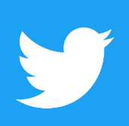

Follow on Twitter:
Commander Chris Hadfield – former resident aboard the International Space Station @cmdrhadfield
Tiktaalik roseae – a 375 million year old fossil fish with its own Twitter account! @tiktaalikroseae
NASA’s Voyager 2 – a satellite launched nearly 40 years ago that is now travelling beyond our Solar System @NSFVoyager2
Neil dGrasse Tyson – Director of the Hayden Planetarium in New York @neiltyson
Sci Curious – feed from writer and Bethany Brookshire tweeting about good, bad and weird neuroscience @scicurious
The SETI Institute – The Search for Extra Terrestrial Intelligence, be the first to know what they find! @setiinstitute
Carl Zimmer – Science writer Carl blogs about the life sciences @carlzimmer
Phil Plait – tweets about astronomy and bad science @badastronomer
Virginia Hughes – science journalist and blogger for National Geographic, keep up to date with neuroscience, genetics and behaviour @virginiahughes
Maryn McKenna – science journalist who writes about antibiotic resistance @marynmck
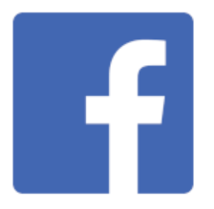

Find on Facebook:
Nature - the profile page for nature.com for news, features, research and events from Nature Publishing Group
Marin Conservation Institute – publishes the latest science to identify important marine ecosystems around the world.
National Geographic - since 1888, National Geographic has travelled the Earth, sharing its amazing stories in pictures and words.
Science News Magazine - Science covers important and emerging research in all fields of science.
BBC Science News - The latest BBC Science and Environment News: breaking news, analysis and debate on science and nature around the world.

