A Level Biology Transition Assessment
The following 40 minute test is designed to test your recall, analysis and evaluative skills and knowledge AFTER you have completed the tasks in the activities document. Remember to use your exam technique: look at the command words and the number of marks each question is worth.
A mark scheme is provided at the end of the questions for you for you to GREEN PEN self-assess your answers.

1. a) What are the base pairs found in DNA? ……………………………………………………………………………………………………………………………………………………………
……………………………………………………………………………………………………………………………………………………… (2)

b) What does DNA code for? ……………………………………………………………………………………………………………………………………………………………
……………………………………………………………………………………………………………………………………………………… (1)

c) Which organelle in a cell carries out this function? ……………………………………………………………………………………………………………………………………………………………
……………………………………………………………………………………………………………………………………………………… (1)

2. a) What theory did Charles Darwin propose? ……………………………………………………………………………………………………………………………………………………………
……………………………………………………………………………………………………………………………………………………… (1)

b) Why did many people not believe Darwin at the time?
……………………………………………………………………………………………………………………………………………………………
……………………………………………………………………………………………………………………………………………………… (1)

c) Describe how fossils are formed. ……………………………………………………………………………………………………………………………………………………………
…………………………………………………………………………………………………………………………………………………………..
……………………………………………………………………………………………………………………………………………………………
……………………………………………………………………………………………………………………………………………………… (3)
d) The fossil record shows us that there have been some species that have formed and some that have become extinct.
i) What is meant by the term ‘species’? ……………………………………………………………………………………………………………………………………………………………
……………………………………………………………………………………………………………………………………………………………
……………………………………………………………………………………………………………………………………………………… (2)

ii) Describe how a new species may arise: ……………………………………………………………………………………………………………………………………………………………
…………………………………………………………………………………………………………………………………………………………..
……………………………………………………………………………………………………………………………………………………………
……………………………………………………………………………………………………………………………………………………… (3)

3. Ecologists regularly study habitats to measure the species present and the effect of any changes. One team of ecologists investigated the habitat shown in the picture below:
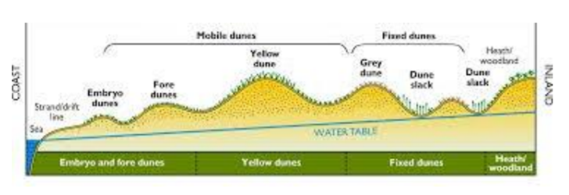
Image taken from http://www.macaulay.ac.uk/soilquality/Dune%20Succession.pdf
a) Define the following keywords:
i) Population ……………………………………………………………………………………………………………………………………………………………
…………………………………………………………………………………………………………………………………………………………… ii) Community ……………………………………………………………………………………………………………………………………………………………
……………………………………………………………………………………………………………………………………………………… (2)
b) Give an example of one biotic factor and one abiotic factor that would be present in this habitat Biotic: ……………………………………………………………………………………………………………………………………………………… Abiotic: ……………………………………………………………………………………………………………………………………………………… (2)

c) Describe how the ecologists would go about measuring the distribution of plant species present from the coast to the inland.
……………………………………………………………………………………………………………………………………………………………
…………………………………………………………………………………………………………………………………………………………..
……………………………………………………………………………………………………………………………………………………………
……………………………………………………………………………………………………………………………………………………………
…………………………………………………………………………………………………………………………………………………………..
……………………………………………………………………………………………………………………………………………………………
……………………………………………………………………………………………………………………………………………………………
…………………………………………………………………………………………………………………………………………………………..
……………………………………………………………………………………………………………………………………………………………
…………………………………………………………………………………………………………………………………………………………..
……………………………………………………………………………………………………………………………………………………………
………………………………………………………………………………………………………………………………………………………(6)

4. Every living organism is made of cells.
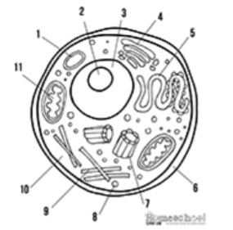
Image taken from http://prestigebux.com/worksheet/label-an-animal-cell-worksheet
- Label the following parts of the animal cell:

2 …………………………………………………

4 ……..……………………………………………

5 …………………………………………………… (3)

b) Describe how is the structure of the cell membrane related to its function?
……………………………………………………………………………………………………………………………………………………………
…………………………………………………………………………………………………………………………………………………………..
……………………………………………………………………………………………………………………………………………………………
………………………………………………………………………………………………………………………………………………………(3)

5. A medical research team investigated how quickly the body deals with glucose after a meal. They studied the blood glucose concentration of people who exercised versus those who did not.
Here are their results:
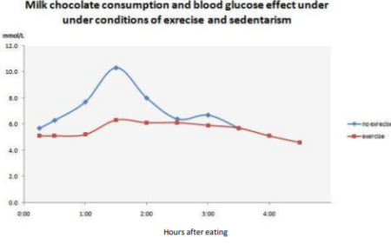
Image taken from https://memoirsofanamnesic.wordpress.com/category/blood-glucose/

- What organ in the body regulates blood glucose concentration?
…………………………………………………………………………………………………………………………………………………(1)

- Explain how the stages that would bring about a return to normal blood glucose concentrations.
………………………………………………………………………………………………………………………………………………………
………………………………………………………………………………………………………………………………………………………
………..……………………………………………………………………………………………………………………………………………
………..……………………………………………………………………………………………………………………………………………
…………………………………………………………………………………………………………………………………………………(4)

- Name one variable the researchers will have controlled.
………………………………………………………………………………………………………………………………………………… (1)

d) The researchers made the following conclusion: “Blood glucose returns to normal values for all people after 4 hours” To what extent do you agree with this conclusion.
………..……………………………………………………………………………………………………………………………………………
………..……………………………………………………………………………………………………………………………………………
………..……………………………………………………………………………………………………………………………………………
………..………………………………………………………………………………………………………………………………………(3)

6. Scientists need to be able to interpret data in graphs to decide if there are trends in the results. For each graph bellow, describe the trend.
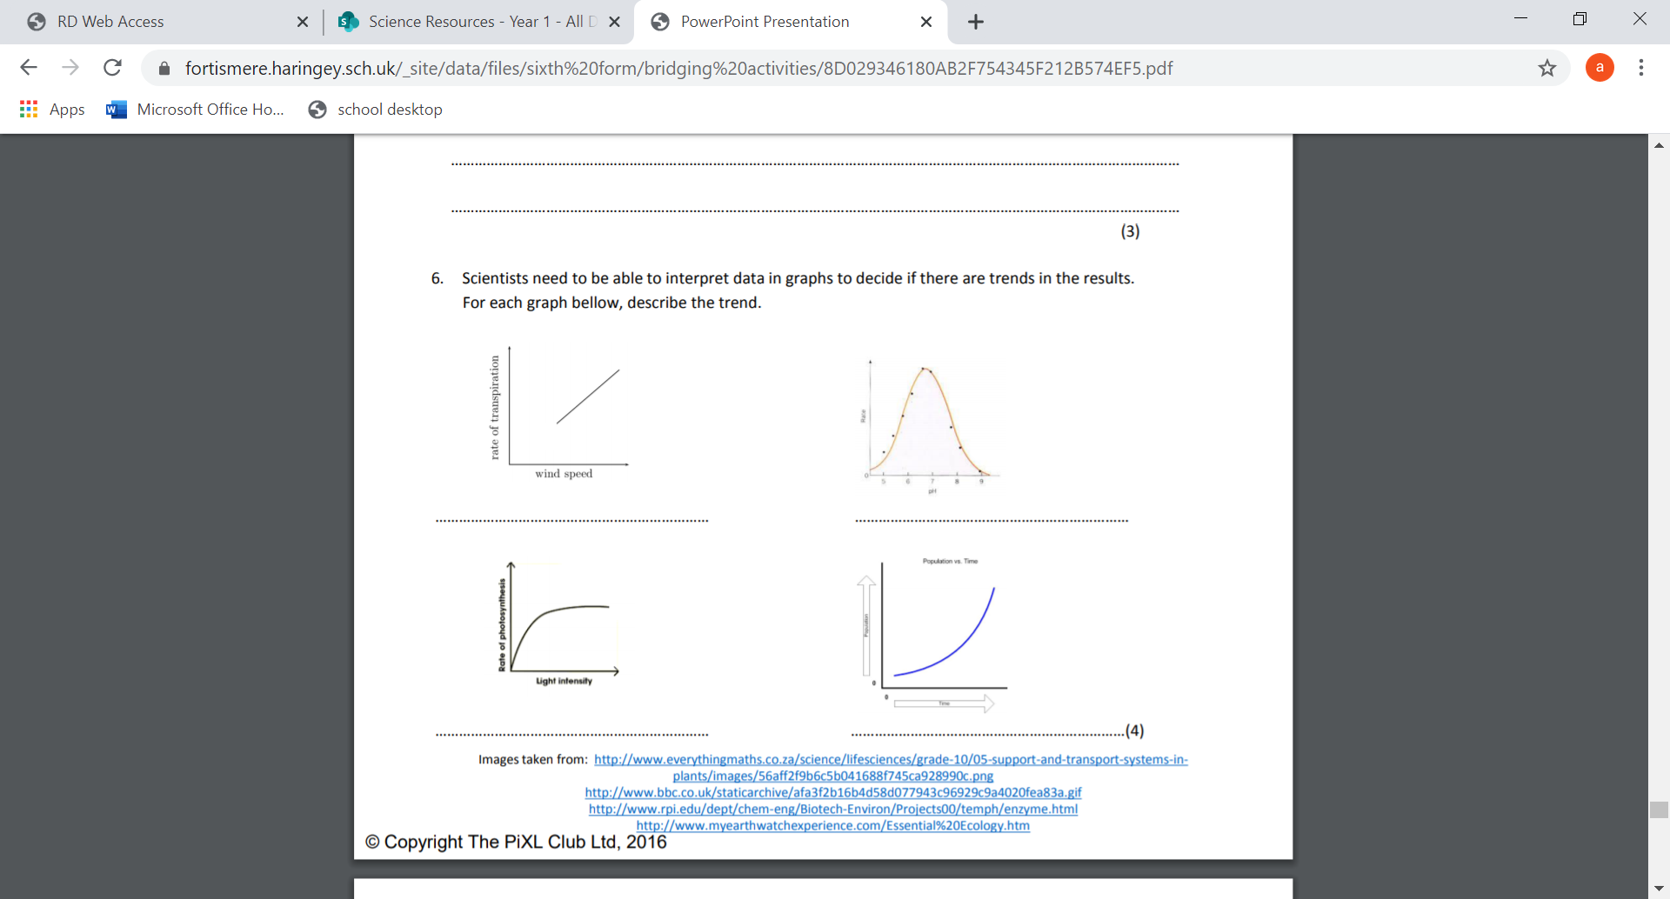
………..…………………………………………………………………….
………………………………………………………………………………
………………………………………………………………………………
………………………………………………………………………………(1)

………..…………………………………………………………………….
………………………………………………………………………………
………………………………………………………………………………
………………………………………………………………………………(1)

………..…………………………………………………………………….
………………………………………………………………………………
………………………………………………………………………………
………………………………………………………………………………(1)

………..…………………………………………………………………….
………………………………………………………………………………
………………………………………………………………………………
………………………………………………………………………………(1)

End of Questions

Mark Scheme:
1 a Adenine-Thymine (A-T)
Cytosine-Guanine (C-G)
2
b production of/code to build Proteins/enzymes
1
c Ribosomes
1
2 a Natural selection(allow survival of the fittest)
1
b lack of evidence (few fossils); Earth though to be younger; literal word of the bible
1
c (Plant/animal dies) and is quickly buried in sediment; Not all conditions for decay are present (eg. lack of oxygen so no/slow decomposition); Hard parts of the body are replaced by rock/minerals.
3
d i Organisms that can reproduce to produce viable offspring/offspring that can also reproduce (fertile)
1
ii any 3 from Geographical isolation/named example; random mutation produces new allele; different environments; Selection/selective advantage;’ over many generations isolated populations become so different can no longer interbreed (not produce fertile offspring)
3
3 a i A group of organisms of the same species living together in a particular habitat.
1
ii The sum of all populations (different species) living together in a particular habitat.
1
b Biotic – one from: Predators, prey, plant, microbes/pathogens
1
Abiotic – one from: Availability of water, temperature, mineral concentration, reference to climate/weather
1
c Measure out a transect/line; Using a tape measure; Use a frame quadrat; At regular (named) intervals; Identify species present Using a key/guide; record number of each species or %cover of each species
6
4 a 2 Nucleolus
4 Golgi body
5 Smooth Endoplasmic Reticulum
3
4 b Any 3 from: the following structure and function must be given.
Lipid bilayer - has a hydrophobic inside and hydrophilic outside, allowing for selective permeability
Proteins - allow for specific substances to come or some molecules to pass through
Cholesterol - allows for fluidity of the membrane
Glycoproteins - for cell identification they serve as markers
3
5 a Pancreas
1
b Any 3 from: Pancreas detects increase in glucose levels; Insulin secreted; By beta cells; Uptake of glucose increased; Respiration increased (more glucose used); Liver increases storage of glucose as glycogen
3
c Any one from: Amount of chocolate, time taken to eat, other food/drink consumed, age, gender, weight, fitness level/metabolic rate, health/pre existing conditions, use of medicines/drugs
1
d Any three from: Data suggests that blood glucose returns to normal; Doesn’t show how much exercise has been done; Doesn’t say age/gender/other named variable; May only be true for chocolate/only one type of food investigated
3
6 a transpiration increases when wind speed increases/there is a positive correlation
b rate increases with pH until the optimum is reached, (optimum is pH 7 = fastest rate) after the optimum, rate decreases
c Increasing light initially increases the rate of photosynthesis, but after a while rate remains constant (plateaus, max rate reached)
d Population increases slowly at first and then increases at a greater rate/increases exponentially
4

