Bridging the Gap Part 3
June – July 2020



Before you start your Chemistry course in September you need to have completed this booklet and all associated tasks. It has been written for you, as students, to help give you some practice of key skills that you will be using over the next two years. There will be some GCSE content that you need to be confident with and some A-Level material that will be part of the foundation we will build on in lessons.
Deadline—This is to be completed over the summer and handed in during your FIRST chemistry lesson in September.
Name: . . . . . . . . . . . . . . . . . . . . . . . . . . . . .
High School: . . . . . . . . . . . . . . . . . . . . . . . .
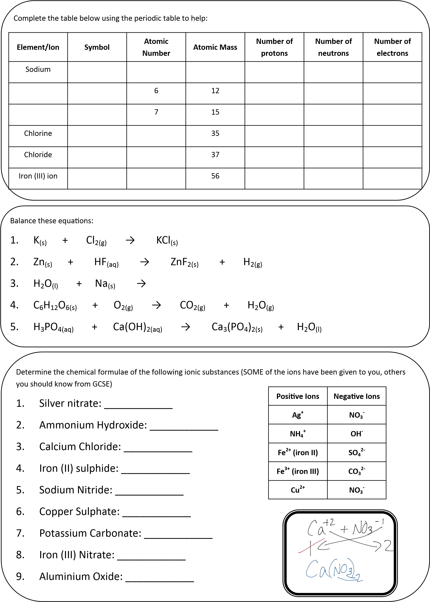
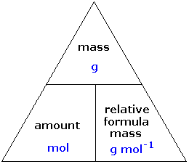

A mole is a chemical unit based on Avogadro
’
s Number. One mole of atoms contains 6 x 10
23

atoms, no matter what
element it is. This number is used in chemistry because if you could count out this many carbon atoms, the total mass of
carbon you would have is 12 g, which is the same as its atomic mass. One mole of water weighs 18g because the atomic
mass of oxygen is 16, the atomic mass of hydrogen is 1, water has the formula H
2
O
→ 16 + 1 + 1 = 18.

Calculate the number of moles or mass of the materials below;

Moles
:

1.

22
g CO
2
:

2.

75
g CaCO
3
:

3.

16
g CuSO
4
:

4.

g Mg(NO
46.1
3
)
2
:

5.

13.6
g Fe(OH
)
3

:

6.

g NiCl
19.44
2
PC
(
18
H
15
)
2
:

Mass

1.

0.125
mol LiAlH
4

:

2.

mol C
0.002
60

:

3.

2.8
mol NaCl:

4.

3
mol (NH
4
)
3
PO
4

:

5.

mol CaCO
0.5
3

:

6.

0.92
mol NaBH
4
:

Describe the similarities and differences between a base and an alkali:

. . . . . . . . . . . . . . . . . . . . . . . . . . . . . . . . . . . . . . . . . . . . . . . . . . . . . . . . . . . . . . .

.
. . . . . . . . . . . . . . . . . . . . . . . . . . . . . . . . . . . . . . . . . .
. . . . . . . . . . . . . . . . . . . . . . . . . . . . . . . . . . . . . . . . . . . . . . . . . . . . . . . . . . . . . . .

.
. . . . . . . . . . . . . . . . . . . . . . . . . . . . . . . . . . . . . . . . . .
. . . . . . . . . . . . . . . . . . . . . . . . . . . . . . . . . . . . . . . . . . . . . . . . . . . . . . . . . . . . . . .

.
. . . . . . . . . . . . . . . . . . . . . . . . . . . . . . . . . . . . . . . . . .

Give an example of the following chemical reactions, with the products, as a word and balanced symbol equation and
identify what type of reaction they are:

Inorganic Acid + Metal Oxide

Inorganic Acid + Metal Hydroxide

Inorganic Acid + Metal Carbonate

Type of reaction: . . . . . . . . . . . . . . . . . . . . . . . . . . . .

Ionic Equation:

How many individual atoms are in the following materials:

1.

mol of Na: ________________
0.5

. 0.75 mol Li:_______________
3

5
. 4x
10
-
6

mol N
2
_________________
:

2.

1.0
mol of O
2
_________________ 4. 3.5 mol K:________________ 6. 2.125 mol H
:
2
SO
4
______________
:

Write a full method for a titration and include a labelled diagram of the equipment you would use.

Draw a results table for a titration.

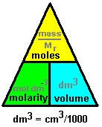
Concentration is measured in mol dm
-
3

(
moles per decimetre cubed / moles per litre). From this you can calculate the
amount of a substance used and do mole calculations for a solution.

Calculate the concentration of the solution you made using the two triangles below:

Write a balanced symbol equation for the reaction that you carried out.

. . . . . . . . . . . . . . . . . . . . . . . . . . . . . . . . . . . . . . . . . . . . . . . . . . . . . . . . . . . . . . .

.
. . . . . . . . . . . . . . . . . . . . . . . . . . . . . . . . . . . . . . . . . . .

What is the ratio of sodium

hydroxide to hydrochloric acid?

Calculate the concentration of the hydrochloric acid solution using your titration
results.

Assuming that the stock solution your acid came from had a total volume of 5L, what mass of anhydrous hydrogen

chloride would be needed to make a stock at this concentration?

Past Paper Questions


