KS4 to KS5 Design Technology Transition Work

Hello Boys,
I hope you are all keeping well and I really hope I see you all again before we start the A Level. I have included two booklets that you can print and work through. They have questions from all of the specification. However, to prepare for the A level I would focus on the following:
- CTP 3.1.1 (New and emerging technologies)
- CTP 3.1.3 (Developments in new materials)
- CTP 3.1.6 (Materials)
- ALL of the Specialist Technical Principles
- ALL of the Designing and Making Principles
Maths content:
The A Level has 15% mathematics questions across both papers. All GCSE level questions but here are the main areas to continue to practise:
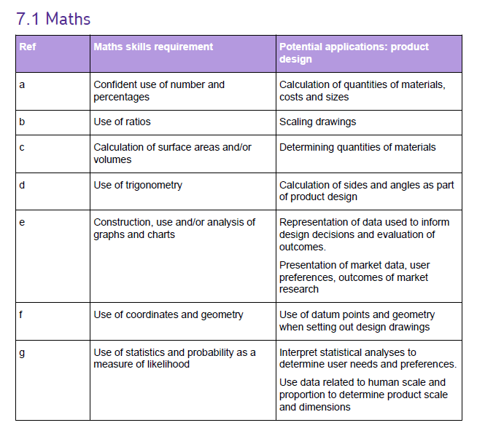
I would also definitely start watching all off the videos in the KS5 folder of the St.Ambrsoe DT Youtube channel. Some of these you will have seen at KS4 but still relevant but great to start watching more complex industrial processes:
https://www.youtube.com/channel/UCrhnTAMhP0pUDufSteLxU6A

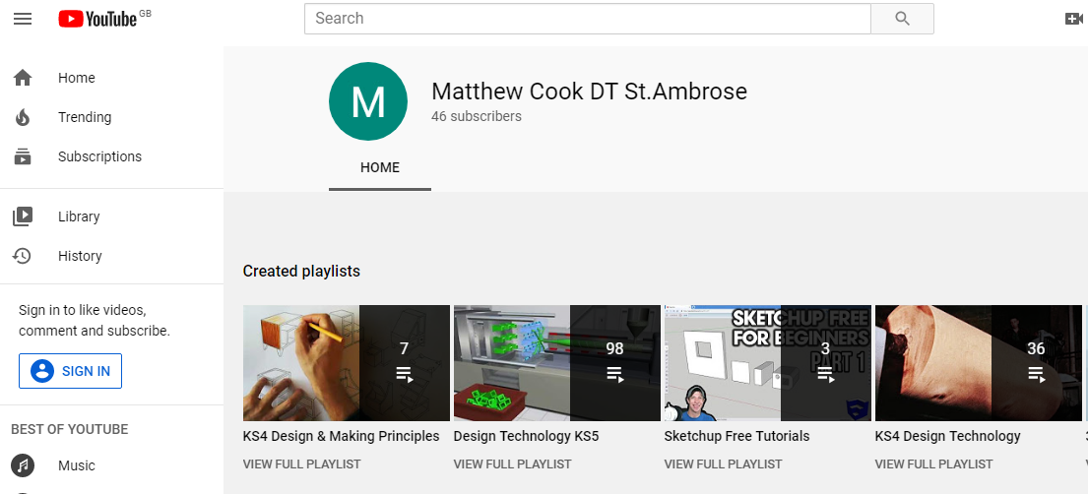

Bring the completed books back and bullet points are fine.
See you all soon and I look forward to testing you on the KS5 youtube videos. Haha.
Take care lads,
Mr Cook

Reading List:
- AQA A Level Product Design (I have some you can borrow. Email me if you want me to leave one in reception)
- Anything on design eras or product design

