Knowledge organiser for KS3 Science Biology Health & Lifestyle at Saint Ambrose College 2020+
What is covered in this unit?
Content of a healthy human diet: carbohydrates, lipids (fats and oils), proteins, vitamins, minerals, dietary fibre, and water, and why each is needed. Simple food tests for starch, simple (reducing) sugars, protein, and lipids. Calculations of energy requirements in a healthy daily diet. The consequences of imbalances in the diet, including obesity, starvation, and deficiency diseases. The tissues and organs of the human digestive system, including adaptations to function and how the digestive system digests food (enzymes simply as biological catalysts). Enzymes simply as biological catalysts. The importance of bacteria in the human digestive system. The effects of ‘recreational’ drugs (including substance misuse) on behaviour, health, and life processes. The effect of maternal lifestyle on the fetus through the placenta.

Key vocabulary
Catalyst – Chemical that speeds up a reaction
Active Site – Region of an enzyme where the chemical reaction takes place
Product – Chemical made during a reaction
Absorb – Movement of a substance across a cell membrane
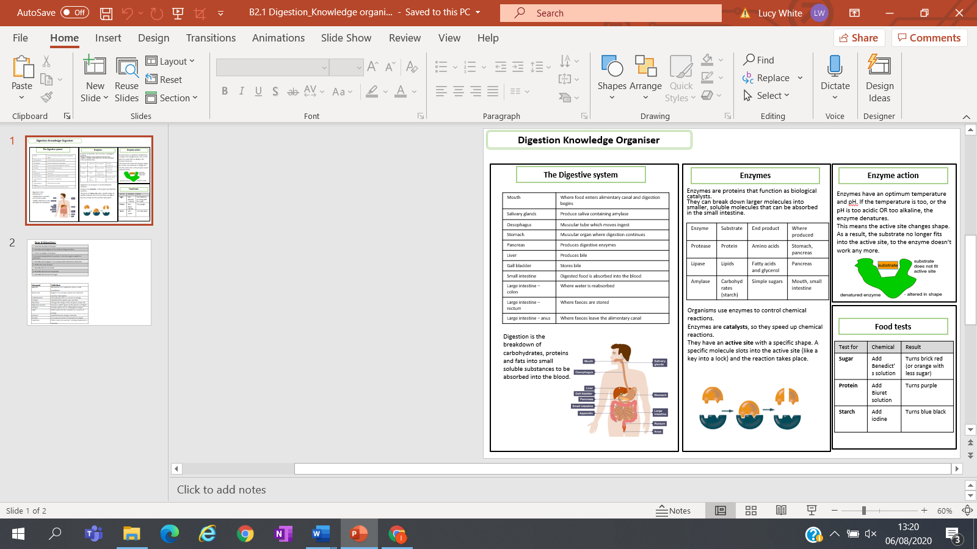
Key facts-

Possible homework tasks I Stretch & challenge (wider reading/independent work)
H/W:including project, Kerboodle, Kahoot. Stretch: modelling tasks, Biological Science Review research.

