Topic |  |  |  | Independent Learning and homework tasks
Topic |  |  |  | MyMaths | CorbettMaths.com
Simplifying algebraic expressions |  |  |  | Algebra, Algebraic manipulation, Simplifying 1 & 2 | Algebra: collecting like terms  Video 9
Expanding single and double brackets |  |  |  | Algebra, Algebraic manipulation, Single brackets & Brackets | Algebra: expanding brackets  Video 13
Factorising expressions |  |  |  | Algebra, Algebraic manipulation, Factorising linear | Factorisation  Video 117
Algebraic Substitution |  |  |  |  | Algebra: substitution  Video 20
Negative Numbers |  |  |  | Number, Counting and Place Value, Negative Numbers 2 | Video 205 - 208
Finding and recognising factors, multiples and primes |  |  |  | Number, Powers and Roots | Number: factors (Video 216)/multiples (Video 220)/ prime numbers (Video 225)
Finding HCF and LCM |  |  |  | Number, Powers and Roots | Number  Videos 218-219
Forming and solving linear equations |  |  |  | Algebra, Equations - Linear | Equations: solving Video 110 & 111
Finding the fraction of a quantity |  |  |  | Number, Fractions, Fractions of amounts | Video 137
Ordering fractions |  |  |  | Number, Fractions, ordering and simplifying fractions | Video 144
Applying four operations to fractions |  |  |  | Number, Fractions | Video 132 - 137
Fractions, decimals and percentages |  |  |  | Number, Percentages, Frac Dec Perc 1 & 2 | FDP  Videos 121 to 131
Knowledge Organiser
Autumn 1 Set 3 Year 9


For full list of Maths knowledge,
scan QR code:

Autumn Term 1 Knowledge
Algebra
‘Changing the Subject’ is another way of describing rearranging formulae.
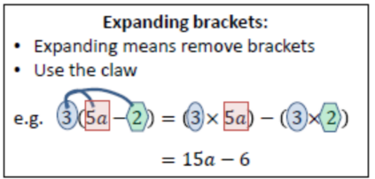
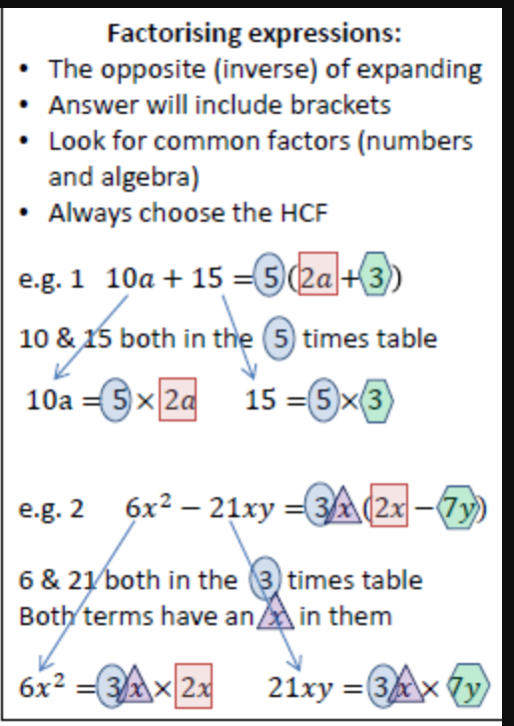
Remember: whatever you do to one side of the formula you have to do the other side to keep it balanced.
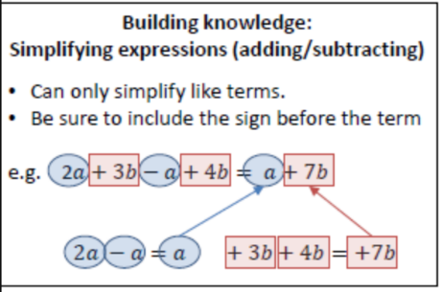
Expanding double brackets
- FOIL Method
(x + 2 )(x + 3) = x² + 3x + 2x + 6
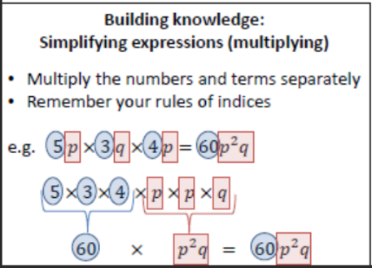
= x² + 5x + 6
- Grid method – see exercise book

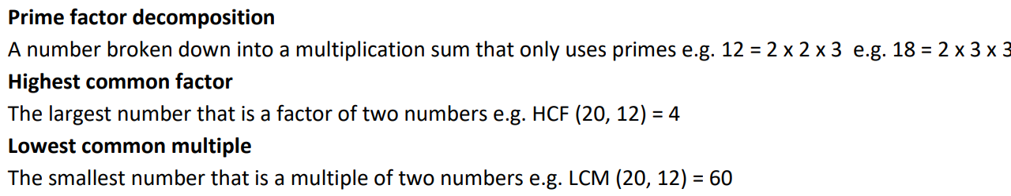

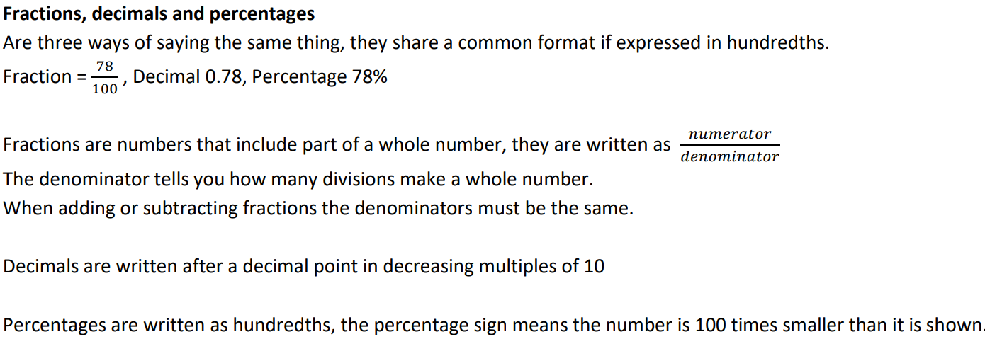

Maths Support Attend KS3 Maths Clinic every week for extra help and support
Stretch and Challenge:
- Practise UKMT Intermediate Maths Challenge Past papers on:
https://www.ukmt.org.uk/competitions/solo/intermediate-mathematical-challenge/archive
- Set up an account on parallel.org.uk website, using your school email address and use teacher code “ha52kh”
- Attend Puzzle Club one lunch time each week

