Knowledge Organiser
Lent Term Set 1 Year 10
Topic | Self-Assessment | Independent Learning and homework tasks
 |  | MyMaths | CorbettMaths.com
Calculate density and pressure (4) |  | N/A | Video 384, 385
Calculate volume & surface area of cones, pyramids & spheres (5/6).  Calculate rates of flow in/out of containers (8). |  | Shape, Volume & Surface Area – Volume of Cones & Spheres, Complex Surface Areas | Video 359 - 361
Enlarging similar shapes – use of volume & SA scale factors (6) |  | Shape, Scale & Similarity – Area Scale Factor, Volume Scale Factor | Video 293a, b
Be able to draw quadratic graphs (5) and use them to solve quadratic equations (7) |  | Algebra, Graphs – Plotting Graphs | Video 264
Determining the equations of straight line graphs (4/5) |  | Algebra, Graphs y=mx+c | Videos 187-191
Finding the equations of parallel and perpendicular lines (7) |  | Algebra, Graphs – Equation of a Line 2 | Videos 196-197
Be able to calculate missing angles using angle rules (3) |  | Shape, Angles – Angles in Parallel Lines & Interior Exterior Angles | Video 25
Understand, prove and use the rules for angles in circles (8) |  | Shape, Circle Theorems – Intersecting Chords, Circle Theorem Proof | Videos 64 - 65
Be able to expand triple brackets (7) |  | GCSE (9-1) Eng: Algebra, Algebraic Manipulation, Expanding Three Binomials | Video 15
Factorising quadratic expressions and solving quadratic equations by factorising (6). |  | Algebra, Equations – quadratic, Quadratic equations 1 & 2 | Video 266
Simplify and manipulate surds (7/8). |  | Number, Powers & Roots, Surds 1 & 2 | Videos 305 - 308
Rationalise the denominator of a surd (9). |  | Number, Powers & Roots, Surds 2 | Video 307

Stretch and Challenge:
- Practise UKMT Intermediate Maths Challenge Past papers on:
https://www.ukmt.org.uk/competitions/solo/intermediate-mathematical-challenge/archive
- Set up an account on parallel.org.uk website, using your school email address and use teacher code “ha52kh”

- Attend Puzzle Club one lunch time each week

Lent Term Knowledge
Volume and Surface Area of 3D shapes
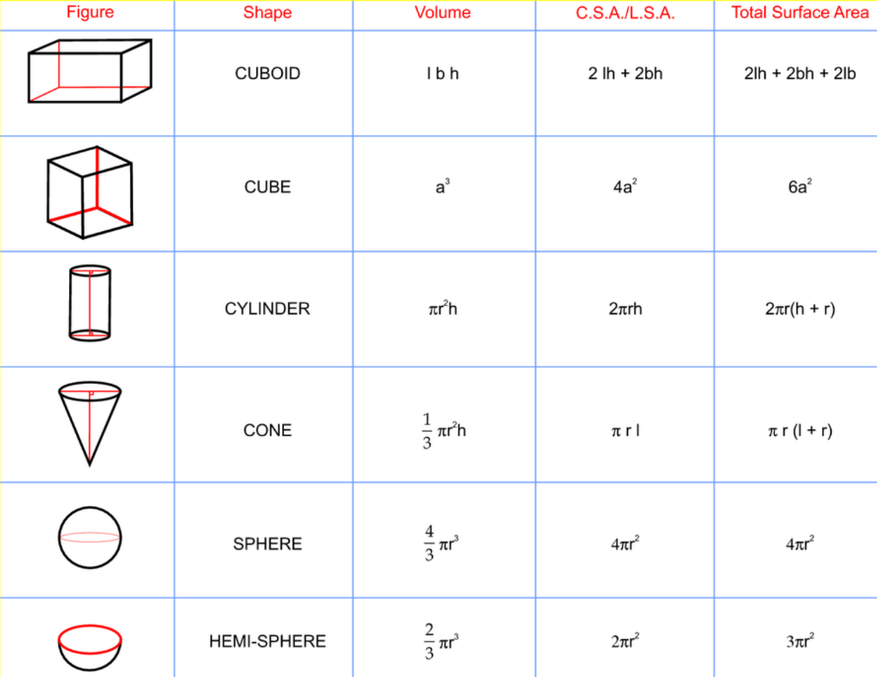

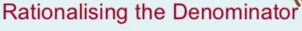
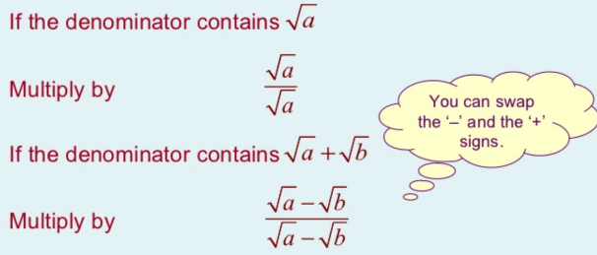
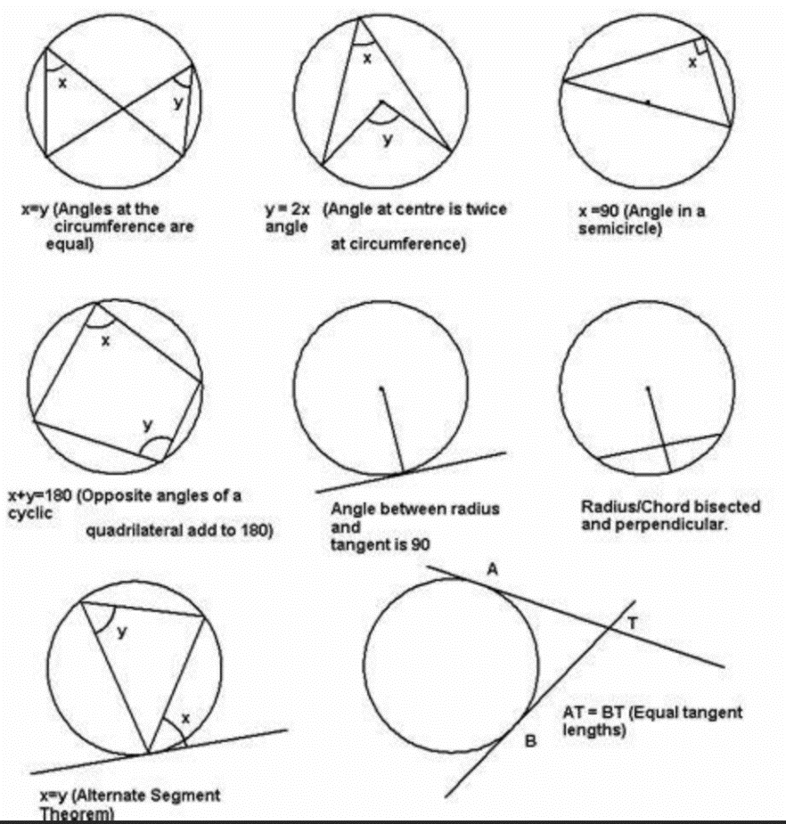
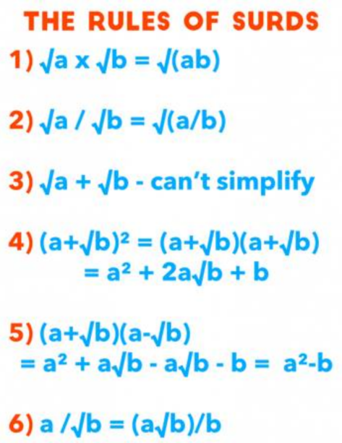
Circle Theorems
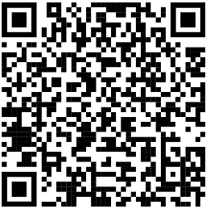
Scan QR Code for Full List of Maths Facts

