Knowledge Organiser
Autumn Term 2 Set 3 Year 11
Topic | Self-Assessment | Independent Learning and  Homework tasks
 |  | MyMaths | CorbettMaths.com
Factorising quadratic expressions, of the form ax²+bx+c, including the difference of two squares. |  | Algebra, Algebra Manipulation, Factorising Quadratics | Quadratics (factorising) video 266
Solving quadratic equations by factorising. |  | Algebra, Equations – quadratics, Quadratic Equations 2 | Video 266
Solving simultaneous equations by elimination and substitution |  | Algebra, Equations – Simultaneous | Videos 295 - 6
Solving simultaneous equations graphically. |  | Algebra, Equations – Simultaneous, Solving Sim Eqs Graphically | Video 297
Forming, then solving simultaneous equations. |  | Algebra, Equations – Simultaneous
Solving quadratic equations using the quadratic formula. |  | Algebra, Equations – quadratics, Completing the square / Quad Formula | Video 267, 267a
Solve problems by first forming quadratic equations. |  | Algebra, Equations – quadratics, Quadratic Equations 2
Solve simultaneous equations consisting of one quadratic and one linear equation. |  | Algebra, Equations – Simultaneous, Quad Simultaneous Equs | Video 298
Understanding the handling data cycle and carrying out effective data collection. |  | Data, Collecting Data | Video 89
Identifying different types of data including qualitative, quantitative, discrete, continuous, primary and secondary data. |  | Data, Collecting Data, Types of Data
Understanding different sampling methods and identifying possible bias. |  | Data, Collecting Data, Sampling | Video 282
Calculating stratified samples. |  | Data, Collecting Data, Sampling | Video 281
Drawing and interpreting histograms.  Calculating frequency density. |  | Data, Presenting Data, Histograms | Video 157 - 8
Scan for full list of Maths facts

Autumn Term 2 Knowledge

Quadratic Formula
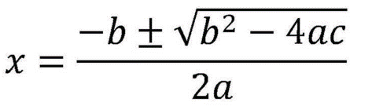
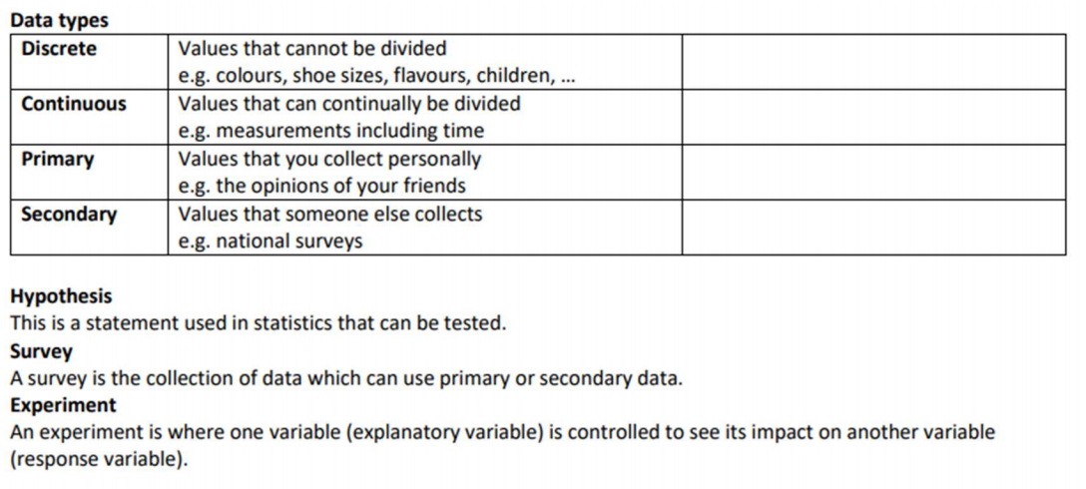

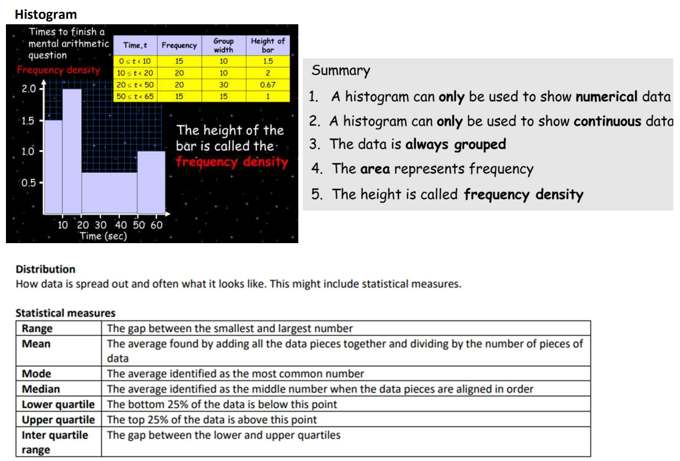

Extra practice: Set up an account on parallel.org.uk website, using your school email address and use teacher code “ha52kh”
Support: Attend Maths Clinic one lunch time each week

