Knowledge Organiser
Autumn Term 1 Set 1 Year 11
Topic | Self-Assessment | Independent Learning and  homework tasks
 |  | MyMaths | CorbettMaths.com
Recognise and use the equation of a circle to find circle centre and radius, equation of tangent |  | Algebra, Graphs, Equation of a circle | Video 372
Use coordinates in 3D |  | Algebra, Coordinates, 3D coordinates | Video 86
Understanding vectors and solving geometric problems using vectors |  | Shape, Vectors, Vectors 1 & 2 | Video 353
Drawing trig graphs for sin, cos and graph functions |  | Shape, Trigonometry, Sine and Cosine Graphs / Tan Graphs | Video 338 - 340
Use trig graphs to find angles greater than 90 degrees |  | Shape, Trigonometry, Sine and Cosine Graphs / Tan Graphs | Video 338 - 340
Using sine and cosine rule to find missing angles and lengths of triangles |  | Shape, Trigonometry, Sine Rule / Cosine Rule missing sides / angles | Video 333 - 336
Using trig formula to find area of a triangle |  | Shape, Trigonometry, Trig Area of a Triangle | Video 337
Be able to use of f(x), fg(x) and f⁻¹(x) notation |  | Algebra, Functions, Functions 1
Understanding ‘inverse function’ and ‘composite function’ |  | Algebra, Functions, Functions 2 | Video 369 - 370
Find approximate solutions to equations numerically using iteration |  | Algebra, Equations – approx. solutions, Iterations | Video 373
Sketch graphs of y=af(x), y =f(ax), y=f(x)+a, y=f(x+a) given the graph of y=f(x) |  | Algebra, Graphs, Transforming Graphs 1 & 2 | Video 323 - 4
Stretch and Challenge:
- Practise UKMT Intermediate Maths Challenge Past papers on:
https://www.ukmt.org.uk/competitions/solo/intermediate-mathematical-challenge/archive
- Set up an account on parallel.org.uk website, using your school email address and use teacher code “ha52kh”
- Attend Puzzle Club one lunch time each week

Autumn Term 1 Knowledge
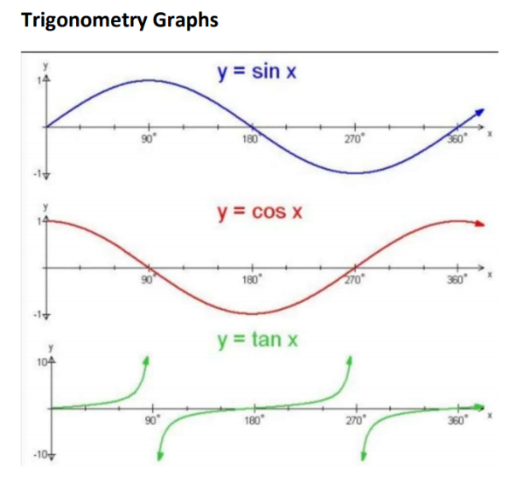
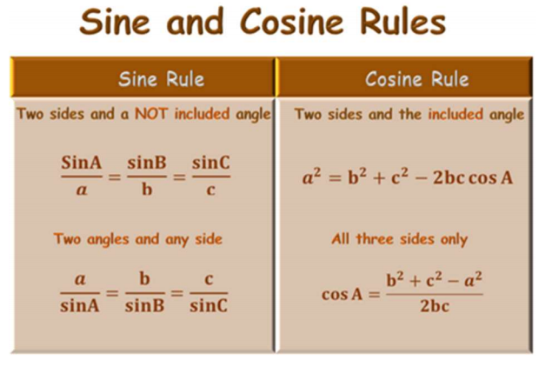

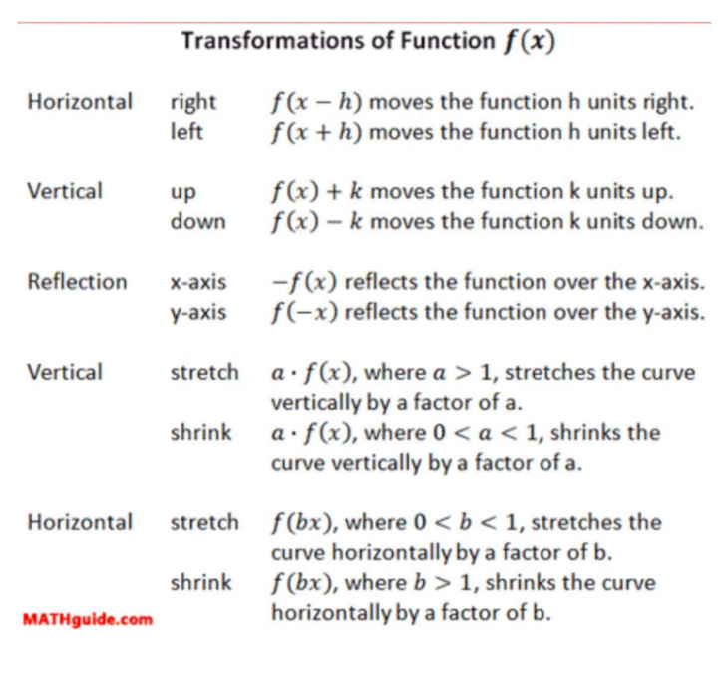

Scan for full list of Maths facts

