5th Year KS4 -> 5: Transition Preparation for A-Level Physics

For those considering A-level physics and referring to Mr. Rainey’s ParentMail(s), I have selected some useful materials and resource links, to help you prepare over summer and get a taste for the standard required at A-level.
GCSE Understanding: You should, as part of your revision for the cancelled GCSEs, have a good idea of where you needed to focus on at GCSE physics in the remaining time before exams; make sure you continue and complete this process! You must have a firm grasp of the topics studied at GCSE; my usual suggested resources to help you go over these are:
https://www.bbc.co.uk/bitesize/examspecs/zsc9rdm GCSE AQA Single Science – Physics (look out for new lessons form 20-04-20 I believe);
https://www.physicsandmathstutor.com/physics-revision/gcse-aqa/ for GCSE questions, answers, notes and flashcards;
https://www.senecalearning.com/ which a lot of you already use;
https://www.kerboodle.com/ for both GCSE AQA (and also OCR Physics A) courses we have subscribed to, including the detailed GCSE 4-6-8 checklists;
https://members.gcsepod.com/login I know some of you have been using this quite a lot for exam preparation;
https://www.youtube.com/channel/UCqbOeHaAUXw9Il7sBVG3_bw - Free Science Lessons channel home.

You will not be surprised to learn that equations are very important in physics. Make sure you do know the 23 you had to learn for GCSE. You will be pleased to know that you get a formula booklet for A-level, with fundamental constants, maths concepts and the physics formulae in module order. I have put this in with the resources if you want to take a look; you can always use this with homework, tests and exams, as well as a calculator!

One of the best sources to then look at would be the OCR Physics A website:
https://www.ocr.org.uk/qualifications/as-and-a-level/physics-a-h156-h556-from-2015/
The specification pdf covers in detail the course structure, organisation and content. You should download and start reading through this.
I have put copies of the specification and other OCR pdfs in with these resources:
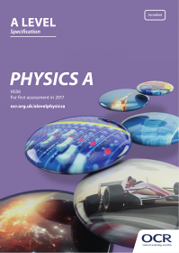 | 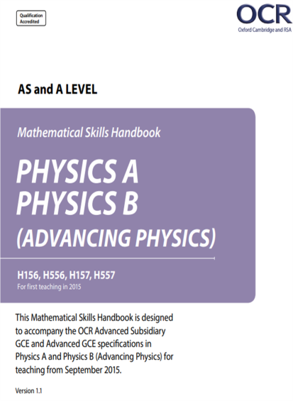
Overall Course Specification | Mathematical Skills Handbook

The mathematical skills handbook is designed to accompany the A-Level specifications in Physics A. You don’t need to do A-level Mathematics to do Physics, but it is generally suggested as a good combination. You do, though, need good GCSE Maths skills; a 7+ is the minimum recommended. This maths handbook is very clear on what skills you need and I would go through it carefully, noting what you can do and what you can’t at this stage, so you can follow these up. The mathematical skills are then developed and checked in module 2 at the start of the course. You should also already have access to the Kerboodle A-level textbook as part of your school Kerboodle access; let me know if you can’t view it. These are the ones you want:
 | 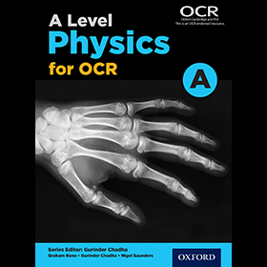
Click this for the A-level course | Then on the digital book tab cycle to this one.

Textbook pages 6 to 18 cover chapter 2; this, along with the maths skills handbook, gives good instruction in the minimum required level of maths ability expected. I also strongly recommend looking through the textbook Appendices, pages 556 to 564. They cover:
A1 – Physical Quantities and Units;
A2 – Recording Results and Straight Lines (Graphs etc);
A3 – Measurements and Uncertainties (always a tricky one but very important!).
You will notice we’ve skipped chapter 1 so far - that’s because it links to the third OCR pdf, the Practical skills handbook:
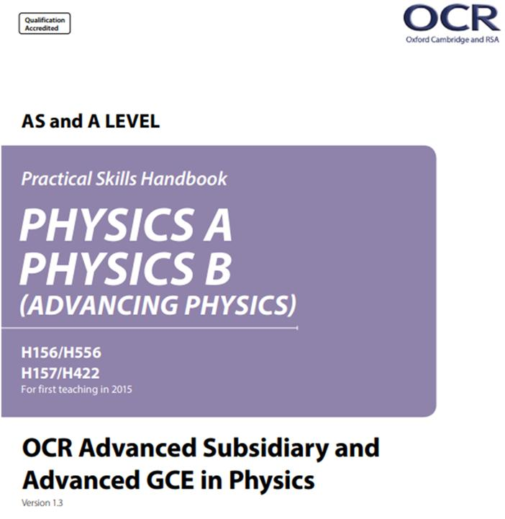
Practical Skills Handbook

During Physics A-level we do a minimum of 12 required practicals (we often call them PAGs). Unlike at GCSE, or even AQA Biology or Chemistry, these are not specific practicals and you are not expected to learn them off-by-heart. Instead you are expected to display (and develop) skills as you do the practicals across the two years, plus around 15% of your exam questions can relate to experimental physics.
For now I recommend going back through Chapter 1 in the textbook (pages 2 to 5) and then going through the start of the Practical Skills booklet, up to / including page 12 at this stage.

I have included with these resources a copy of “Alvl Physics GCSE Transition Info and Questions.docx” and also the answer sheet; I suggest attempting the questions after you have read through your GCSE notes and the Chapter 1, 2, Maths and Practical skills booklet (introduction). You can then self-assess and go back over areas you struggled with. In particular the focus here is on:
- defining practical science key terms
- recall the answers to the retrieval questions
- perform maths skills including:
  - unit conversions
  - uncertainties
  - using standard form and significant figures
  - resolving vectors
  - rearranging equations
  - equations of work, power, and efficiency
Challenge Work: I also include three sub-folders of L6th-level questions and answers for you to practice with over the summer; for some you may need to look in the textbook; for others it might be the case of working backwards from the provided answer sheets. Also, as a bonus challenge, some of the pdf files might need rotating 90 or 180 degrees due to the way they were scanned!

Details are still to be confirmed, but some form of assessment is likely at the start of the L6th course to make sure we feel you can handle the challenge; this would likely be on high-grade GCSE topic questions and the topic areas I have mentioned in this document.

Additional External Links and Resources – Going Further
https://www.physicsandmathstutor.com/physics-revision/a-level-ocr-a/ for OCR A-level physics questions, answers, notes and flashcards, if you are feeling brave!
https://www.senecalearning.com/ which a lot of you already use but there are resources for A-level, too;
https://www.amazon.co.uk/dp/B00VE2NII4/ref=cm_sw_r_oth_api_i_Dw4FEbBBRGTEV the free (kindle version) CGP transition guide on offer on Amazon (or £5 for hard copy);
https://www.alevelphysicsonline.com/ocr-spec-a some students have used this; some parts are free but some you have to subscribe. Might be one for the future or have a look at the free bits for now.

Final Thoughts
It is currently an odd and quite stressful time, with a fair bit of uncertainty. I can say one thing for sure, though, as I (and other physics teachers always do) – A-level Physics is tough! You must approach it with the right attitude and the desire to work hard from day one of lower 6th. You should also be interested in it and enjoy it; you will be doing 9 or 10 lessons every two weeks on it for the best part of the next two years! Having a passion for science, discoveries and technology will help you a great deal and one of the best forms of preparation for KS5 (and beyond) is finding things out for yourselves. We have had some excellent presentations at Physics and Engineering Society over the years and I will be pushing this next year. I would expect all 6th Form physics students to want to present a talk on something they are interested in, or a new discovery, over their time in 6th Form – it doesn’t have to be alone, but don’t expect to hide away ... As always if you have questions email me, or your physics teacher, and we will do our best to help.
Dr. Gardener, April 2020.

