Y8 LATIN –
Big question: Can I use knowledge of noun and verb endings to work out increasingly harder sentences?
Module assessment level: ____________ Effort grade: ____________________
Target 1: _______________________________________________________________________________________________________
Target 2: ____________________________________________________________________________________________________
____________________________________________________________________________________________________________________
Key Skills and strategies
- Recognise agreements
- Search vocab.)
- Memorise vocab.
- Re-using language
- Use sources to draw conclusions ( about Slavery)

Key details
Nature of assessment:
Comprehension
Example question:
- Answer qus in English on ‘Marcus Comes to Rescue’.
- Translate a section acurrately
- Translate sentences from English into Latin

Aims / Objectives
- Recognise accusative case endings
- Recognise verb-groups and person-endings
- Draw simple conclusions from Source material on Slavery
- Translate, and show comprehension of, Latin texts

Assessment task to be completed by all Year 7 classes:
Completed? | Task | Assessment
 | Ex. 4b | Peer
 | Source work on Slavery | Teacher
 | End of unit assessment | Teacher
 |  | T

Success criteria
- Completion of exercises
- Oral and written translation work
- Vocab. Test scores
- Extended writing on Slavery
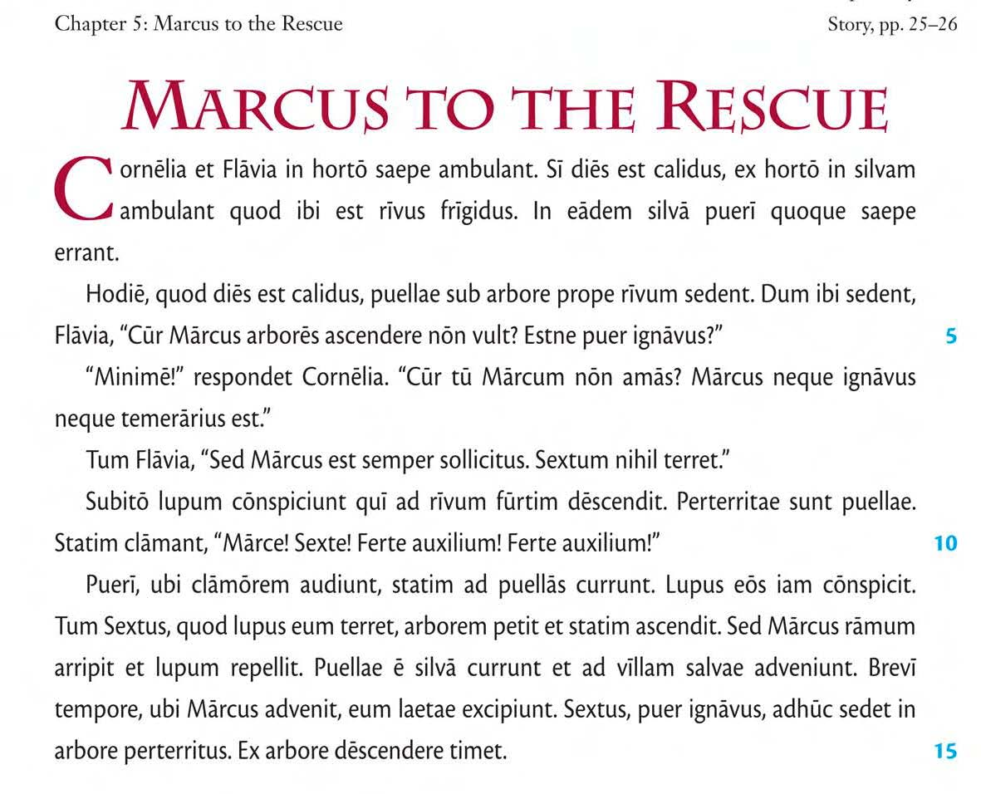

Vocabulary:
YEAR 2 VOCABULARY
SORT THE WORDS INTO DIFFERENT GROUPS: ADVERBS, NOUNS, VERBS etc. . HIGHLIGHT WORDS YOU ARE LESS CONFIDENT WITH.
Puella - girl dies - day
Qui /Quae - who calidus - warm
Ubi - where in silvam – into the wood
Laetus /laeta -happy rivus - stream
Quod - because prope - near
Iam – now/ already vult – he/she wants
Dum - while ignavus - cowardly
Quis? - who? Neque…neque – neither…nor
Quoque - also scribere – to write
Amicus - friend laborantes - working
Hodie - today meus - my
Sed - but inquit - says
Ambulare – to walk atrium - hall
Defessus -tired area - courtyard
Tandem – at last culina - kitchen
Lente - slowly agri - fields
Saepe - often cubiculum - bedroom
Puer - boy eheu! – alas!
Hortus - garden in urbem – to the city
Clamare - to shout eugepae! – hurray!
Ridere – to laugh ducere – to lead
Servus - slave legere – to read
Vir - man omnia - everything
Multus - many nos – we /us
Solus - only tradere – to hand over
Laborare – to work tempus - time
Iratus - angry iterum - again
Subito - suddenly deinde – next, then
Facere - to do surgere – to get up
Semper - always mihi – to/for me
Igitur - therefore hic - here
Appropinquare - to approach tamen - however
Audire - to hear nunc - now
Videre - to see omnes – all / everyone
Tum - then festinare - to hurry
Ubi - when manere – to stay
Mane - in the morning volo – I want
Tuus - your nolo – I do not want
Si - if potest - He /she can
Adhuc - still auxilium- help
Redire - to return minime!- No!
Statim - at once ita vero!- Yes!
Ibi - there quid? - What?
Eam / eum – her /him nescio – I do not know

